Recent Examples of MPP Systems and Clusters
This lecture is devoted to examination of a number of multicomputer systems.
Multiprocessors
1. The Sun Microsystems E25K multiprocessor.
2. The IBM BlueGene
3. The Cray Red Storm
4. The Cray XT5
Clusters*
1. The Google cluster.
2. Some typical blade servers.
3. The “SETI at home” distributed computing effort.

There are a number of motivations for this lecture. The primary motivation is to show that recent technological improvements (mostly with VLSI designs) have invalidated the earlier pessimism about MPP systems. We show this by describing a number of powerful MPP systems.
* Tanenbaum [Ref. 4, page 627] likes to call these “Collections of Workstations” or “COWs”.
The E25K NUMA Multiprocessor by Sun Microsystems
Our first example is a shared–memory NUMA multiprocessor built from seventy–two processors.
Each processor is an UltraSPARC IV, which itself is a pair of UltraSPARC III Cu processors. The “Cu” in the name refers to the use of copper, rather than aluminum, in the signal traces on the chip.
A trace can be considered as a “wire” deposited on the surface of a chip; it carries a signal from one component to another. Though more difficult to fabricate than aluminum traces, copper traces yield a measurable improvement in signal transmission speed, and are becoming favored.
Recall that NUMA stands for “Non–Uniform Memory Access” and describes those multiprocessors in which the time to access memory may depend on the module in which the addressed element is located; access to local memory is much faster than access to memory on a remote node.
The basic board in the multiprocessor comprises the following:
1. A CPU and memory board with four UltraSPARC IV processors, each with an 8–GB
memory. As each processor is dual core, the board has 8 processors and 32 GB memory.
2. A snooping bus between the four processors, providing for cache coherency.
3. An I/O board with four PCI slots.
4. An expander board to connect all of these components and provide communication
to the other boards in the multiprocessor.
A full E25K configuration has 18 boards; thus 144 CPU’s and 576 GB of memory.
The E25K Physical Configuration
Here is a figure from Tanenbaum [Ref. 4] depicting the E25K configuration.
The E25K has a centerplane with three 18–by–18 crossbar switches to connect the boards. There is a crossbar for the address lines, one for the responses, and one for data transfer.
The number 18 was chosen because a system with 18 boards was the largest that would fit through a standard doorway without being disassembled. Design constraints come from everywhere.
Cache Coherence in the E25K
How does one connect 144 processors (72 dual–core processors) to a distributed memory and still maintain cache coherence? There are two obvious solutions: one is too slow and the other is too expensive. Sun Microsystems opted for a multilevel approach, with cache snooping on each board and a directory structure at a higher level. The next figure shows the design.
The memory address space is broken into blocks of 64 bytes each. Each block is assigned a “home board”, but may be requested by a processor on another board. Efficient algorithm design will call for most memory references to be served from the processors home board.
The IBM BlueGene
The description of this MPP system is based mostly on Tanenbaum [Ref. 4, pp. 618 – 622].
The system was designed in 1999 as “a massively parallel supercomputer for solving computationally–intensive problems in, among other fields, the life sciences”. It has long been known that the biological activity of any number of important proteins depends on the three dimensional structure of the protein. An ability to model this three dimensional configuration would allow the development of a number of powerful new drugs.
The BlueGene/L was the first model built; it was shipped to Lawrence Livermore Lab in June 2003.
A quarter–scale model, with 16,384 processors, became operational in November 2004 and achieved a computational speed of 71 teraflops.
The full model, with 65,536 processors, was scheduled for delivery in the summer of 2005. In October 2005, the full system achieved a peak speed on 280.6 teraflops on a standard benchmark called “Linpack”. On real problems, it achieved a sustained speed of over 100 teraflops.
The connection topology used in the BlueGene is a three–dimensional torus. Each processor chip is connected to six other processor chips. The connections are called “North”, “East”, “South”, “West”, “Up”, and “Down”.
The Custom Processor Chip
IBM intended the BlueGene line for general commercial and research applications. Because of this, the company elected to produce the processor chips from available commercial cores.
Each processor chip has two PowerPC 440 cores operating at 700 MHz. The configuration of the chip, with its multiple caches is shown in the figure below. Note that only one of the two cores is dedicated to computation, the other is dedicated to handling communications.
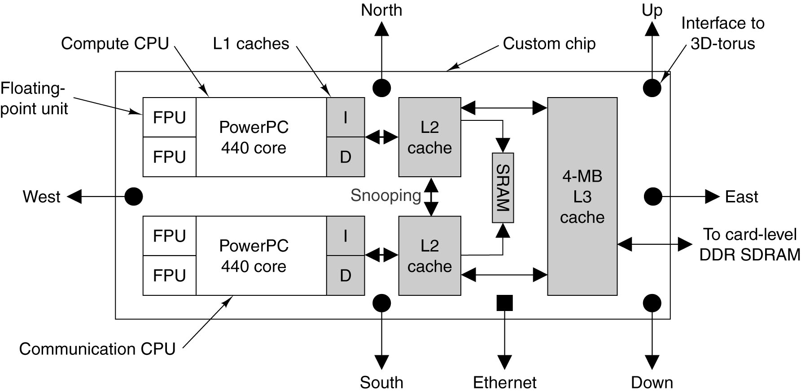
In a recent upgrade (June 2007), IBM upgraded this chip to hold four PowerPC 450 cores operating at 850 MHz. In November 2007, the new computer, called the BlueGene/P achieved a sustained performance of 167 teraflops. This design obviously has some “growing room”.
The BlueGene/L Hierarchy
The 65,536 BlueGene/L is designed in a hierarchical fashion. There are two chips per card,
16 cards per board, 32 boards per cabinet, and 64 cabinets in the system.
We shall see that the MPP systems manufactured by Cray, Inc. follow the same design philosophy.
It seems that this organization will become common for large MPP systems.
The AMD Opteron
Before continuing with our discussion of MPP systems, let us stop and examine the chip that has recently become the favorite for use as the processor, of which there are thousands.
This chip is the AMD Opteron, which is a 64–bit processor that can operate in three modes.
In legacy mode, the Opteron runs standard Pentium binary programs unmodified.
In compatibility mode, the operating system runs in full 64–bit mode, but applications
must run in 32–bit mode.
In 64–bit mode, all programs can issue 64–bit addresses; both 32–bit and 64–bit
programs can run simultaneously in this mode.
The Opteron has an integrated memory controller, which runs at the speed of the processor clock.
This improves memory performance. It can manage 32 GB of memory.
The Opteron comes in single–core, dual–core, or quad–core processors. The standard clock rates for these processors range from 1.7 to 2.3 GHz.

The Red Storm by Cray, Inc.
The Red Storm is a MPP system in operation at Sandia National Laboratory. This lab, operated by Lockheed Martin, doe classified work for the U.S. Department of Energy. Much of this work supports the design of nuclear weapons. The simulation of nuclear weapon detonations, which is very computationally intensive, has replaced actual testing as a way to verify designs.
In 2002, Sandia selected Cray, Inc. to build a replacement for its current MPP, called ASCI Red. This system had 1.2 terabytes of RAM and operated at a peak rate of 3 teraflops.
The Red Storm was delivered in August 2004 and upgraded in 2006 [Ref. 9]. The Red Storm now uses dual–core AMD Opterons, operating at 2.4 GHz. Each Opteron has 4 GB of RAM and a dedicated custom network processor called the Seastar, manufactured by IBM.
Almost all data traffic between processors moves through the Seastar network, so great care was taken in its design. This is the only chip that is custom–made for the project.
The next step in the architecture hierarchy is the board, which holds four complete Opteron systems (four CPU’s, 16 GB RAM, four Seastar units), a 100 megabit per second Ethernet chip, and a RAS (Reliability, Availability, and Service) processor to facilitate fault location.
The next step in the hierarchy is the card cage, which comprises eight boards inserted into a backplane. Three card cages and their supporting power units are placed into a cabinet.
The full Red Storm system comprises 108 cabinets, for a total of 10,836 Opterons and 10 terabytes of SDRAM. Its theoretical peak performance is 124 teraflops, with a sustained rate of 101 teraflops.
Security Implications of the Architecture
In the world on national laboratories there are special requirements on the architecture of computers that might be used to process classified data. The Red Storm at Sandia routinely processes data from which the detailed design of current U.S. nuclear warheads may be inferred. Naturally, such data are considered to be quite sensitive.
The solution to the security problem was to partition Red Storm into classified and unclassified sections. This partitioning was done by mechanical switches, which would completely isolate one section from another. There are three sections: classified, unclassified, and a switchable section.
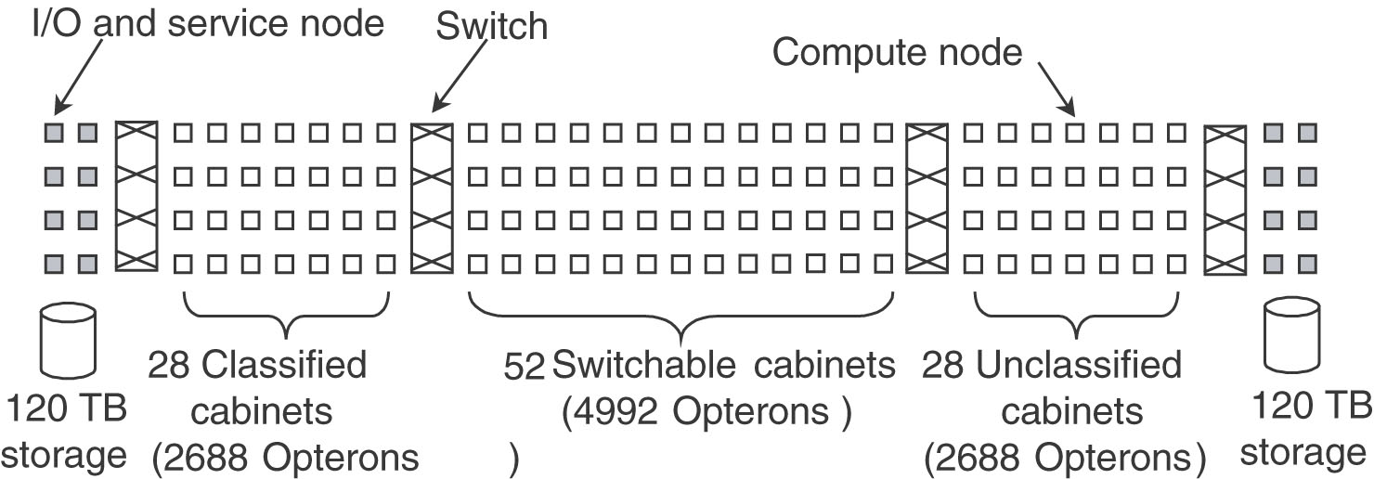
The figure above, taken from Tanenbaum [Ref. 4], shows the configuration as it was in 2005.
The Cray XT5h
The Cray XT3 is a commercial design based on the Red Storm installed at Sandia National Labs.
The Cray XT3 led to the development of the Cray XT4 and Cray XT5, the latest in the line.
The XT5 follows the Red Storm approach in using a large number of AMD Opteron processors. The processor interconnect uses the same three–dimensional torus as found in the IBM BlueGene and presumably in the Cray Red Storm. The network processor has been upgraded to a system called ‘Seastar 2+”; each switch having six 9.6 GB/second router–to–router ports.
The Cray XT5h is a modified XT5, adding vector coprocessors and FPGA (Field Programmable Gate Array) accelerators. FPGA processors might be used to handle specific calculations, such as Fast Fourier Transforms, which often run faster on these units than on general purpose processors.
In April 2008, Cray, Inc. was chosen to deliver an XT4 to the University of Tennessee. This monster is expected to achieve one petaflop (1000 teraflops) in performance.

The Google Cluster
We now examine a loosely–coupled cluster design that is used at Google, the company providing the popular search engine. We begin by listing the goals and constraints of the design.
There are two primary goals for the design.
1. To provide key–word search of all the pages in the World Wide Web, returning answers
in not more than 0.5 seconds (a figure based on human tolerance for delays).
2. To “crawl the web”, constantly examining pages on the World Wide Web and indexing
them for efficient search. This process must be continuous in order to keep the index current.
There are two primary constraints on the design.
1. To obtain the best performance for the price. For this reason, high–end servers are eschewed
in favor of the cheaper mass–market computers.
2. To provide reliable service, allowing for components that will fail. Towards that end,
every component is replicated, and maintenance is constant.
What makes this design of interest to our class is the choice made in creating the cluster. It could have been created from a small number of Massively Parallel Processors or a larger number of closely coupled high–end servers, but it was not. It could have used a number of RAID servers, but it did not. The goal was to use commercial technology and replicate everything.
According to our textbook [Ref. 1, page 9–39], the company has not suffered a service outage
since it was a few months old, possibly in late 1998 or early 1999.
The Google Process
We begin by noting that the success of the cluster idea was due to the fact that the processing of a query is one that can easily be partitioned into independent cooperating processes.
Here is a depiction of the Google process, taken from Tanenbaum [Ref. 4, page 629].
The Google Process: Sequence of Actions
The process of handling a web query always involves a number of cooperating processors.
1. When the query arrives at the data center, it is first handled by a load balancer. This load
balancer will select three other computers, based on processing load, to handle the query.
2. The load balancer selects one each from the available spell checkers, query handlers, and
advertisement servers. It sends the query to all three in parallel.
3. The spell checker will check for alternate spellings and attempt to correct misspellings.
4. The advertisement server will select a number of ads to be placed on the final display,
based on key words in the query.
5. The query handler will break the query into “atomic units” and pass each unit to a
distinct index server. For example, a query for “Google corporate history” would generate
three searches, each handled by a distinct index server.
6. The query handler combines the results of the “atomic queries” into one result. In the example
above, a logical AND is performed; the result must have been found in all three atomic queries.
7. Based on the document identifiers resulting from the logical combination, the query handler
accesses the document servers and retrieves links to the target web pages.
Google uses a proprietary algorithm for ranking responses to queries. The average query involves processing about 100 megabytes of data. Recall that this is to be done in under a half of a second.
The Google Cluster
The typical Google cluster comprises 5120 PC’s, two 128–port Ethernet switches, 64 racks each with its own switch, and a number of other components. A depiction is shown below.
Note the redundancy built into the switches and the two incoming lines from the Internet.
Blade Servers and Blade Enclosures
Blade enclosures represent a refinement of the rack mounts for computers, as found in the Google cluster. In a blade enclosure, each blade server is a standard design computer with many components removed for space and power considerations.
The common functions (such as power, cooling, networking, and processor interconnect) are provided by the blade enclosure, so that the blade server is a very efficient design.
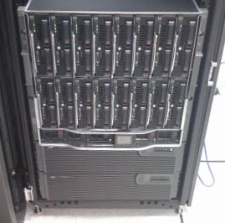
The figure at left shows an HP Proliant blade enclosure with what appears to be sixteen blade servers, arranged in two racks of 8.
Typically blade servers are “hot swappable”, meaning that a unit can be removed without shutting down and rebooting all of the servers in the enclosure. This greatly facilitates maintenance.
Essentially a blade enclosure is a closely coupled multicomputer. Typical uses include web hosting, database servers, e–mail servers, and other forms of cluster computing.
According to Wikipedia [Ref. 10], the first unit called a “blade server” was developed by RTX Technologies of Houston, TX and shipped in May 2001.
It is interesting to speculate about the Google design, had blade servers been available in the late 1990’s when Google was starting up.
Radio SETI
This information is taken from the SETI@Home web page [Ref. 7].
SETI is the acronym for “Search for Extra–Terrestrial Intelligence”. Radio SETI refers to the use of radio receivers to detect signals that might indicate another intelligent species in the universe.
The SETI antennas regularly detect signals from a species that is reputed to be intelligent; unfortunately that is us on this planet. A great deal of computation is required to filter the noise and human–generated signals from the signals detected, possibly leaving signals from sources that might be truly extraterrestrial.
Part of this processing is to remove extraterrestrial signals that, while very interesting, are due to natural sources. Such are the astronomical objects originally named “Little Green Men”, but later named as “quasars” and now fully explained by modern astrophysical theory.
Radio SETI was started under a modest grant and involved the use of dedicated radio antennas and supercomputers (the Cray–1 ?) located on the site.
In 1995, David Gedye proposed a cheaper data–processing solution: create a virtual supercomputer composed of large numbers of computers connected by the global Internet. SETI@home was launched in May 1999 and continues active to this day [May 2008].
Many computer companies, such as Sun Microsystems, routinely run the SETI@home on their larger systems for about 24 hours as a way of testing before shipping to the customer.
A Radio Telescope
Here is a picture of the very large radio telescope at Arecibo in Puerto Rico.
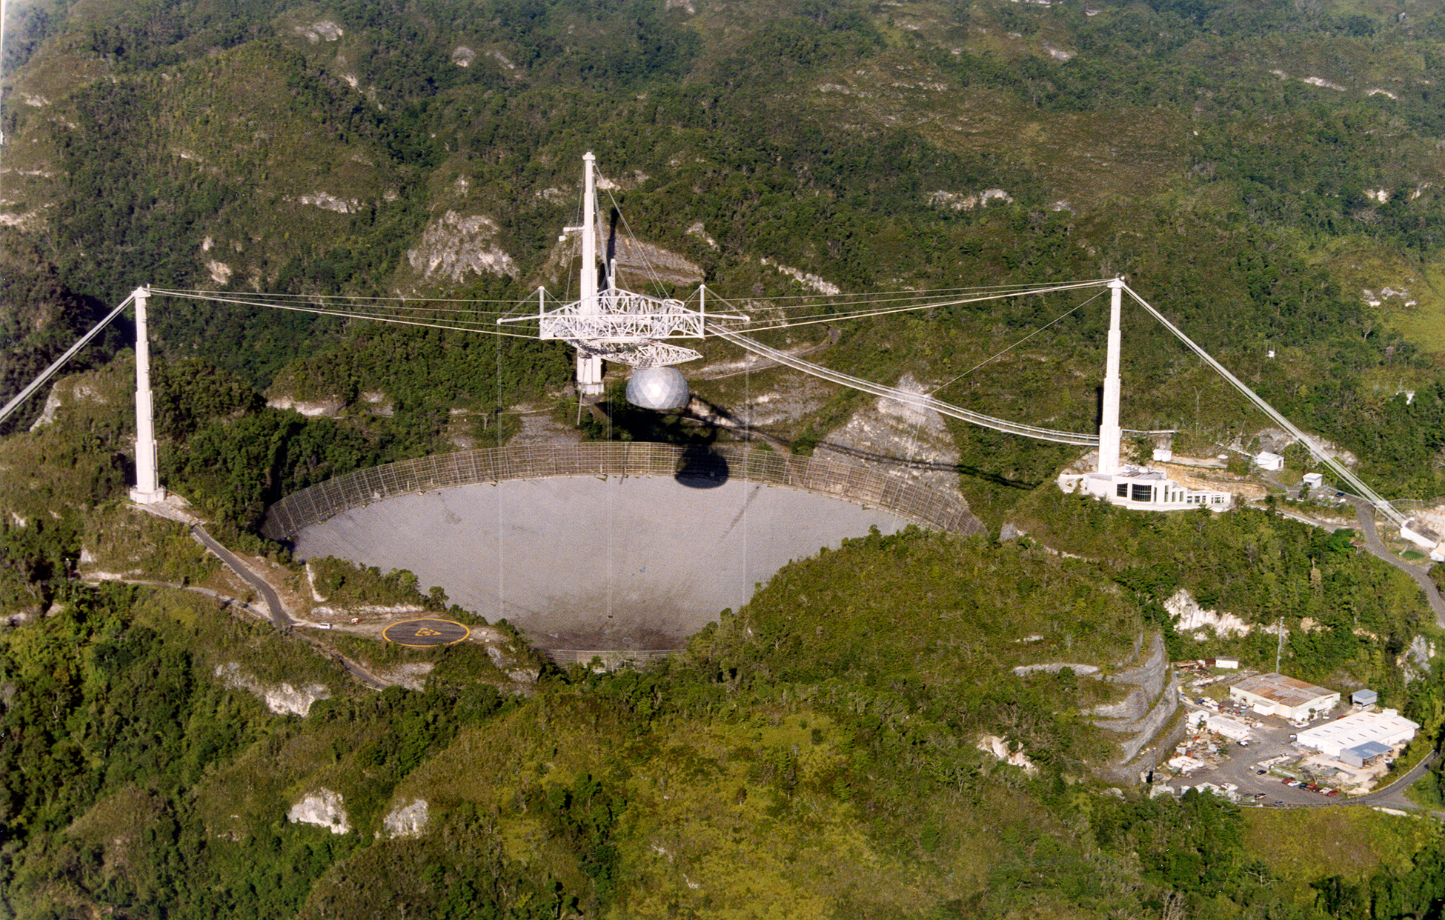
This is the source of data to be processed by the SETI@home project at Berkeley. Arecibo produces about 35 gigabytes of data per day. These data are given a cursory examination and sent by U.S. Mail to the Berkeley campus in California; Arecibo lacks a high–speed Internet connection.
The Radio SETI Process
Radio SETI monitors a 2.5 MHz radio band from 1418.75 to 1421.25 MHz. This band, centered at the 1420 MHz frequency called the “Hydrogen line” is thought to be optimal for interstellar transmissions. The data are recorded in analog mode and digitized later.
When the analog data arrive at Berkeley, they are broken into 250 kilobyte chunks, called “work units” by a software program called “Splitter” Each work unit represents a 9,766 Hz slice of the 2,500 kHz spectrum. This analog signal is digitized at 20,000 samples per second.
Participants in the Radio SETI project are sent these work units, each representing about 107 seconds of analog data. The entire packet, along with the work unit, is about 340 kilobytes.
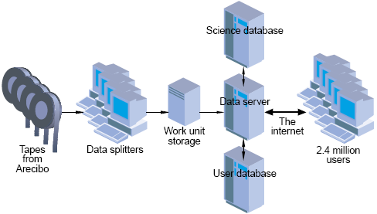
This figure shows the processing network, including the four servers at Berkeley and the 2.4 million personal computers that form the volunteer network.
References
In this lecture, material from one or more of the following references has been used.
1. Computer Organization and Design, David A. Patterson & John L. Hennessy,
Morgan Kaufmann, (3rd Edition, Revised Printing) 2007, (The course textbook)
ISBN 978 – 0 – 12 – 370606 – 5.
2. Computer Architecture: A Quantitative Approach, John L. Hennessy and
David A. Patterson, Morgan Kauffman, 1990. There is a later edition.
ISBN 1 – 55860 – 069 – 8.
3. High–Performance Computer Architecture, Harold S. Stone,
Addison–Wesley (Third Edition), 1993. ISBN 0 – 201 – 52688 – 3.
4. Structured Computer Organization, Andrew S. Tanenbaum,
Pearson/Prentice–Hall (Fifth Edition), 2006. ISBN 0 – 13 – 148521 – 0
5. Computer Architecture, Robert J. Baron and Lee Higbie,
Addison–Wesley Publishing Company, 1992, ISBN 0 – 201 – 50923 – 7.
6. W. A. Wulf and S. P. Harbison, “Reflections in a pool of processors / An
experience report on C.mmp/Hydra”, Proceedings of the National Computer
Conference (AFIPS), June 1978.
Web Links
7. The link describing SETI at home: http://setiathome.berkeley.edu/
8. The web site for Cray, Inc.: http://www.cray.com/
9. The link for Red Storm at Sandia National Labs: http://www.sandia.gov/ASC/redstorm.html
10. The Wikipedia article on blade servers: http://en.wikipedia.org/wiki/Blade_server

