Loosely Coupled Multiprocessors
Our previous discussions of multiprocessors focused on systems built with a modest number of processors (no more than about 50), which communicate via a shared bus.
The class of computers we shall consider in this and the next lecture is called “MPP”, for Massively Parallel Processor”. As we shall see, the development of MPP systems was resisted for a long time, due to the belief that such designs could not be cost effective.
We shall see that MPP systems finally evolved due to a number of factors, at least one of which only became operative in the late 1990’s.
1. The availability of small and inexpensive microprocessor units (Intel 80386, etc.)
that could be efficiently packaged into a small unit.
2. The discovery that many very important problems were quite amenable to
parallel implementation.
3. The discovery that many of these important problems had structures of such
regularity that sequential code could be automatically translated for parallel
execution with little loss in efficiency.
The process of converting a sequential program for parallel execution is often called “parallelization”. One speaks of “parallelizing an algorithm”; often this is misspoken as “paralyzing an algorithm” – which unfortunately might be true.
The Speed–Up Factor
In an earlier lecture, we spoke of the speed–up factor, S(N), which denotes how much faster a program will execute on N processors than on one processor. At the time, we referenced early opinions that the maximum speed–up for N processors would be somewhere in the range [log₂(N), N/log₂(N)].
We shall show some data for multicomputers with 2 to 65,536 processors in the next few slides. Recall that 65,536 = 2¹⁶. The processor counts were chosen so that I could perform the calculation log₂(N) in my head; log₂(65,536) = 16 because 65,536 = 2¹⁶.
The plots are log–log plots, in which each axis is scaled logarithmically. This allows the data to be seen. The top line represents linear speedup, the theoretical upper limit.
In the speedup graph, we see that the speed–up factor N/log₂(N) might be acceptable, though it is not impressive.
The next graph is what I call “cost efficiency”. It is the speed–up factor divided by the number of processors: S(N)/N. This factor measures the economic viability of the design.
Given the assumptions above, we see easily why large MPP designs did not appear
to be attractive in the early 1990’s and before.
The Speed–Up Factor: S(N)
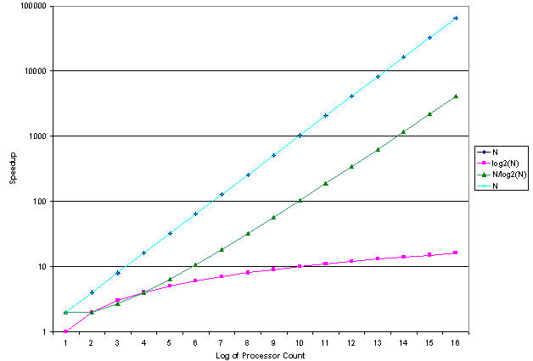
Examine a few values for the N/log₂(N) speedup: S(1024) = 102 and S(65536) = 4096. These might be acceptable under certain specific circumstances.
The Cost Efficiency Factor: S(N) / N
This chart shows the real problem that was seen for MPP systems before the late 1990’s. Simply put, they were thought to be very cost inefficient.
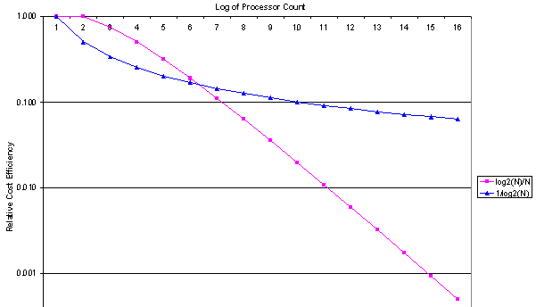
Linear Speedup: The MPP Goal
The goal of MPP system design is called “linear speedup”, in which the performance of an N–processor system is approximately N times that of a single processor system.
Earlier in this lecture we made the comment that “Many important problems, particularly ones that apply regular computations to massive data sets, are quite amenable to parallel implementations”.
Within the context of our lectures, the ambiguous phrase “quite amenable to parallel implementations” acquires a specific meaning: there are well–know algorithms to solve the problem and these algorithms can display a nearly–linear speedup when implemented on MPP systems.
As noted in an earlier lecture “Characteristics of Numerical Applications”, problems that can be solved by algorithms in the class called “continuum models” are likely to show near–linear speedup. This is due to the limited communication between cells in the continuum grid.
There are other situations in which MPP systems might be used. In 1990, Hennessy and Patters on [Ref. 2, page 575] suggested that “a multiprocessor may be more effective for a timesharing workload than a SISD [single processor]”. This seems to be the usage on the large IBM mainframe used by CSU to teach the course in assembly language.
Linear Speedup: The View from the Early 1990’s
Here is what Harold Stone [Ref. 3] said in his textbook. The first thing to note is that he uses the term “peak performance” for what we call “linear speedup”.
His definition of peak performance is quite specific. I quote it here.
“When a multiprocessor is operating at peak performance, all processors are engaged in useful work. No processor is idle, and no processor is executing an instruction that would not be executed if the same algorithm were executing on a single processor. In this state of peak performance, all N processors are contributing to effective performance, and the processing rate is increased by a factor of N. Peak performance is a very special state that
is rarely achievable.” [Ref. 3, page 340].
Stone notes a number of factors that introduce inefficiencies and inhibit peak performance. Here is his list.
1. The delays introduced by interprocessor communication.
2. The overhead in synchronizing the work of one processor with another.
3. The possibility that one or more processors will run out of tasks and do nothing.
4. The process cost of controlling the system and scheduling the tasks.
Early History: The C.mmp
While this lecture will focus on multicomputers, it is instructive to begin with a review of a paper on the C.mmp, which is a shared–memory multiprocessor developed at Carnegie Mellon University in the early 1970’s.
The C.mmp is described in a paper by Wulf and Harbinson [Ref. 6], which has been noted as “one of the most thorough and balanced research–project retrospectives … ever seen”. Remarkably, this paper gives a thorough description of the project’s failures.
The C.mmp is described [Ref. 6] as “a multiprocessor composed of 16 PDP–11’s, 16 independent memory banks, a crosspoint [crossbar] switch which permits any processor to access any memory, and a typical complement of I/O equipment”. It includes an independent bus, called the “IP bus”, used to communicate control signals.
As of 1978, the system included the following 16 processors.
5 PDP–11/20’s, each rated at 0.20 MIPS (that is 200,000 instructions per second)
11 PDP–11/40’s, each rated at 0.40 MIPS
3 megabytes of shared memory (650 nsec core and 300 nsec semiconductor)
The system was observed to compute at 6 MIPS.
The Design Goals of the C.mmp
The goal of the project seems to have been the construction of a simple system using as many commercially available components as possible.
The C.mmp was intended to be a research project not only in distributed processors, but also in distributed software. The native operating system designed for the C.mmp was called “Hydra”. It was intended as an OS kernel, intended to provide only minimal services and encourage experimentation in system software.
As of 1978, the software developed on top of the Hydra kernel included file systems, directory systems, schedulers and a number of language processors.
Another part of the project involved the development of performance evaluation tools, including the Hardware Monitor for recording the signals on the PDP–11 data bus and software tools for analyzing the performance traces.
One of the more important software tools was the Kernel Tracer, which was built into the Hydra kernel. It allowed selected operating system events, such as context swaps and blocking on semaphores, to be recorded while a set of applications was running.
The Hydra kernel was originally designed based on some common assumptions. When experimentation showed these to be false, the Hydra kernel was redesigned.
The C.mmp: Lessons Learned
The researchers were able to implement the C.mmp as “a cost–effective, symmetric
multiprocessor” and distribute the Hydra kernel over all of the processors.
The use of two variants of the PDP–11 was considered as a mistake, as it complicated the process of making the necessary processor and operating system modifications. The authors had used newer variants of the PDP–11 in order to gain speed, but concluded that “It would have been better to have had a single processor model, regardless of speed”.
The critical component was expected to be the crossbar switch. Experience showed the switch to be “very reliable, and fast enough”. Early expectations that the “raw speed” of the switch would be important were not supported by experience.
The authors concluded that “most applications are sped up by decomposing their algorithms to use the multiprocessor structure, not by executing on processors with short memory access times”.
The simplicity of the Hydra kernel, with much system software built on top of it, yielded benefits, such as few software errors caused by inadequate synchronization.

The C.mmp: More Lessons Learned
Here I quote from Wulf & Harbison [Ref. 6], arranging their comments in an order not found in their original. The PDP–11 was a memory–mapped architecture with a single bus, called the UNIBUS, that connected the CPU to both memory and I/O devices.
1. “Hardware (un)reliability was our largest day–to–day disappointment … The aggregate mean–time–between–failure (MTBF) of C.mmp/Hydra fluctuated between two to six hours.”
2. “About two–thirds of the failures were directly attributable to hardware problems. There is insufficient fault detection built into the hardware.”
3. “We found the PDP–11 UNIBUS to be especially noisy and error–prone.”
4. “The crosspoint [crossbar] switch is too trusting of other components; it can be hung by malfunctioning memories or processors.”
My favorite lesson learned is summarized in the following two paragraphs in the report.
“We made a serious error in not writing good diagnostics for the hardware. The software developers should have written such programs for the hardware.”
“In our experience, diagnostics written by the hardware group often did not test components under the type of load generated by Hydra, resulting in much finger–pointing between groups.”
Task Management in Multicomputers
The basic idea behind both multicomputers and multiprocessors is to run multiple tasks or multiple task threads at the same time. This goal leads to a number of requirements, especially since it is commonly assumed that any user program will be able to spawn a number of independently executing tasks or processes or threads.
According to Baron and Higbie [Ref. 5], any multicomputer or multiprocessor system must provide facilities for these five task–management capabilities.
1. Initiation A process must be able to spawn another process;
that is, generate another process and activate it.
2. Synchronization A process must be able to suspend itself or another process
until some sort of external synchronizing event occurs.
3. Exclusion A process must be able to monopolize a shared resource,
such as data or code, to prevent “lost updates”.
4. Communication A process must be able to exchange messages with any
other active process that is executing on the system.
5. Termination A process must be able to terminate itself and release
all resources being used, without any memory leaks.
These facilities are more efficiently provided if there is sufficient hardware support.
Hardware Support for Multitasking
Any processor or group of processors that supports multitasking will do so more efficiently if the hardware provides an appropriate primitive operation.
A test–and–set operation with a binary semaphore (also called a “lock variable”) can be used for both mutual exclusion and process synchronization. This is best implemented as an atomic operation, which in this context is one that cannot be interrupted until it completes execution. It either executes completely or fails.
The MIPS provides another set of instructions to support synchronization. In this design, synchronization is achieved by using a pair of instructions, issued in sequence.
After the first instruction in the sequence is executed, the second is execute and returns a value from which it can be deduced whether or not the instruction pair was executed as if it were a single atomic instruction.
The MIPS instruction pair is load linked and store conditional.
These are often used in a spin lock scenario, in which a processor executes in a tight loop awaiting the availability of the shared resource that has been locked by another processor.
In fact, this is not a necessary part of the design, but just its most common use.
Clusters, Grids, and the Like
There are many applications amenable to an even looser grouping of multicomputers. These often use collections of commercially available computers, rather than just connecting a number of processors together in a special network.
In the past there have been problems of administering large clusters of computers; the cost of administration scaling as a linear function of the number of processors. Recent developments in automated tools for remote management are likely to help here.
It appears that blade servers are one of the more recent adaptations of the cluster concept. The major advance represented by blade servers is the ease of mounting and interconnecting the individual computers, called “blades”, in the cluster.
In this aspect, the blade server hearkens back to the 1970’s and the innovation in instrumentation called “CAMAC”, which was a rack with a standard bus structure for interconnecting instruments. This replaced the jungle of interconnecting wires, so complex that it often took a technician dedicated to keeping the communications intact.
Clusters can be placed in physical proximity, as in the case of blade servers, or at some distance and communicate via established networks, such as the Internet. When a network is used for communication, it is often designed using TCP/IP on top of Ethernet simply due to the wealth of experience with this combination.
References
In this lecture, material from one or more of the following references has been used.
1. Computer Organization and Design, David A. Patterson & John L. Hennessy,
Morgan Kaufmann, (3rd Edition, Revised Printing) 2007, (The course textbook)
ISBN 978 – 0 – 12 – 370606 – 5.
2. Computer Architecture: A Quantitative Approach, John L. Hennessy and
David A. Patterson, Morgan Kauffman, 1990. There is a later edition.
ISBN 1 – 55860 – 069 – 8.
3. High–Performance Computer Architecture, Harold S. Stone,
Addison–Wesley (Third Edition), 1993. ISBN 0 – 201 – 52688 – 3.
4. Structured Computer Organization, Andrew S. Tanenbaum,
Pearson/Prentice–Hall (Fifth Edition), 2006. ISBN 0 – 13 – 148521 – 0
5. Computer Architecture, Robert J. Baron and Lee Higbie,
Addison–Wesley Publishing Company, 1992, ISBN 0 – 201 – 50923 – 7.
6. W. A. Wulf and S. P. Harbison, “Reflections in a pool of processors / An
experience report on C.mmp/Hydra”, Proceedings of the National Computer
Conference (AFIPS), June 1978.

