The System Bus
The System Bus is one of the four major components of a computer.
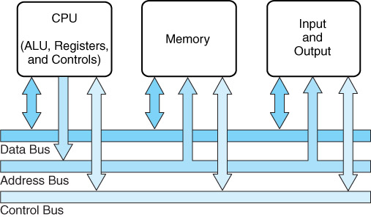
This logical representation is taken from the textbook.
The system bus is used by the other major components to communicate
data, addresses, instructions, and control signals.
The CPU: A High–Level Description
Just how does the CPU interact with the rest of the system?
1. It sends out and takes in data (in units of 8, 16, 32, or 64 bits)
2. It sends out addresses indicating the source or destination of such data.
An address can indicate either memory or an input/output device.
3. It sends out signals to control the system bus and arbitrate its use.
4. It accepts interrupts from I/O devices and acknowledges those interrupts.
5. It sends out a clock signal and various other signals.
6. It must have power and ground as input.
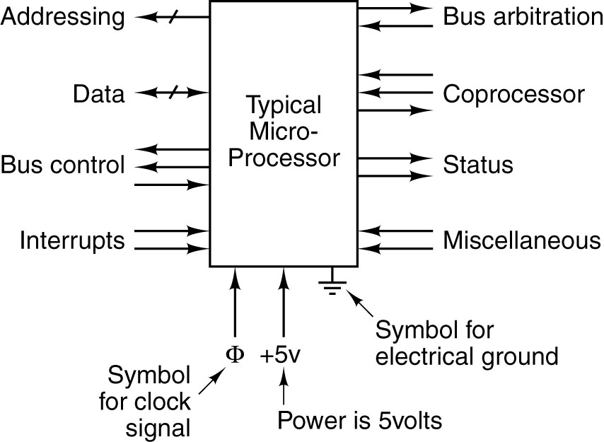
The CPU Interacts Via the System Bus
The System Bus allows the CPU to interact with the rest of the system. Each of the logical pinouts on the previous figure is connected to a line in the system bus.
Ground lines on the bus have two purposes
1. To complete the electrical circuits
2. To minimize cross–talk between the signal lines.
Here is a small bus with three data lines (D₂, D₁, D₀), two address lines (A₁, A₀),
a system clock (Φ) and a voltage line (+ V).
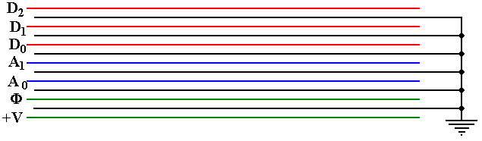
In our considerations, we generally ignore the multiple grounds, and the power lines.
Notations Used for a Bus
Here is the way that we would commonly represent the small bus shown above.
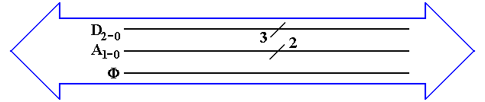
The big “double arrow” notation indicates a bus of a number of different signals.
Our author calls this a “fat arrow”.
Lines with similar function are grouped together. Their count is denoted with the
“diagonal slash” notation.
From top to bottom, we have
1. Three data lines D₂, D₁, and D₀
2. Two address lines A₁ and A₀
3. The clock signal for the bus Φ
Power and ground lines usually are not shown in this diagram.
Computer Systems Have Multiple Busses
Early computers had only a single bus, but this could not handle the data rates.
Modern computers have at least four types of busses
1. A video bus to the display unit
2. A memory bus to connect the CPU to memory, which is often SDRAM.
3. An I/O bus to connect the CPU to Input/Output devices.
4. Busses internal to the CPU, which generally has at least three busses.
Often the proliferation of busses is for backward compatibility with older devices.
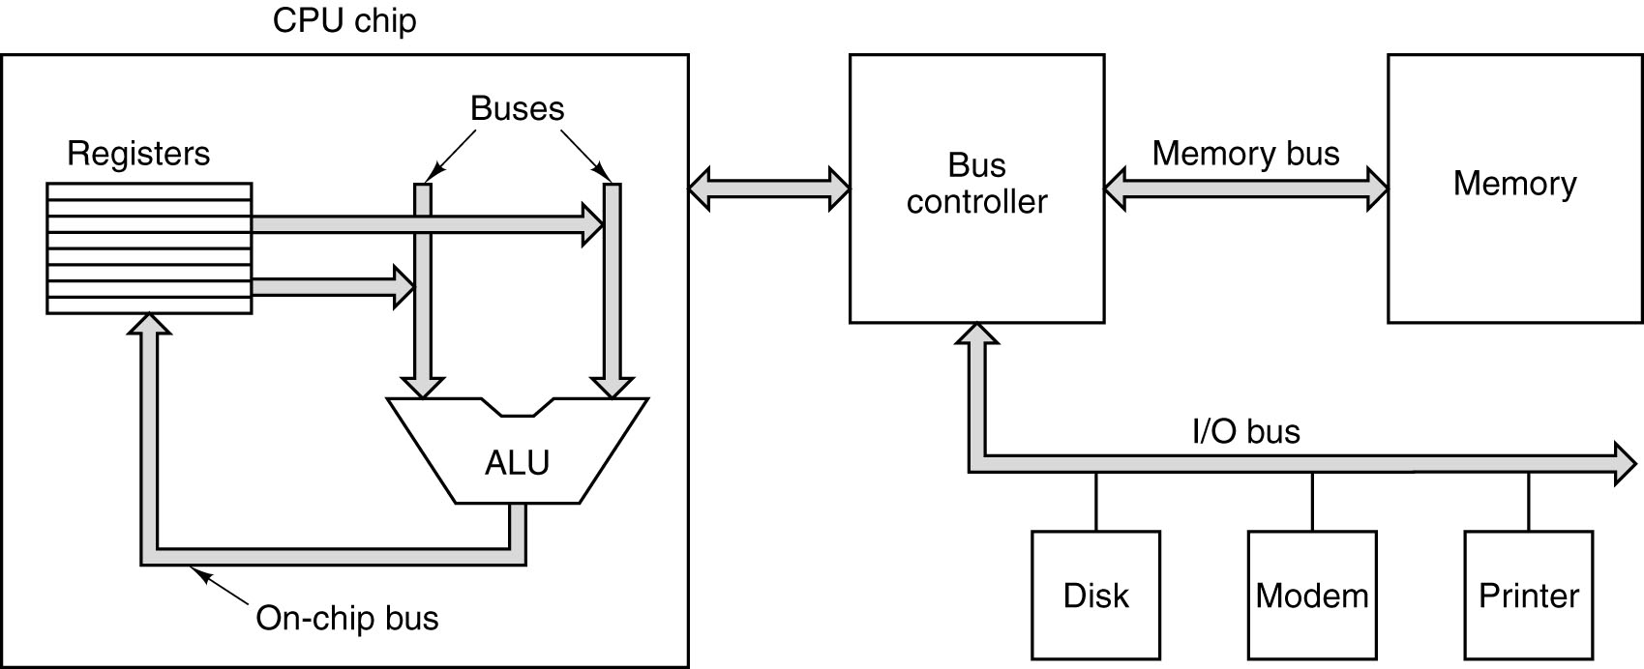
Backward Compatibility in PC Busses
Here is a figure that shows how the PC bus grew from a 20–bit address through
a 24–bit address to a 32–bit address while retaining backward compatibility.
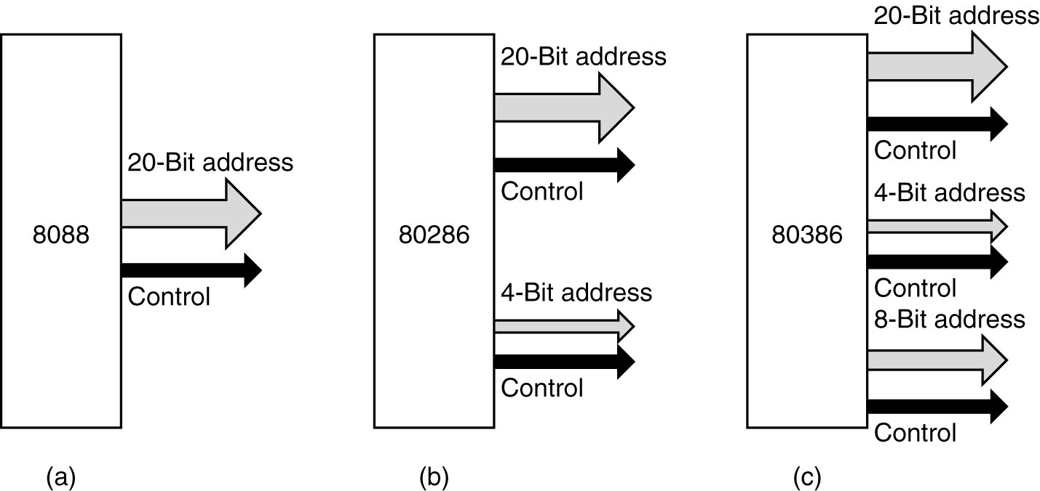

Backward Compatibility in PC Busses (Part 2)
Here is a picture of the PC/AT bus, showing how the original configuration was kept and augmented, rather than totally revised.
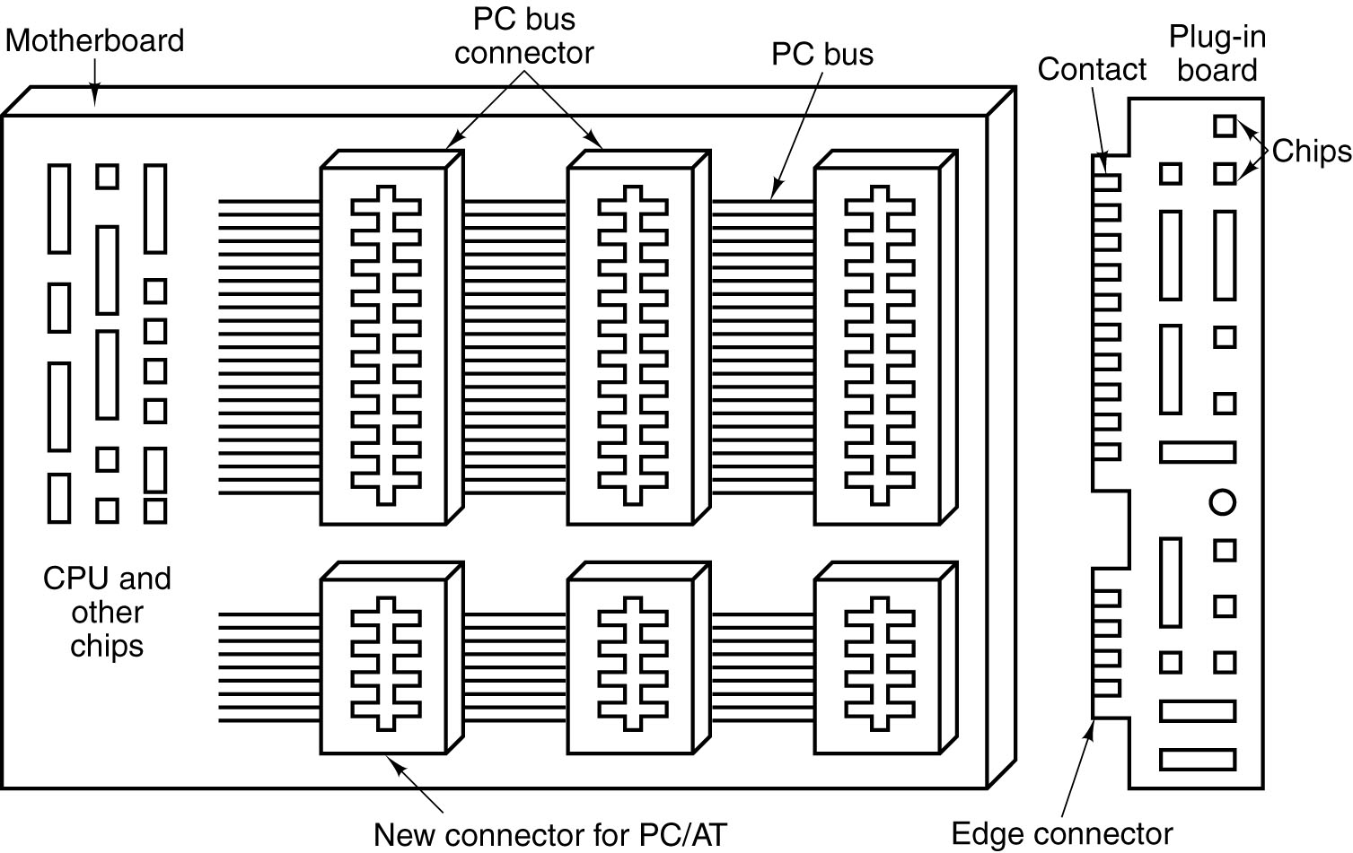
Note that the top slots can be used by the older 8088 cards, which do not have the
“extra long” edge connectors.
Notation for Bus Signal Levels
The system clock is represented as a trapezoidal wave to emphasize the fact that it does not change instantaneously.
Here is a typical depiction. Others may be seen, but this is what our author uses.
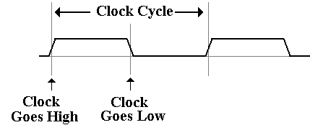
Single control signals are depicted in a similar fashion, except (of course) that they
may not vary in “lock step” with the bus clock.
Notation for Multiple Signals
A single control signal is either low or high (0 volts or 5 volts).
A collection, such as 32 address lines or 16 data lines cannot be represented with such a simple diagram. For each of address and data, we have two important states
address or data is valid
address or data is not valid
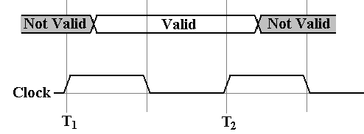
For example, consider the address lines on the bus. Imagine a 32–bit address.
At some time after T₁, the CPU asserts an address on the address lines. This means
that each of the 32 address lines is given a value.
When the CPU has asserted the address, it is valid until the CPU ceases assertion.
Reading Bus Timing Diagrams
Sometimes, we need to depict signals on a typical bus. Here we are looking at a
synchronous bus, of the type used for connecting memory.
This figure, taken from the textbook, shows the timings on a typical bus.
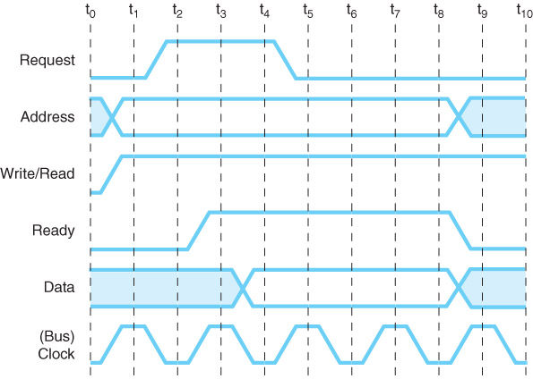
Note the form used for the Address Signals: between t₀ and t₁ they change value.
According to the figure, the address signals remain valid from t₁ through the end of t₇.
Read Timing on a Synchronous Bus
The bus protocol calls for certain timings to be met.
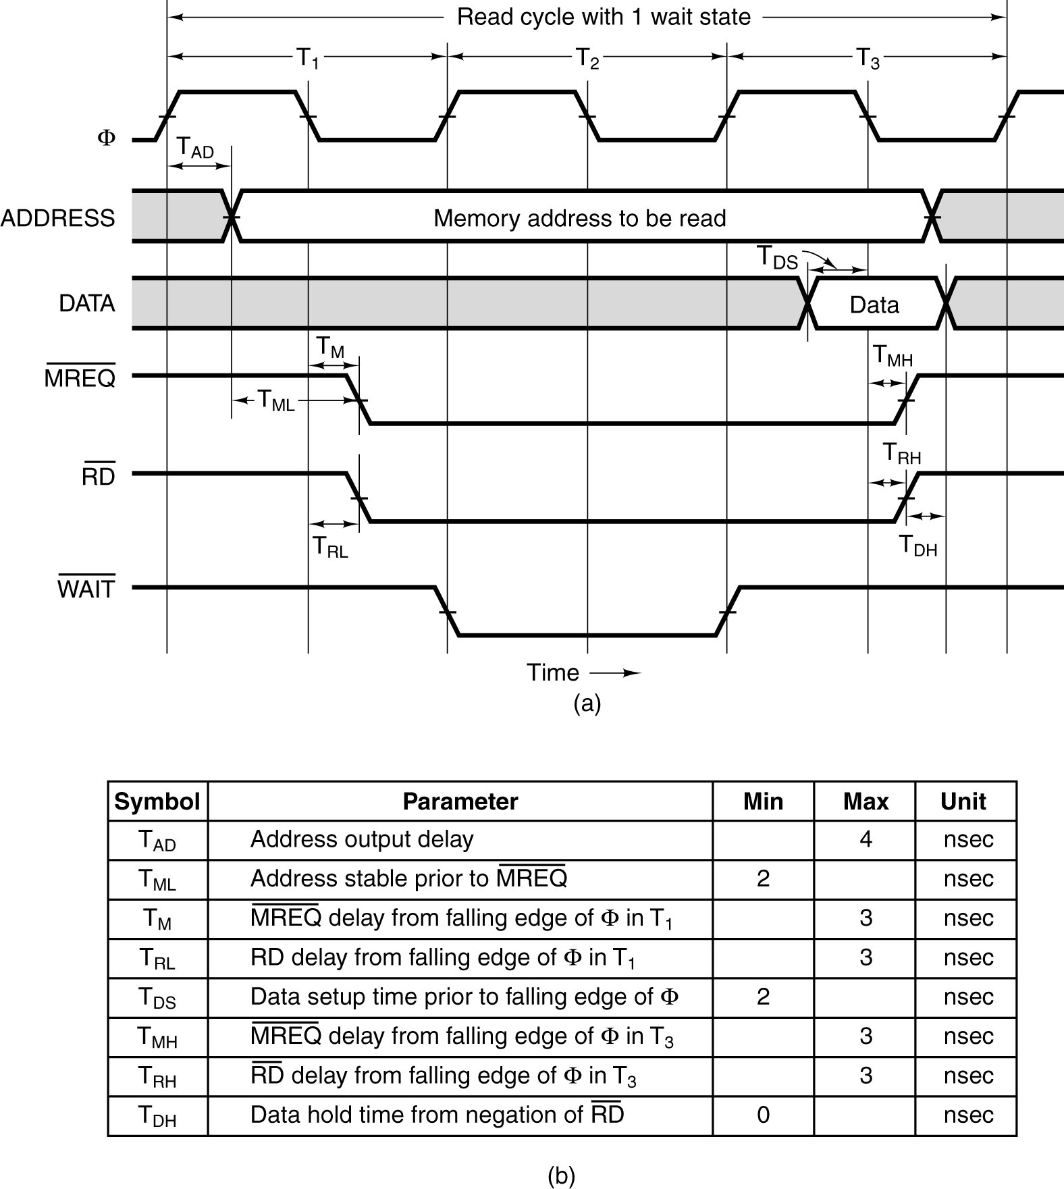
T_{AD} the maximum allowed delay for asserting the address after the clock pulse
T_{ML} the minimum time that the address is stable before the MREQ is asserted.
Read Sequences on an Asynchronous Bus
Here the focus is on the protocol by which the two devices interact.
This is also called the “handshake”.
The bus master asserts MSYN and the bus slave responds with SSYN when done.

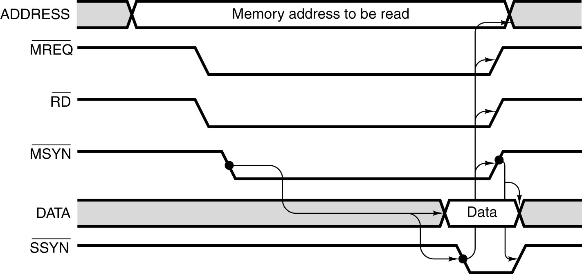
Attaching an I/O Device to a Bus
This figure shows a DMA Controller for a disk attached to a bus.
It is only slightly more complex than a standard controller.
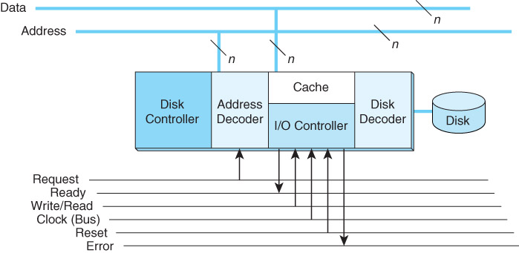
Each I/O Controller has a range of addresses to which it will respond.
Specifically, the device has a number of registers, each at a unique address.
When the device recognizes its address, it will respond to I/O commands sent on the command bus.
Bus Arbitration
A number of I/O devices are usually connected to a bus.
Each I/O device can generate an Interrupt, called “INT” when it needs service.
The CPU will reply with an acknowledgement, called “ACK”.
The handling by the CPU is simple. There are two signals only
INT some device has raised an interrupt
ACK the CPU is ready to handle that interrupt.
We need an arbitrator to take the ACK and pass it to the correct device.
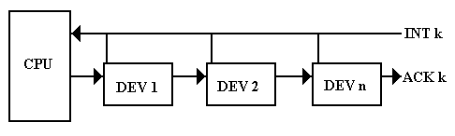
The common architecture is to use a “daisy chain”, in which the ACK is passed
from device to device until it reaches the device that raised the interrupt.
Details of the Device Interface
Each device has an Interrupt Flip–Flop that is set when the device raises the interrupt.
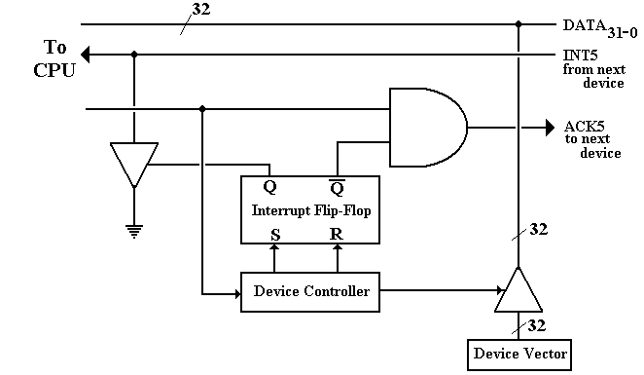
Note that the interrupt line is grounded out as a signal to the CPU.
The ACK comes from the left of the figure and is trapped by the AND gate.
The device identifies itself by a “vector”, a pointer to the address of the device
controller that will handle the I/O.

