Sequencing the Major State Register
Recall that the hardwired control unit is based on two interrelated registers:
the Minor State Register and the Major State Register.
The Minor State Register is a modulo–4 counter, producing the sequence
T0, T1, T2, and T3 continuously while the computer is running.
T3 from the Minor State Register is the trigger for the Major State Register to change.
This causes the Major State Register to accept control input and possibly change on the rising edge of the T0 pulse.
The possible sequences of the Major State Register follow three patterns
1. Fetch to Fetch
2. Fetch to Execute
3. Fetch to Defer to Execute
The sequencing of the Major State Register depends on two control signals generated by the control unit. These are called S₁ and S₂.

The State Diagram for the Major State Register
Here is the state diagram for the register. It has three states: F, D, and E.
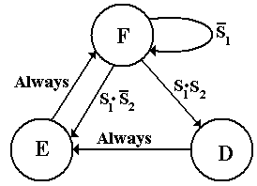
The two control signals S₁ and S₂ control the sequence of this register.
If the present state is Fetch (F) then
If S₁ = 0, the next major state will be Fetch.
If S₁ = 1 and S₂ = 0, the next major state will be Execute.
If S₁ = 1 and S₂ = 1, the next major state will be Defer.
If the present state is Defer (D), the next state will be Execute.
If the present state is Execute (E), the next state will be Fetch.
Sequencing the Major States: Observations on the ISA
Recall that 14 of the 22 instructions in the ISA complete execution in Fetch.
Of the eight instructions that require the Execute state, only four can enter Defer.
The next table examines these eight instructions.
 | IR₃₁ | IR₃₀ | IR₂₉ | IR₂₈ | IR₂₇ | IR₂₆ = 0 | IR₂₆ = 1
GET | 0 | 1 | 0 | 0 | 0 | Execute
PUT | 0 | 1 | 0 | 0 | 1 | Execute
RET | 0 | 1 | 0 | 1 | 0 | Execute
RTI | 0 | 1 | 0 | 1 | 1 | Execute
LDR | 0 | 1 | 1 | 0 | 0 | Execute | Defer
STR | 0 | 1 | 1 | 0 | 1 | Execute | Defer
JSR | 0 | 1 | 1 | 1 | 0 | Execute | Defer
BR | 0 | 1 | 1 | 1 | 1 | Execute if Branch = 1,  Fetch Otherwise | Defer if Branch = 1, Fetch Otherwise
Two patterns become obvious.
1. Only instructions with IR₃₁ = 0 and IR₃₀ = 1 can leave Fetch
2. Only instructions with IR₃₁ = 0, IR₃₀ = 1, IR₂₉ = 1, and IR₂₆ = 1 can enter Defer.
Generation of the S₁ Control Signal
We note the following about the generation of the S₁ control signal.
1. S₁ is 0 when IR₃₁IR₃₀ ≠ “01”.
For this reason, we say S₁ = $\overline{{\text{IR}}_{\text{31}}}⋅{\text{IR}}_{\text{30}}$• (Something else).
2. If IR₃₁IR₃₀ = “01”, then S₁ is 0 when if Branch = 0 and IR₂₉IR₂₈IR₂₇ = “111”.
Put another way, IR₃₁IR₃₀ = “01”, then S₁ is 1 when either
a) Branch = 1, or
b) IR₂₉IR₂₈IR₂₇ ≠ “111”. This is equivalent to $\overline{{\text{IR}}_{\text{29}}}+\overline{{\text{IR}}_{\text{28}}}+\overline{{\text{IR}}_{\text{27}}}$ = 1.
So we have the following for the S₁ control signal.
S₁ = $\overline{{\text{IR}}_{\text{31}}}⋅{\text{IR}}_{\text{30}}$•(Branch + $\overline{{\text{IR}}_{\text{29}}}+\overline{{\text{IR}}_{\text{28}}}+\overline{{\text{IR}}_{\text{27}}}$).

Condition 2 addresses the Branch instruction when the branch condition is not met.
Generation of the S₂ Control Signal
Generation of the S₂ control signal is simplified by the fact that it is used only
in combination with the S₁ control signal.
Technically we should say that S₂ = $\overline{{\text{IR}}_{\text{31}}}⋅{\text{IR}}_{\text{30}}$ • IR₂₉ • IR₂₆.
However the first part is handled by the S₁ control signal, so S₂ = IR₂₉ • IR₂₆.
Again, here is the state diagram for the Major State Register.

Design of the Major State Register
The Major State Register is implemented by two D flip–flops, D₁ and D₀.
The inputs to these flip–flops are derived from the major state and the signals S₁ and S₂.
The trigger for the state transitions is the T3 pulse from the Minor State Register.
The binary encoding for the major states is shown in the following table.
State | Y₁ | Y₀
F | 0 | 0
D | 0 | 1
E | 1 | 0
We note that the circuit, when operating properly, never has both D₁ = 1 and D₀ = 1.
Thus we may say that D₁ = conditions to move to Execute
D₀ = conditions to move to Defer
This gives rise to the following equations.
D₀ = F•S₁•S₂ // F = 1 if and only if the major state is Fetch
D₁ = $F⋅S_{1}⋅\overline{S_{2}}$ + D // D = 1 if and only if the major state is Defer
Circuitry for the Major State Register
Here it is.
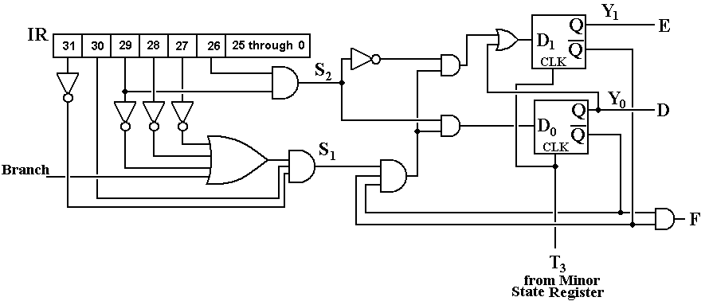

Impact of the Major State Register on ISA Design
The Boz–5 has had four different allocations of numeric codes to the assembly language instructions. Each of the three revisions was done to simplify the Major State Register.
Op-Code |  | Version 1 |  | Version 2 |  | Version 3 |  | Version 4
00 000 |  | HLT |  | HLT |  | HLT |  | HLT
00 001 |  | LDI |  | LDI |  | LDI |  | LDI
00 010 |  | ANDI |  | ANDI |  | ANDI |  | ANDI
00 011 |  | ADDI |  | ADDI |  | ADDI |  | ADDI
00 100 |  | GET
00 101 |  | PUT
00 110 |  | LDR
00 111 |  | STR
01 000 |  | BR |  | GET |  | GET |  | GET
01 001 |  | JSR |  | PUT |  | PUT |  | PUT
01 010 |  | RET |  | LDR |  | RET |  | RET
01 011 |  | RTI |  | STR |  | RTI |  | RTI
01 100 |  |  |  | BR |  | LDR |  | LDR
01 101 |  |  |  | JSR |  | STR |  | STR
01 110 |  |  |  | RET |  | BR |  | JSR
01 111 |  |  |  | RTI |  | JSR |  | BR
NOTE: Version 1 is just a listing in the order I thought of the instructions.
Modifications of the ISA Order
Version 2
This numbering leads to the simplification that only instructions with
IR₃₁ = 0 and IR₃₀ = 1 can enter either the Defer or Execute State.
Version 3
Moving the RET and RTI instructions to follow GET and PUT yields the
structure that only instructions with IR₃₁ = 0, IR₃₀ = 1, and IR₂₉ = 1 can enter Defer.
Version 4
A minor reordering to yield the condition (Branch + $\overline{{\text{IR}}_{\text{29}}}+\overline{{\text{IR}}_{\text{28}}}+\overline{{\text{IR}}_{\text{27}}}$) for S₁.
Here is the ISA structure achieved for Versions 3 and 4.
IR₃₁ | IR₃₀ | IR₂₉ | Result
0 | 0 | d | Executes in the Fetch cycle
0 | 1 | 0 | Executes in Fetch and Execute, cannot enter Defer
0 | 1 | 1 | Executes in Fetch and Execute, may enter Defer
1 | d | d | Executes in the Fetch cycle

