Review of Instruction Fetch
We have discussed the common fetch sequence in previous lectures.
We have given both the sequence of microoperations and the corresponding sequence of control signals. Remember that memory timings restrict access to memory during the
(Fetch, T1) time slot, so we elect to update the Program Counter during this time.
Fetch, T0: (PC) → B1, tra1, B3 → MAR, READ.
Fetch, T1: (PC) → B1, 1 → B2, add, B3 → PC.
Fetch, T2: (MBR) → B2, tra2, B3 → IR.
This lecture focuses on the impact of incrementing the program counter on
1) the design of the ALU, and
2) the bus structure of the CPU.
It is immediately obvious that the ALU must have either an addition operation or an increment (add 1) operation. For simplicity, the design uses a simple addition operation, associated with the control signal “add”.
We have always assumed that the CPU has three internal data busses.
We now show why such a configuration is desirable.
Constraints Due to the ALU
Recall that the ALU itself has two inputs and one output.
We consider how to create a bus structure for the CPU that will make efficient
use of this ALU. For this discussion, we focus on the addition operation
associated with updating the PC (Program Counter).

One–Bus Design for the CPU
The simplest design for the CPU calls for one common internal bus.
The restriction that only one binary data set can be on a single bus at
any given time gives rise to severe timing problems.
Specifically, it will take two clock pulses to put the two arguments (PC and 1)
on the bus and one clock pulse to transfer the updated value to the PC.
This one–bus design calls for two holding registers, here called “Y” and “Z”.
The control signals required for this structure are:
T1: 1 → Bus, Bus → Y.
T2: PC → Bus, add.
T3: Z → Bus, Bus → PC.
The addition takes three clock pulses.

It is easy to show that a 2–bus design requires
two clock pulses to perform the addition.
Efficient Addition Requires a Three–Bus Structure
With this structure, the CPU can complete the addition in one clock cycle.
This example is only one case in which the CPU design is considerably simplified
by having a three bus structure.
It can be seen that having three internal busses only modestly increases the design
complexity of the CPU. This is considered a good trade–off.
Immediate Implications of the Three–Bus Design
The design of the CPU calls for it to have three internal busses.
These are called B1, B2, and B3.
B1 and B2 serve as input busses for the ALU.
B3 serves as an output bus for the ALU.
This design can be seen in another light.
B1 and B2 are the only busses to which any register can transfer data directly.
B3 is the only bus that can transfer data directly to any register.
The protocol for register–to–register transfer becomes as follows:
1. Transfer from the source register to either bus B1 or bus B2 (but not both).
2. Signal the ALU to connect the appropriate input bus to bus B3.
3. Transfer the contents of bus B3 to the destination register.
This implies two additional ALU control signals: tra1 and tra2
tra1 transfer the contents of B1 to B3
tra2 transfer the contents of B2 to B3
More Requirements of the Common Fetch Sequence
Let’s repeat the common fetch sequence and examine it for more requirements.
Fetch, T0: (PC) → B1, tra1, B3 → MAR, READ.
Fetch, T1: (PC) → B1, 1 → B2, add, B3 → PC.
Fetch, T2: (MBR) → B2, tra2, B3 → IR.
T0: We have handled the requirements for bus transfer. This demands the signal
tra1 to the ALU. The READ control signal goes to the memory interface.
T1: We have handled these requirements completely.
T2: Here we have two more registers to be assigned to input busses.
My earlier designs required that the Memory Buffer Register and Instruction
Register be assigned to different busses, so this design reflects that.
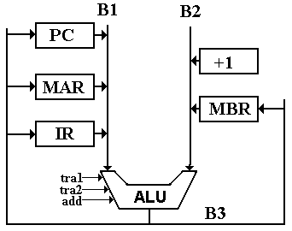
Connecting the IR to Bus B1
The structure of the IR (Instruction Register) calls for bits to be sent directly to the Control Unit and bits to be sent to the bus B1.
We focus on the twenty lower order bits of the IR: IR₁₉ – IR₀.
In some instructions these bits IR₁₉ – IR₀ form an address for accessing memory.
In some instructions these bits IR₁₉ – IR₀ are interpreted as an immediate operand,
either a 20–bit (five hexadecimal digit) bit mask,
or a 20–bit two’s–complement signed integer.
In some instructions, bits IR₁₉ – IR₁₇ are part of the instruction and
bits IR₁₆ – IR₀ are not used.
In any case, provision is made to transfer only bits IR₁₉ – IR₀ to bus B1.
This transfer is enabled by the signal IR → B1.

Sign Extension in Connecting the IR to Bus B1
Two of the immediate instructions, LDI and ADDI, require the contents of bits IR₁₉ – IR₀ to be sign extended and treated as a 32–bit two’s–complement integer.
The other instructions that use bits IR₁₉ – IR₀ treat them as an unsigned integer.
To handle this we have a control signal “Extend”, which is emitted by the control unit.
Here is a representation of the transfer mechanism for the IR.
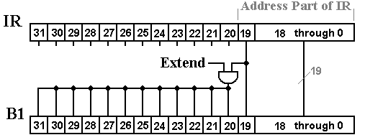
Labeling Control Signals
Control signals are Boolean signals with two values:
Logic 1 Usually asserted as + 5 volts.
Logic 0 Usually asserted as 0 volts.
Each control signal is labeled by the action that it enables.
IR → B1 This signal enables the transfer of IR₁₉ – IR₀ to bus B1.
It might be called IR_{19–0} → B1
Extend When IR → B1 is asserted, this causes the transfer to
be sign extended.
Control signals that enable data transfers to either bus B1 or bus B2 will take
effect by enabling a tri–state buffer. The IR is one of many possible inputs to B1.

The Complete Connection Scheme for the Instruction Register
Here is a schematic that shows the basic processes associated with the transfer.
The Control Unit emits both signals (Extend and IR → B1). Only the latter is shown explicitly, due to a desire to keep the figure uncluttered.

The General Purpose Registers
In this version of the design, the CPU has eight general–purpose registers.
R0 This register is read–only, holding the value 0.
R1 – R7 These seven registers are read/write and can be used for any purpose.
They are often used as index registers.
Each of these eight registers can output to either bus B1 or bus B2.
Bus B3 can place data into any of the seven registers R1 – R7, but is not connected to R0.

The Complete Register Set
Here is the complete register set and bus structure for the CPU. Note the two special purpose constant registers +1 and –1, used by the Control Unit.
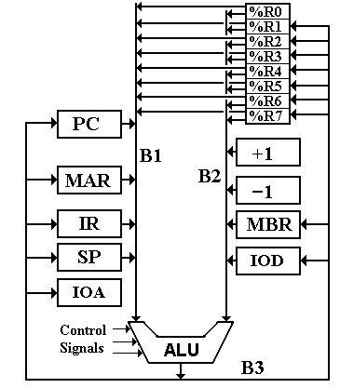
Attaching the General Purpose Registers to the Bus Structure
There are only three control signals emitted by the Control Unit that enable these transfers. These are:
R → B1 The selected register is copied to bus B1.
R → B2 The selected register is copied to bus B2.
B3 → R The contents of bus B3 are copied into the selected register.
We now ask how each of these registers is selected.
The Control Unit uses three selector registers, each based on bit fields in the IR.
The generation of these selector registers will be discussed later.
B1S This selects the register to be placed on B1 when R → B1 is asserted.
B2S This selects the register to be placed on B2 when R → B2 is asserted.
B3D This selects the register to copy the contents of B3
when B3 → R is asserted. If B3D = 000, no transfer occurs.
Each of the signals B1S and B2S is the control input to an 8–to–1 multiplexer that outputs to a bus through a tri–state buffer enabled by the appropriate control signal.
The signal B3D is the 3–bit input to an active–high 3–to–8 decoder that is
enabled by the control signal B3 → R.
Figure: Connecting a Single Bit to the Busses
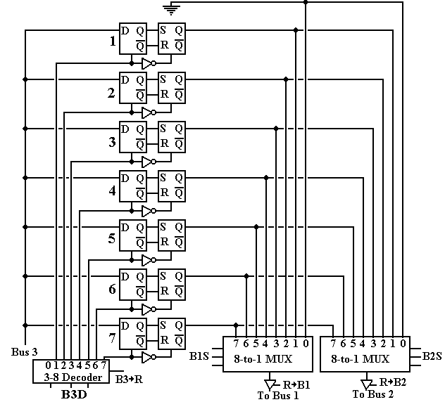
Comments on the Connection
Transfer to a register.
When control signal B3 → R is asserted, the 3–to–8 decoder is activated and asserts the clock input of all flip–flops associated with the selected register.
Each flip–flop associated with the selected register takes input from its bit line on B3.
Output 0 of the decoder is not connected to any register, so that asserting
B3 → R when B3D = 000 has no effect.
If B3 → R is not asserted, all decoder outputs are 0 and nothing happens.
Transfer from a register.
Note that the selector registers B1S and B2S always have values, so that the output of the multiplexer associated with each bus always copies some general–purpose register.
When control signal R → B1 is asserted the selected register is output to bus B1.
If it is not asserted, either B1 is not active or a special purpose register is feeding it.
When control signal R → B2 is asserted the selected register is output to bus B2.
If it is not asserted, either B2 is not active or a special purpose register is feeding it.
It is expected that the two signals R → B1 and R → B2 can be asserted simultaneously.

