More on Addressing Modes
Here we review the material from the previous lecture and give other examples.
Modes of interest here span quite a few architectures and might use inconsistent notation.
We begin with the idea of an Effective Address, often denoted “EA” or “E.A.” This basic idea facilitates understanding the function of any given operation.
Consider two basic operators: Load from memory and Store to memory
Load Register from Memory: R ← M[EA]
Store Register to Memory: M[EA] ← (R)
By definition of the term “Effective Address”, all memory references use that address when accessing memory. M[EA] denotes the contents of the effective address.
Understanding addressing modes then becomes equivalent to understanding how to calculate the Effective Address.
We begin with a simple mode, called “Direct Address” and then move to a few addressing modes for which the term “Effective Address” is not appropriate.
We then move to a series of increasingly complex addressing modes, ending with a few actually used on commercial machines.
Calculation of Effective Address
We now consider how to calculate an effective address, given the ISA instruction.
We begin with the format of a generic instruction referencing memory. The standard format includes an Address Field, which is used in many address calculations. Often it is the Effective Address, but again can be just part of that address.
The Boz–5 instruction format is as follows.
Bits | 31 – 27 | 26 | 25 – 23 | 22 – 20 | 19 – 0
Use | Five–bit Opcode | Indirect  Bit | Destination or  Source Register | Index  Register | Address  Field
In general, the only parts of the instruction that are used in computing the EA are
the Address Field this contains an address, which may be modified.
the Index Register this contains the register used as “array index”.
If this field is 0, indexing is not used.
the Indirect Bit this is used for Indirect and Indexed–Indirect addressing.
If this is 1, indirect addressing is used; otherwise not.
Instructions that do not use an address field conventionally have that field set to 0.
Direct and Immediate Addressing
Before discussing the idea of an Effective Address, let’s discuss instructions
for which the idea of an EA is not appropriate.
No argument: HLT // Stop the computer.
Immediate Argument: LDI %R3, 2 // Load the value 2 into R3.
ADDI %R4, %R4, 1 // Increment R4
98% of Load Immediate and Add Immediate use the values – 1, 0, and + 1.
Register–To–Register: ADD %R3, %R1, %R2 // R3 = R1 + R2
SUB %R3, %R1, %R2 // R3 = R1 – R2
To clarify the difference between direct and immediate addressing, consider these:
LDI %R5, 400 // Load register R5 with the value 400; R5 ← 400.
LDR %R5, 400 // Load register R5 with the contents of memory
// location 400; R5 ← M[400]. EA = 400.
NOTE: Many of my examples use hexadecimal notation; this example is ambiguous.
Direct and Indirect Addressing
Opcode | Registers | Mode Flags | Address Field
In each of direct and indirect addressing, the computation is simple:
Just copy the address field itself.
In direct addressing, the address field contains the address of the argument.
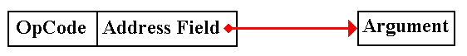
In indirect addressing, the address field contains the address of a pointer to the argument. Put another way, the contents of the memory indicated by the address field contain the address of the argument.
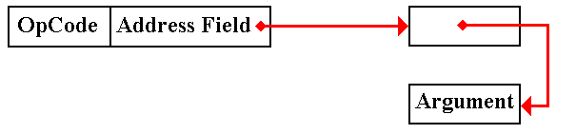
In subroutine linkage, argument passing by preference basically uses indirect addressing.
Direct and Indirect Addressing (Example)
Consider the following address map as an example for our addressing modes.
Z represents address 0x0A. Z == 0x0A and M[Z] = 5.
Address | 5 | 6 | 7 | 8 | 9 | A | B | C | D | E | F | 10 | 11
Contents | 11 | 32 | 2C | 1E | 56 | 5 | 7A | 10 | 3 | F | E | D | 8

Direct Addressing LDR %R1, Z
Effective Address: EA = Z Here EA = 0x0A.
Effect: R1 ← M[Z] Here R1 ← M[0x0A] or R1 = 5.
Indirect Addressing LDR %R1, *Z
Effective Address: EA = M[Z] Here EA = M[0x0A] = 5
Effect: R1 ← M[EA] = M [ M[Z] ]
Here R1 ← M[0x05] or R1 = 11.

NOTE: The complexity of notation such as “R1 ← M[ M[X] ]” is one reason we use
the Effective Address idea. Break the address computation into small steps.
Indexed Addressing
This is used to support array addressing in all computers. Languages such as C and
C++ implement this directly using “zero based” arrays.
In this mode, the contents of a general–purpose register are used as an index.
The contents of the register are added to the address field to form the effective address.
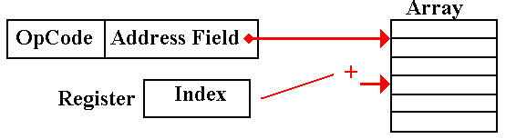
EA = (Address Field) + (Register)
Although we expect the index to be smaller than the value of the address, such considerations are not profitable.
The contents of the address field should be considered as having a different data type from those of the register, which holds a signed integer.
Indexed Addressing (Example)
LDR %R1, Z, 3 // Z indexed by the general–purpose register R3.
Z represents address 0x0A. Z == 0x0A and M[Z] = 5. (R3) = = 4
Address | 5 | 6 | 7 | 8 | 9 | A | B | C | D | E | F | 10 | 11
Contents | 11 | 32 | 2C | 1E | 56 | 5 | 7A | 10 | 3 | F | E | D | 8
Effective address: EA = Z + (%R3) Here EA = 0x0A + 4 = 0x0E
Effect: R1 ← M[EA] = M[0x0E] or R1 = F
In this, the most common, variant of indexed addressing we see Z as an array.
The first five elements of the array are placed in memory as follows:
Memory Map | 0x0A | 0x0B | 0x0C | 0x0D | 0x0E
Contents: | Z[0] | Z[1] | Z[2] | Z[3] | Z[4]

One Variant of Indexed Addressing
Consider the use of general purpose register %R0 as an index register.
LDR %R2, Z, 0
There are two possible interpretations of this instruction.
1. Do not use indexing in computation of this address. The effective address is
simply EA = Z and the mode is really direct addressing.
2. Register R0 is identically 0; %R0 ≡ 0. Use this value to calculate the effective
address, EA = Z + (%R0) = Z + 0 = Z. The mode is the same as direct addressing.
OUR MOTTO: If it acts identically to direct addressing, it is direct addressing.
We shall use this fact to simplify the design of the control unit.
Another Variant of Indexed Addressing
LDR %R4, Z, 7 // Address Z indexed by R7
But suppose Z = 0. The format of the machine language instruction is:
31 | 30 | 29 | 28 | 27 | 26 | 25 | 24 | 23 | 22 | 21 | 20 | 19 – 0
0 | 1 | 1 | 0 | 0 | 0 | 4 |  |  | 7 |  |  | 0x00000
The effective address is EA = Z + (%R7) = 0 + (%R7).
The register itself contains the address; this is register indirect addressing.
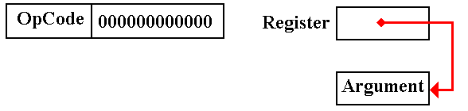

Based Addressing
This is quite similar to indexed addressing, so much so that it seems redundant.
This mode arises from an entirely different consideration.
Indexed addressing basically supports the use of arrays.
Based addressing supports the Operating System in partitioning the user address space.
User addresses are mapped into physical addresses that cannot conflict.
The Boz–5 uses the page number in the PSR as a base register.
Indexed–Indirect Addressing
This is a combination of both modes. Question: Which is done first?
Pre–Indexed Indirect: The indexing is done first. We have an array of pointers.
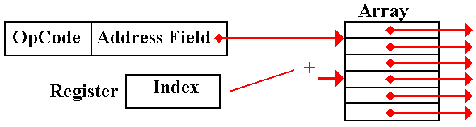

Post–Indexed Indirect: The indirect is done first. We have a pointer to an array.
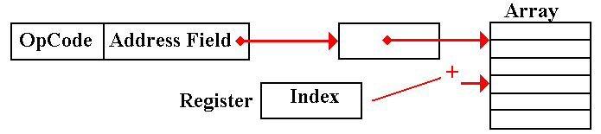

Indexed–Indirect Addressing (Example)
Let Z refer to address 0xA, so that M[Z] = = 0x05. Let (R3) = 0x07.
Address | 5 | 6 | 7 | 8 | 9 | A | B | C | D | E | F | 10 | 11
Contents | 11 | 32 | 2C | 1E | 56 | 5 | 7A | 9 | 3 | F | E | D | 8
Pre–Indexed Indirect: LDR %R1, *Z, 3
Effective address EA = M[ Z + (R3) ] = M[0xA + 0x7]
= M[ 0x11] = 0x08.
Effect R1← M[ M[Z + (R3)] ] or R1 ← M[0x08] or R1 ← 1E
Post–Indexed Indirect: LDR %R1, *Z, 3
Effective address EA = M[ M[Z] + (R3) ] = M[ M[0x0A] + 0x07]
= M[0x05 + 0x07] = M[0x0C] = 0x09.
Effect R1 ← M[0x09] or R1 ← 0x56
Pre–Indexed Indirect Addressing: Variant 1
Again, consider the use of general–purpose register R0 as an index register.
Remember that this register is set identically to 0; %R0 ≡ 0.
Pre–Indexed Indirect: LDR %R1, *Z, 0
Effective address EA = M[ Z + (R0) ] = M[Z]
Effect R1← M[ M[Z] ].
But this is just the indirect addressing, discussed above.
Again, this feature will be used to simplify the control unit.

Pre–Indexed Indirect Addressing: Variant 2
We now come to a more unusual variant of pre–indexed indirect addressing.
Suppose the address part is 0, Z = 0.
LDR %R4, *Z, 7 // Address Z indexed by R7
31 | 30 | 29 | 28 | 27 | 26 | 25 | 24 | 23 | 22 | 21 | 20 | 19 – 0
0 | 1 | 1 | 0 | 0 | 1 | 4 |  |  | 7 |  |  | 0x00000
The Effective Address is a bit unusual
Effective address EA = M[ Z + (R7) ] = M[0 + (R7)] = M[(R7)]
Effect R1← M[ M[(R7)] ]
R7 contains the address of a pointer. R7 is a pointer to a pointer.
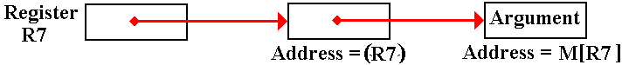
We would have to make the control unit more complex to remove this addressing mode.
Getting Rid of Direct Addressing
We now simplify our control unit by introducing a new register convention.
As is common among many modern computers, we define a register zero, called R0
and demand that it be identically 0. Thus R0 ≡ 0.
Stores to register R0 are ignored. This register cannot be changed.
Consider two instructions
Load X, (R2) EA = X + (R2) Indexed addressing
Load X, (R0) EA = X + (R0) = X Really direct addressing.
Consider a typical address part of an instruction:
Mode Field | Index Register | Address Field
There are two options for the Index field.
More complex If zero, use direct addressing
If not zero, use the register as an index register.
Less complex Use the given register as an index register for indexed
addressing. If R0, then add 0 to the address field, giving
essentially direct addressing.
At the microarchitecture level, we lose no efficiency in always adding the register to form the address. We gain a great deal by simplifying the address computation.
Double Indirect Addressing: Use 1
Suppose a common data structure that is used by a number of programs.
In modern systems, this could be a DLL (Dynamic Linked Library) module.
Each program contains a pointer to this structure, used to access that structure.
Singly indirect addressing, in which the pointer is stored in every program, presents problems when the data block is moved by the memory manager. Every reference to that block must be found and adjusted.
In doubly indirect addressing, all programs have a pointer to a data structure which itself is a pointer. When the data block is moved, only this one pointer must be adjusted.
As an extra benefit, this intermediate pointer can be expanded to a data structure containing an ACL (Access Control List) and other descriptors for the data block.
This presents the beginning of a more secure operating system.
Double Indirect Addressing: Use 2
The Operating System uses double indirection to activate a device driver associated with a given I/O device. For each type of I/O device, the O/S stores the address of a
“device vector”, which contains the actual address of the software to handle the device.
This arrangement allows the operating system and the device drivers to be developed independently. The only fixed location is the address of this device vector.
When the driver software is loaded, the O/S places it in the memory location that is most convenient for the current configuration and copies that start address into the address part of the device vector. Double indirection is then used to call the driver.
This is really a “vectored interrupt” mechanism, described more fully in a later chapter.

