Architectural Support
for
A More Secure Operating System

Edward L. Bosworth, Ph.D.
TSYS Department of Computer Science

Columbus State University
Columbus, GA

A Few Comments

The term “Secure Operating System” is not used in current academic literature.

The favored terms are:
1. “More secure operating system”,
2. “Trusted operating system”.

This avoids the significant and important question, “What is Security?”.

Two Approaches

Trusted Operating System
Define a logical trust model, and a series of tests that determine compliance with that trust model. Design a system to implement that model.

More Secure Operating System
Develop hardware and software systems that will demonstrably increase the OS security, without having a security or trust goal in mind. “More secure is better”.
Both approaches achieve their effect by denying access to
1. Certain classes of instructions, and
2. Certain segments of memory and sensitive files.

Privileged Instructions
Computer instructions are usually divided into two classes:
user instructions and privileged instructions.
User instructions are those that are not privileged.
Instructions can be labeled as privileged for a number of reasons.
Confusion Instructions such as input / output instructions can cause
difficulties if executed directly by the user. Consider
output to a shared print device.

Security Instructions such as memory management can cause
severe security problems if executed by the user.
I can directly read and corrupt your program memory.

Protection Rings

One of the earliest protection mechanisms

These are also called “access modes”.

In an architecture that supports protection rings, the CPU is always executing in one of these rings or privilege levels.

These modes are used in controlling access to memory, I/O devices, and other system resources.
Rings of Protection
The simple security models in a computer call for rings of protection.
The protection rings offered by the Pentium 4 architecture (IA–32) are fairly typical.
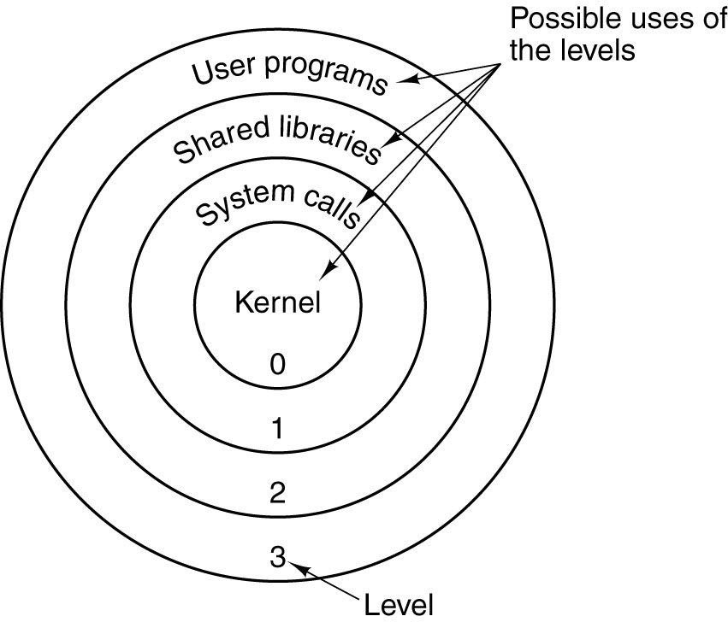
Attempts to read data at higher (less protected) rings are permitted.
Attempts to read data at lower (more protected) rings are not permitted and
cause traps to the operating system.

Architectural Support for
Protection Rings

There is always a special register, often called Program Status Register, with a bit field indicating the current ring. A two bit field would indicate four protection rings.

We need a trap instruction, to allow a user program to access services provided only by programs with more privilege.

We need a Change Mode Instruction for use by the operating system.

Scenario of the Change Mode Instruction:
1. The User Program generates a trap, signaling the O/S,
2. The O/S processes the trap and allows the processing, and
3. The O/S must change to a higher protection to execute the service.
The PSW (Program Status Word)
Often called the PSL (Program Status Longword), as with the VAX–11/780.
Not really a word or longword, but a collection of bits associated with the program
being executed.
Some bits reflect the status of the program under execution.
N the last arithmetic result was negative
Z the last arithmetic result was zero
V the last arithmetic result caused an overflow
C the last arithmetic result had a “carry out”
The security–relevant parts of the PSW relate to the protection ring that
is appropriate for the program execution.
The VAX–11/780 and the Pentium 4 each offered four protection rings.
The ring number was encoded in a two–bit field in the PSW.
The VAX stored both the ring for the current program and the previous program in the PSW. This allowed a program running at kernel level (level 00) to determine the privilege level of the program that issued the trap for its services.

Efficient Protection Rings

These comments based on early work with the MULTICS operating system.

MULTICS was first implemented on a GE–645 that emulated the protection rings in software.

Procedure calls that crossed protection rings took excessive time. Code was inappropriately placed in the kernel to avoid this time penalty.

Later implementations of a Honeywell Level 68 computer, with hardware support of protection rings, allowed better placement of code modules.
Commercialization of the Protection Rings
Early computers had operating systems tailored to the specific architecture.
Examples of this are the IBM 360 and OS/360; VAX–11/780 and VMS.
More modern operating systems, such as UNIX, are designed to run on many
hardware platforms, and so use the “lowest common denominator” of protection rings.
This figure shows the IA–32 protection rings as intended and as normally implemented.
The problem here is that any program that executes with more than user privileges must have access to all system resources. This is a security vulnerability.

The “Superuser Fallacy”

This is my own term.

Most operating systems implement only two protection rings or privilege levels, loosely called “User” and “Superuser”.

As a result, any system utility (such as a print spooler) that requires more than simple user privileges must have access to all system resources.

This violates the principle of least privilege.
SPOOLING: A Context for Discussing O/S Services
The term “SPOOL” stands for “System Peripheral Operation On–Line”.
Direct access to a shared output device can cause chaos.
The Spooling approach calls for all output to be to temporary files. The print manager has sole control of the shared printer and prints in order of closing the files.

Privileges: User vs. SPOOL
A User Program must be able to create a file and write data to that file.
It can read files in that user’s directory, but usually not in other user’s directory.
It cannot access the shared printer directly.
The Print Manager must be able to:
Read a temporary file in any user’s directory and delete that file when done.
Access a printer directly and output directly to that device.
It should not be able to create new files in any directory.
The Print Manager cannot be run with Level 3 (Application) privilege, as that would disallow direct access to the printer and read access to the user’s temporary files.
Under current designs, the Print Manager must be run with “Superuser Privileges”, which include the ability to create and delete user accounts, manage memory, etc.
This violates the principle of least privilege, which states that an executing program should be given no more privileges than necessary to do its job.
We need at least four fully–implemented rings of privilege, as well as specific role restrictions within a privilege level.
Memory Segmentation
Memory paging divides the address space into a number of equal sized blocks,
called pages. The page sizes are fixed for convenience of addressing.
Memory segmentation divides the program’s address space into logical segments, into which logically related units are placed. As examples, we conventionally have code segments, data segments, stack segments, constant pool segments, etc.
Each segment has a unique logical name. All accesses to data in a segment must be through a <name, offset> pair that explicitly references the segment name.
For addressing convenience, segments are usually constrained to contain an integral number of memory pages, so that the more efficient paging can be used.
Memory segmentation facilitates the use of security techniques for protection.
All data requiring a given level of protection can be grouped into a single segment,
with protection flags specific to giving that exact level of protection.
All code requiring protection can be placed into a code segment and also protected.
It is not likely that a given segment will contain both code and data. For this reason,
we may have a number of distinct segments with identical protection.
Segmentation and Its Support for Security
The segmentation scheme used for the MULTICS operating system is typical.
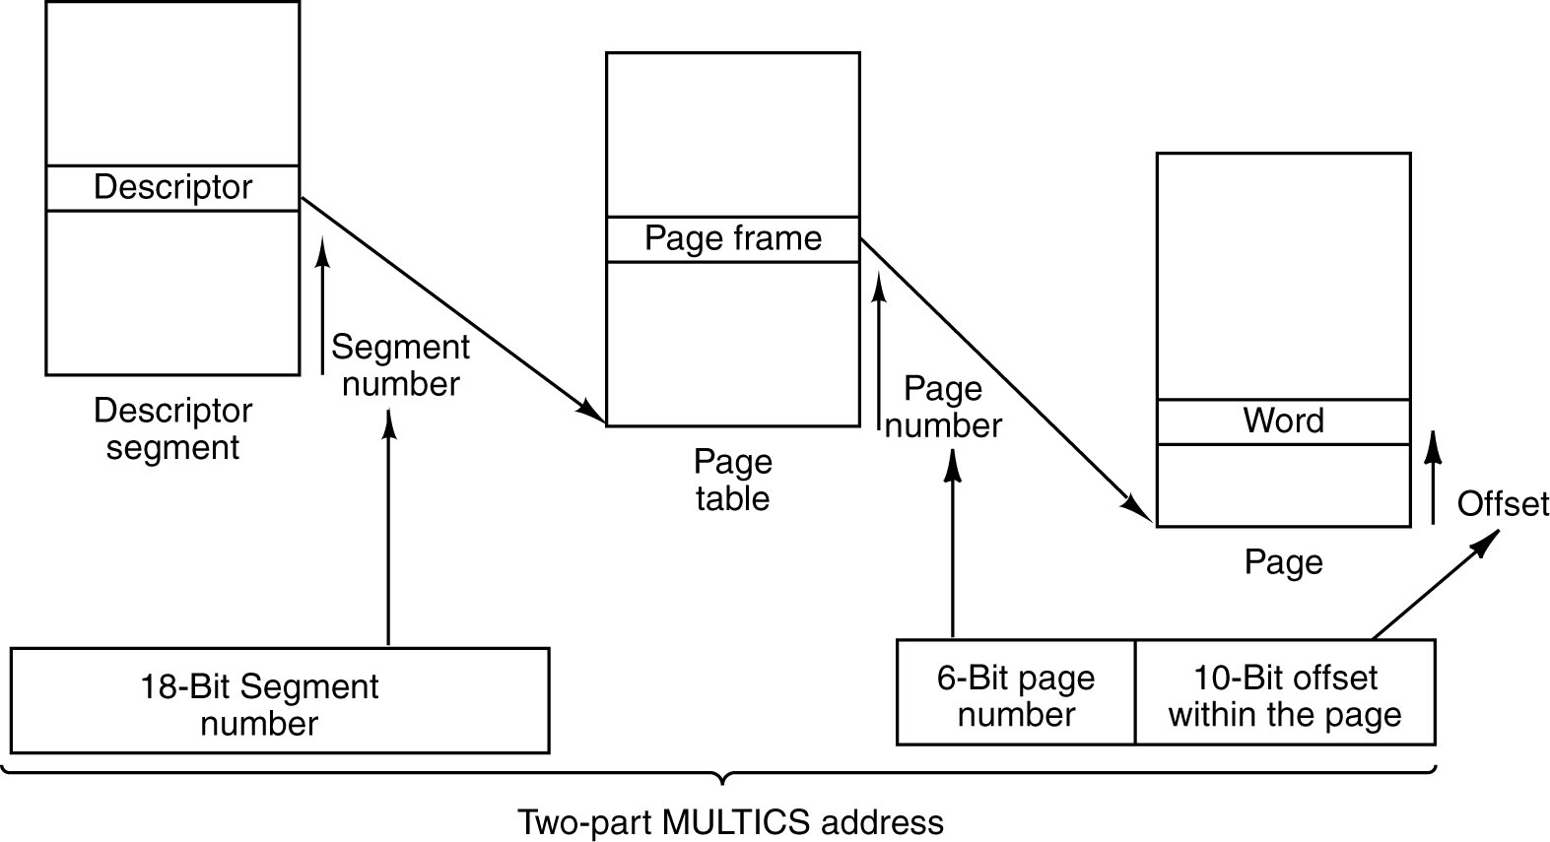
Each segment has a number of pages, as indicated by the page table associated with
the segment. The segment can have a number of associated security descriptors.
Modern operating systems treat a segment as one of a number of general objects, each with its Access Control List (ACL) that specifies which processes can access it.
More on Memory Protection
There are two general protections that must be provided for memory.
Protection against unauthorized access by software can be provided by a segmentation scheme, similar to that described above.
Each memory access must go through each of the segment table and its associated page table in order to generate the physical memory address.
Direct Memory Access (DMA) provides another threat to memory.
In DMA, an input device (such as a disk controller) can access memory directly without the intervention of the CPU. It can issue physical addresses to the MAR and write directly to the MBR. This allows for efficient Input / Output operations.
Unfortunately, a corrupted device controller can write directly to memory not associated with its application. We must protect memory against unauthorized DMA.
Some recent proposals for secure systems provide for a “NoDMA Table” that can be used to limit DMA access to specific areas of physical memory.
Securing Input and Output
Suppose that we have secured computing. How can we insure that our input and output are secure against attacks such as key logging and screen scraping?
Input Sequence.
Suppose that we want to input an “A”. We press the shift key and then the “A” key.
The keyboard sends four scan codes to the keyboard handler, operating in user mode.
This might be 0x36, 0x1E, 0x9E, 0xB6 – for pressing the Shift Key, then pressing the
“A” key, then releasing the “A” key, then releasing the Shift Key.
This sequence is then translated to the ASCII code 0x41, which is sent to the O/S.
Either the scan codes or the ASCII code can be intercepted by a key logger.
Output Sequence.
When the program outputs data, it is sent to the display buffer.
The display buffer represents the bit maps to be displayed on the screen. While it does not directly contain ASCII data (just its “pictures”), it does contain an image that can be copied and interpreted. This is called “screen scraping”.
Protecting the Code under Execution
We can wrap the CPU in many layers of security so that it correctly executes the code.
How do we assure ourselves that the code being executed is the code that we want?
More specifically, how do we insure that the code being executed is what we think it is and has not been maliciously altered?
One method to validate the code prior to execution is called a cryptographic hash.
One common hash algorithm is called “SHA–1” for “Secure Hash Algorithm 1”.
This takes the code to be executed, represented as a string of 8–bit bytes, and produces a 20 byte (160 bit) output associated with the input.
The hardware can have another mechanism that stores what the 20–byte hash should be.
The hardware loads the object code, computes its SHA–1 hash, and then compares it to the stored value. If the two values match, the code is accepted as valid.
What Is a Cryptographic Hash?
First, we begin with the definition of a hash function. It is a many–to–one function that produces a short binary number that characterizes a longer string of bytes.
Consider the two characters “AC” with ASCII codes 0100 0001 and 0100 0011.
One hash function would be the parity of each 8–bit number: 0 and 1 (even and odd).
Another would be the exclusive OR of the sequence of 8–bit bytes.
A 0100 0001
C 0100 0011
⊕ 0000 0010
The hash function must be easy to compute for any given input.
A cryptographic hash function has a number of additional properties.
1. A change of any single bit in the input being processed changes the output in
a very noticeable way. For the 160–bit SHA–1, it changes about 80 of the bits.
2. While it is easy to compute the SHA–1 hash for a given input, it is computationally
infeasible to produce another input with the identical 20–byte hash.
Thus, if a code image has the correct hash output; it is extremely probable that it is the correct code image and not some counterfeit.

Terms Related to Security

In order to follow the current research, we must define a few terms.

Object

Reference Monitor

VM (Virtual Machine)

VMM (Virtual Machine Monitor)

MVMM (Measured Virtual Machine Monitor)

RTM (Root of Trust for Measurement)

Auditable Security Kernel

An Object

This definition is almost obvious.

An object is any asset that can be accessed, including memory, I/O devices, the CPU, etc.

Data structures, such as the page tables and segment tables, are also objects.

This is a logical abstraction that allows the designer to devise a uniform strategy for accessing these assets and protecting them.

Reference Monitor

A reference monitor is code associated with an object that is invoked upon every reference to that object.

Every change of data, authorization, or state must go through the RM.

A security kernel is defined as the hardware and software to realize the reference monitor abstraction.

Auditable Security Kernel

The security kernel is that part of the OS kernel that enforces the security policies.

As seen above, it is responsible for implementing the reference monitor model.

The Security Kernel must be designed to a formal security model.

The Security Kernel must be small enough to be “audited”; i.e., undergo a formal verification of its compliance to the model.

Virtual Machine

In information security, a VM (Virtual Machine) is defined as an “efficient
isolated duplicate or a real machine”. Popek and Goldberg, 1974.
This is not the common definition of Virtual Machine as used by authors of
books on Computer Architecture.

Duplicate – the VM acts as if it were the real machine and provides all its services.

Isolated – the VM isolates a user program from the OS and all other user programs.

All physical assets of the real machine are virtualized, not directly accessed or controlled by a user program.

Virtual memory is one of the assets of the real machine that are virtualized.
Precise Definition of Virtual Memory
Virtual memory is a mechanism for translating logical addresses (as issued by an executing program) into actual physical memory addresses.

This definition alone provides a great advantage to an Operating System, which can then allocate processes to distinct physical memory locations according to some optimization.
Secondary Storage
Although this is a precise definition, virtual memory has always been implemented by pairing a fast DRAM Main Memory with a bigger, slower “backing store”. Originally, this was magnetic drum memory, but it soon became magnetic disk memory.
The invention of time–sharing operating systems introduced another variant of VM, now part of the common definition. A program and its data could be “swapped out” to the disk to allow another program to run, and then “swapped in” later to resume.

VM: Virtualized Assets

Virtual Memory – all accesses to memory go through a standard virtual memory system with page and segment tables. DMA I/O is an important exception.

If all memory references must go through the page management of the OS, then
direct access to memory is almost impossible. This increases security and allows the OS to set aside selected memory pages as “protected”.

I/O Devices are virtualized, with the user program having no direct I/O access.
For example, all print requests might be managed by a Print Spooler, which first writes the data to disk and then prints from the disk file.
Spoolers can be written with security rules to prevent disclosure of sensitive data

System Registers – all accesses to these cause trap instructions.

VMM: Virtual Machine Monitor

The VM approach to secure computing is based on the creation of multiple isolated execution environments.

The VMM is used to manage these multiple environments and control all access to sensitive system resources.

The VMM is not the same as the OS, which might be one of the VMM clients executing in its own virtual machine.

Measured Virtual Machine Monitor

Measured code is that code for which a recognized cryptographic hash has been computed and published.

A MVMM is a Virtual Machine Monitor that has been measured.

Cryptographic hashing provides a very strong assurance that the code is authentic.

The trust issue is now focused on determining the trust level of the software developer.

Root of Trust for Measurement

Launching a MVMM:
1. Load the MVMM
2. Compute its cryptographic hash
3. Compare to published value and report
OK if the two values match.
4. Start the VMM.

This task cannot be trusted to the VMM or any hardware under its control.

The RTM is a separate hardware device, under the control of its own ROM.

Security Implications of DMA

Almost all access to memory is based on the virtual memory system, managed by the VMM.

Direct Memory Access I/O presents a problem. Efficiency issues dictate that it use physical memory addresses. These can be translations of virtual addresses that are done prior to the I/O.

The solution is the “NoDMA table”, based on a new chip that can block DMA by memory page.

The NoDMA table is managed by the VMM.

Trusted I/O Channels

We must have at least two trusted channels for I/O: the keyboard and the monitor.

Input from the keyboard and mouse will be encrypted scan codes (not ASCII) that are sent to a trusted handler.

Output to the monitor is through a TGTT (Trusted Graphics Translation Table) that is an exception to the NoDMA table.

The “secure screen” must be always on top and easily identifiable. It must be hard to spoof.

Commercial Ventures

Intel is sponsoring research on its
“Safer Computing Initiative”, based on technology developed under the LT or “LaGrande Technology” project.

Microsoft is sponsoring the NGSCB, the Next Generation Secure Computing Base.

Much has been promised, but little delivered. This is difficult work.

