Overview of Computer Architecture
Again, the topic of our study is a Stored Program Computer, also called a
“von Neumann Machine”. The top–level logical architecture is as follows.
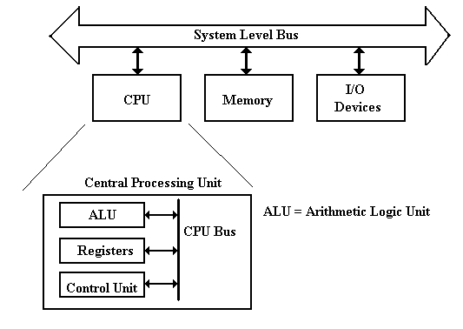
Recall that the actual architecture of a real machine will be somewhat different, due to the necessity of keeping performance at an acceptable level.
The Fetch–Execute Cycle
This cycle is the logical basis of all stored program computers.
Instructions are stored in memory as machine language.
Instructions are fetched from memory and then executed.
The common fetch cycle can be expressed in the following control sequence.
MAR ← PC. // The PC contains the address of the instruction.
READ. // Put the address into the MAR and read memory.
IR ← MBR. // Place the instruction into the MBR.
This cycle is described in many different ways, most of which serve to highlight additional steps required to execute the instruction. Examples of additional steps are: Decode the Instruction, Fetch the Arguments, Store the Result, etc.
A stored program computer is often called a “von Neumann Machine” after one of the originators of the EDVAC.
This Fetch–Execute cycle is often called the “von Neumann bottleneck”, as the necessity for fetching every instruction from memory slows the computer.
Modifications to Fetch–Execute
As we have seen before, there are a number of adaptations that will result in significant speed–up in the Fetch–Execute Cycle.
Advanced techniques include Instruction Pre–Fetch and Pipelining.
We may discuss these later.
For the moment, we discuss an early strategy based on two facts:
1. Instructions are most often executed in linear sequence.
2. Memory requires at least two cycles to return the instruction.
Here is the RTL (Register Transfer Language) for the common fetch sequence.
At the beginning of fetch, the PC contains the address of the next instruction.
1. MAR ← PC, READ. // Initiate a READ of the next instruction.
2. PC ← (PC) + 1. // Must wait on the memory to respond.
// Update the PC to point to the next instruction.
3. IR ← MBR. // Get the current instruction into the Instruction
// Register, so that it can be executed.
NOTE: In almost all computers, when an instruction is being executed, the
PC has already been updated to point to the following instruction.
The Data Path
Imagine the flow of data during an addition, when all arguments are in registers.
1. Data flow from the two source registers into the ALU.
2. The ALU performs the addition.
3. The data flow from the ALU into the destination register.
The term “data path” usually denotes the ALU, the set of registers, and the bus.
This term is often used to mean “data path timing”, as illustrated below.
Here is a real timing diagram for an addition of the contents of MBR to R1.
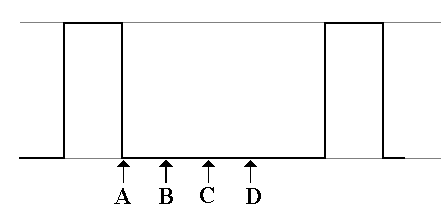
A: The operation starts.
B: The inputs to the ALU are stable
C: The ALU output is stable.
D: The result is stable in the R1.
The ALU (Arithmetic Logic Unit)
The ALU performs all of the arithmetic and logical operations for the CPU.
These include the following:
Arithmetic: addition, subtraction, negation, etc.
Logical: AND, OR, NOT, Exclusive OR, etc.
This symbol has been used for the ALU since the mid 1950’s.
It shows two inputs and one output.
The reason for two inputs is the fact that many operations, such as addition and logical AND, are dyadic; that is, they take two input arguments.
For operations with one input, such as logical NOT, one of the input busses will be ignored and the contents of the other one used.
The Data Path of a Typical Stored Program Computer
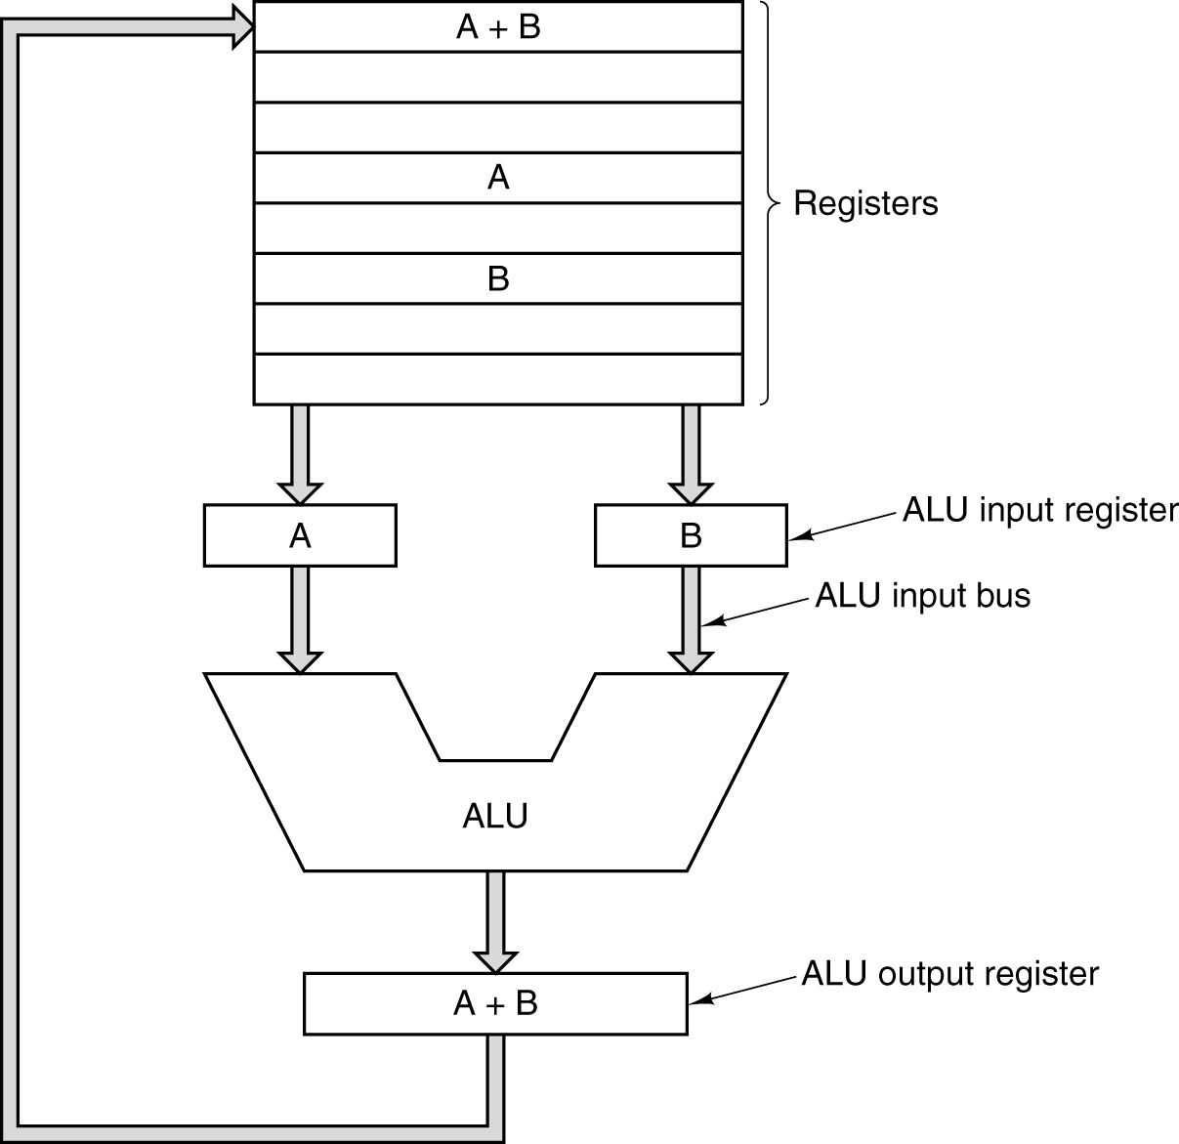
Note the standard way of depicting an ALU. It has two inputs and one output.
The Central Processing Unit (CPU)
The CPU has four main components:
1. The Control Unit (along with the IR) interprets the machine language instruction
and issues the control signals to make the CPU execute it.
2. The ALU (Arithmetic Logic Unit) that does the arithmetic and logic.
3. The Register Set (Register File) that stores temporary results related to the
computations. There are also Special Purpose Registers used by the Control Unit.
4. An internal bus structure for communication.
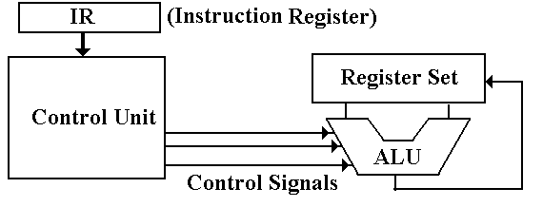
The function of the control unit is to decode the binary machine word in the IR (Instruction Register) and issue appropriate control signals, mostly to the CPU.
Design of the Control Unit
There are two related issues when considering the design of the control unit:
1) the complexity of the Instruction Set Architecture, and
2) the microarchitecture used to implement the control unit.
In order to make decisions on the complexity, we must place the role of the control unit within the context of what is called the DSI (Dynamic Static Interface).
The ISA (Instruction Set Architecture) of a computer is the set of assembly language commands that the computer can execute. It can be seen as the interface between the software (expressed as assembly language) and the hardware.
A more complex ISA requires a more complex control unit.
At some point in the development of computers, the complexity of the control unit became a problem for the designers. In order to simplify the design, the developers of the control unit for the IBM–360 elected to make it a microprogrammed unit.
This design strategy, which dates back to the Manchester Mark I in the early 1950’s, turns the control unit into an extremely primitive computer that interprets the contents of the IR and issues control signals as appropriate.
The Dynamic–Static Interface
In order to understand the DSI, we must place it within the context of a compiler for a higher–level language. Although most compilers do not emit assembly language, we shall find it easier to under the DSI if we pretend that they do.
What does the compiler output? There are two options:
1. A very simple assembly language. This requires a sophisticated compiler.
2. A more complex assembly language. This may allow a simpler compiler,
but it requires a more complex control unit.
The Dynamic–Static Interface (Part 2)
The DSI really defines the division between what the compiler does and what the microarchitecture does. The more complexity assigned to the compiler, the less that is assigned to the control unit, which can be simpler, faster, and smaller.
Consider code for the term used in solving quadratic equations
D = B² – 4•A•C
In assembly language, this might become
1 LR %R1 A // Load the value into R1
2 LR %R2 B // Load the value into R2
3 LR %R3 C // Load the value into R3
4 MUL %R1, %R3, %R5 // R5 has A•C
5 SHL %R5, 2 // Shift left by 2 is multiplication by 4
6 MUL %R2, %R2, %R6 // R6 has B²
7 SUB %R6, %R5, %R7 // R7 has B² – 4•A•C
8 SR %R7 D // Now D = B² – 4•A•C
Many of these operations can be performed in parallel. For example, there are no dependencies among the first three instructions.
Dependency Analysis
The proper sequencing of instructions depends on the dependencies present.
The following is a dependency graph of this set of 8 assembly language instructions.
This analysis is much more easily done in software by the compiler than in hardware by any sort of reasonably simple control unit.
An EPIC Compiler
The compiler for Explicitly Parallel Instruction Computing is complex.
It might emit the equivalent of the following code.
Instruction  Time Slot | Thread 1 | Thread 2
I | (1) LR %R1 A | (3) LR %R3 C
II | (2) LR %R2 B | (4) MUL %R1, %R3, %R5
III | (5) MUL %R2, %R2, %R6 | (6) SHL %R5, 2
IV | (7) SUB %R6, %R5, %R7 | NOP
V | (8) SR %R7 D | NOP
Again, the compiler needed some sophisticated analysis to postpone the instruction
“LR %R2 B” to the second instruction slot.
Nevertheless, creating a compiler of such complexity is much easier that creating a control unit of equivalent complexity.
The Register File
There are two sets of registers, called “General Purpose” and “Special Purpose”.
The origin of the register set is simply the need to have some sort of memory on the computer and the inability to build what we now call “main memory”.
When reliable technologies, such as magnetic cores, became available for main memory, the concept of CPU registers was retained.
Registers are now implemented as a set of flip–flops physically located on the CPU chip. These are used because access times for registers are two orders of magnitude faster than access times for main memory: 1 nanosecond vs. 80 nanoseconds.
General Purpose Registers
These are mostly used to store intermediate results of computation. The count of such registers is often a power of 2, say 2⁴ = 16 or 2⁵ = 32, because N bits address 2^{N} items.
The registers are often numbered and named with a strange notation so that the assembler will not confuse them for variables; e.g. %R0 … %R15. %R0 is often fixed at 0.
NOTE: It used to be the case that registers were on the CPU chip and memory was not.
The advent of multi–level cache memory has erased that distinction.
The Register File
Special Purpose Registers
These are often used by the control unit in its execution of the program.
PC the Program Counter, so called because it does not count anything.
It is also called the IP (Instruction Pointer), a much better name.
The PC points to the memory location of the instruction to be executed next.
IR the Instruction Register. This holds the machine language version of
the instruction currently being executed.
MAR the Memory Address Register. This holds the address of the memory word
being referenced. All execution steps begin with PC → MAR.
MBR the Memory Buffer Register, also called MDR (Memory Data Register).
This holds the data being read from memory or written to memory.
PSR the Program Status Register, often called the PSW (Program Status Word),
contains a collection of logical bits that characterize the status of the program
execution: the last result was negative, the last result was zero, etc.
SP on machines that use a stack architecture, this is the Stack Pointer.
Another Special Purpose Register: The PSR
The PSR (Program Status Register) is actually a collection of bits that describe the running status of the process. The PSR is generally divided into two parts.
ALU Result Bits: C the carry–out from the last arithmetic computation.
V set if the last arithmetic operation resulted in overflow.
N set if the last arithmetic operation gave a negative number.
Z set it the last arithmetic operation resulted in a 0.
Control Bits: I set if interrupts are enabled. When I = 1, an I/O device can
raise an interrupt when it is ready for a data transfer.
Priority A multi–bit field showing the execution priority of the
CPU; e.g., a 3–bit field for priorities 0 through 7.
This facilitates management of I/O devices that have
different priorities associated with data transfer rates.
Access Mode The privilege level at which the current program is
allowed to execute. All operating systems require at
least two modes: Kernel and User.
The CPU Control of Memory
The CPU controls memory by asserting control signals.
Within the CPU the control signals are usually called READ and WRITE.
Reading Memory First place an address in the MAR.
Assert a READ control signal to command memory to be read.
Wait for memory to produce the result.
Copy the contents of the MBR to a register in the CPU.
Writing Memory First place and address in the MAR
Copy the contents of a register in the CPU to the MBR.
Assert a WRITE control signal to command the memory.
The memory control unit might convert these control signals into the Select and R/$\overline{W}$.
In interleaved memory systems, the memory control unit selects only the addressed bank of memory. The other banks remain idle.
Example: The CPU Controls a 16–Way Interleaved Memory
Assume a 64 MB (2²⁶ byte) memory with 16 banks that are low–order interleaved.
The address format might look like the following.
Bits | 25 – 4 | 3 – 0
Use | Address to the chip | Bank Select
Address bits 25 – 4 and the R/$\overline{W}$ are sent to each of the 16 banks.
This shows an enabled–high decoder used to select the bank when (READ + WRITE) = 1

Input/Output System
Each I/O device is connected to the system bus through a number of registers.
Collectively, these form part of the device interface.
These fall into three classes:
Data Contains data to be written to the device or just read from it.
Control Allows the CPU to control the device. For example, the CPU
` might instruct a printer to insert a CR/LF after each line printed.
Status Allows the CPU to monitor the status of the device. For example
a printer might have a bit that is set when it is out of paper.
There are two major strategies for interfacing I/O devices.
Memory Mapped I/O is designated through specific addresses
Load Reg KBD_Data This would be an input, loading into the register
Store Reg LP_Data This would be an output, storing into a special address
Isolated I/O (Instruction–Based I/O) Uses special instructions.
Input Reg Dev Read from the designated Input Device into the register.
Output Reg Dev Write from the register to the designated Output Device
As we shall see, Isolated I/O can also use addresses for the I/O devices.

