Views of Memory
We begin with a number of views of computer memory and comment on their use.
The simplest view of memory is that presented at the ISA (Instruction Set Architecture) level. At this level, memory is a monolithic addressable unit.
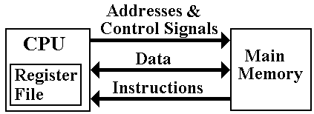
At this level, the memory is a repository for data and instructions, with no internal structure apparent. For some very primitive computers, this is the actual structure.
In this view, the CPU issues addresses and control signals. It receives instructions and data from the memory and writes data back to the memory.
This is the view that suffices for many high–level language programmers.
In no modern architecture does the CPU write instructions to the main memory.
The Logical Multi–Level View of Memory
In a course such as this, we want to investigate the internal memory structures that allow for more efficient and secure operations.
The logical view for this course is a three–level view with
cache memory, main memory, and virtual memory.
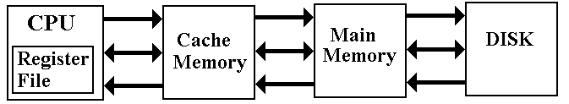
The primary memory is backed by a “DASD” (Direct Access Storage Device), an external high–capacity device.
While “DASD” is a name for a device that meets certain specifications, the standard disk drive is the only device currently in use that “fits the bill”. Thus DASD = Disk.
This is the view we shall take when we analyze cache memory.
A More Realistic View of Multi–Level Memory
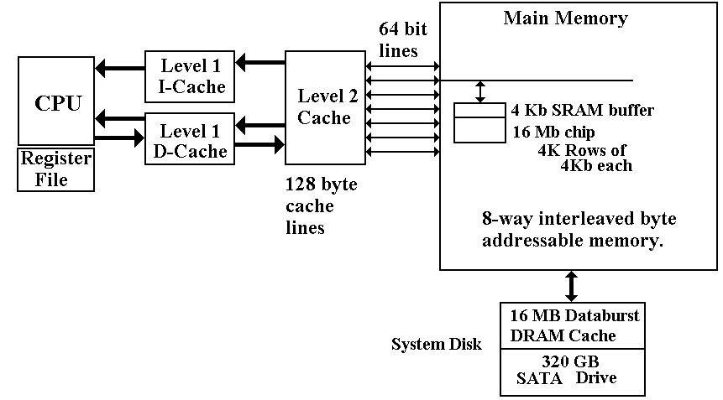
Generic Primary / Secondary Memory
This lecture covers two related subjects: Virtual Memory and Cache Memory.
In each case, we have a fast primary memory backed by a bigger secondary memory.

The “actors” in the two cases are as follows:
Technology Primary Memory Secondary Memory Block
Cache Memory SRAM Cache DRAM Main Memory Cache Line
Virtual Memory DRAM Main Memory Disk Memory Page
Access Time T_{P} (Primary Time) T_{S} (Secondary Time)

Effective Access Time: T_{E} = h • T_{P} + (1 – h) • T_{S}, where h (the primary hit rate) is the fraction of memory accesses satisfied by the primary memory; 0.0 ≤ h ≤ 1.0.
This formula does extend to multi–level caches. For example a two–level cache has
T_{E} = h₁ • T₁ + (1 – h₁) • h₂ • T₂ + (1 – h₁) • (1 – h₂) • T_{S}.
NOTATION WARNING: In some contexts, the DRAM main memory is called
“primary memory”. I never use that terminology when discussing multi–level memory.
Examples: Cache Memory
Suppose a single cache fronting a main memory, which has 80 nanosecond access time.
Suppose the cache memory has access time 10 nanoseconds.
If the hit rate is 90%, then T_{E} = 0.9 • 10.0 + (1 – 0.9) • 80.0
` = 0.9 • 10.0 + 0.1 • 80.0 = 9.0 + 8.0 = 17.0 nsec.
If the hit rate is 99%, then T_{E} = 0.99 • 10.0 + (1 – 0.99) • 80.0
` = 0.99 • 10.0 + 0.01 • 80.0 = 9.9 + 0.8 = 10.7 nsec.
Suppose a L1 cache with T₁ = 4 nanoseconds and h₁ = 0.9
Suppose a L2 cache with T₂ = 10 nanoseconds and h₂ = 0.99
This is defined to be the number of hits on references that are a miss at L1.
Suppose a main memory with T_{S} = 80.0
T_{E} = h₁ • T₁ + (1 – h₁) • h₂ • T₂ + (1 – h₁) • (1 – h₂) • T_{S}.
= 0.90 • 4.0 + 0.1 • 0.99 • 10.0 + 0.1 • 0.01 • 80.0
= 0.90 • 4.0 + 0.1 • 9.9 + 0.1 • 0.80
= 3.6 + 0.99 + 0.08 = 4.67 nanoseconds.
Note that with these hit rates, only 0.1 • 0.01 = 0.001 = 0.1% of the memory references are handled by the much slower main memory.
Precise Definition of Virtual Memory
Virtual memory has a common definition that so frequently represents its actual implementation that we may use it. However, I shall give its precise definition.
Virtual memory is a mechanism for translating logical addresses (as issued by an executing program) into actual physical memory addresses.

This definition alone provides a great advantage to an Operating System, which can then allocate processes to distinct physical memory locations according to some optimization.
Secondary Storage
Although this is a precise definition, virtual memory has always been implemented by pairing a fast DRAM Main Memory with a bigger, slower “backing store”. Originally, this was magnetic drum memory, but it soon became magnetic disk memory.
The invention of time–sharing operating systems introduced another variant of VM, now part of the common definition. A program and its data could be “swapped out” to the disk to allow another program to run, and then “swapped in” later to resume.
Common (Accurate) Definition of Virtual Memory
Virtual memory allows the program to have a logical address space much larger than the computers physical address space. It maps logical addresses onto physical addresses and moves “pages” of memory between disk and main memory to keep the program running.
An address space is the range of addresses, considered as unsigned integers, that can be generated. An N–bit address can access 2^{N} items, with addresses 0 … 2^{N} – 1.
16–bit address 2¹⁶ items 0 to 65535
20–bit address 2²⁰ items 0 to 1,048,575
32–bit address 2³² items 0 to 4,294,967,295
In all modern applications, the physical address space is no larger than the logical address space. It is often somewhat smaller than the logical address space. As examples, we use a number of machines with 32–bit logical address spaces.
Machine Physical Memory Logical Address Space
VAX–11/780 16 MB 4 GB (4, 096 MB)
Pentium (2004) 128 MB 4 GB
Desktop Pentium 512 MB 4 GB
Server Pentium 4 GB 4 GB
NOTE: The MAR structure usually allows the two address spaces to be equal.
Generic Primary / Secondary Memory View
A small fast expensive memory is backed by a large, slow, cheap memory.
Memory references are first made to the smaller memory.
1. If the address is present, we have a “hit”.
2. If the address is absent, we have a “miss” and must transfer the addressed
item from the slow memory. For efficiency, we transfer as a unit the block
containing the addressed item.
The mapping of the secondary memory to primary memory is “many to one” in that each primary memory block can contain a number of secondary memory addresses.
To compensate for each of these, we associate a tag with each primary block.
For example, consider a byte–addressable memory with 24–bit addresses and 16 byte blocks. The memory address would have six hexadecimal digits.
Consider the 24–bit address 0xAB7129. The block containing that address is every item with address beginning with 0xAB712: 0xAB7120, 0xAB7121, … , 0xAB7129, 0xAB712A, … 0xAB712F.
The primary block would have 16 entries, indexed 0 through F. It would have the 20–bit tag 0XAB712 associated with the block, either explicitly or implicitly.
Valid and Dirty Bits
At system start–up, the faster memory contains no valid data, which are copied as needed from the slower memory.
Each block would have three fields associated with it
The tag field (discussed above) identifying the memory addresses contained
Valid bit set to 0 at system start–up.
set to 1 when valid data have been copied into the block
Dirty bit set to 0 at system start–up.
set to 1 whenever the CPU writes to the faster memory
set to 0 whenever the contents are copied to the slower memory.
Associative Memory
Associative memory is “content addressable” memory. The contents of the memory are searched in one memory cycle.
Consider an array of 256 entries, indexed from 0 to 255 (or 0x0 to 0xFF).
Suppose that we are searching the memory for entry 0xAB712.
Normal memory would be searched using a standard search algorithm, as learned in beginning programming classes.
If the memory is unordered, it would take on average 128 searches to find an item.
If the memory is ordered, binary search would find it in 8 searches.
Associative memory would find the item in one search. Think of the control circuitry as “broadcasting” the data value (here oxAB712) to all memory cells at the same time. If one of the memory cells has the value, it raises a Boolean flag and the item is found.
We do not consider duplicate entries in the associative memory. This can be handled by some rather straightforward circuitry, but is not done in associative caches.
Associative Cache
We now focus on cache memory, returning to virtual memory only at the end.
Primary memory = Cache Memory (assumed to be one level)
Secondary memory = Main DRAM
Assume a number of cache lines, each holding 16 bytes. Assume a 24–bit address.
The simplest arrangement is an associative cache. It is also the hardest to implement.
Divide the 24–bit address into two parts: a 20–bit tag and a 4–bit offset.
Bits | 23 – 4 | 3 – 0
Fields | Tag | Offset
A cache line in this arrangement would have the following format.
D bit | V Bit | Tag | 16 indexed entries
0 | 1 | 0xAB712 | M[0xAB7120] … M[0xAB712F]
The placement of the 16 byte block of memory into the cache would be determined by a cache line replacement policy. The policy would probably be as follows:
1. First, look for a cache line with V = 0. If one is found, then it is “empty”
and available, as nothing is lost by writing into it.
2. If all cache lines have V = 1, look for one with D = 0. Such a cache line
can be overwritten without first copying its contents back to main memory.
Direct–Mapped Cache
This is simplest to implement, as the cache line index is determined by the address.
Assume 256 cache lines, each holding 16 bytes. Assume a 24–bit address.
Recall that 256 = 2⁸, so that we need eight bits to select the cache line.
Divide the 24–bit address into three fields: a 12–bit explicit tag, an 8–bit line number, and a 4–bit offset within the cache line. Note that the 20–bit memory tag is divided between the 12–bit cache tag and 8–bit line number.
Bits | 23 – 12 | 11 – 4 | 3 – 0
Cache View | Tag | Line | Offset
Address View | Block Number |  | Offset
Consider the address 0xAB7129. It would have
Tag = 0xAB7
Line = 0x12
Offset = 0x9
Again, the cache line would contain M[0xAB7120] through M[0xAB712F].
The cache line would also have a V bit and a D bit (Valid and Dirty bits).
This simple implementation often works, but it is a bit rigid. An design that is a blend of the associative cache and the direct mapped cache might be useful.
Set–Associative Caches
An N–way set–associative cache uses direct mapping, but allows a set of N memory blocks to be stored in the line. This allows some of the flexibility of a fully associative cache, without the complexity of a large associative memory for searching the cache.
Suppose a 2–way set–associative implementation of the same cache memory.
Again assume 256 cache lines, each holding 16 bytes. Assume a 24–bit address.
Recall that 256 = 2⁸, so that we need eight bits to select the cache line.
Consider addresses 0xCD4128 and 0xAB7129. Each would be stored in cache line
0x12. Set 0 of this cache line would have one block, and set 1 would have the other.

Entry 0 |  |  |  | Entry 1
D | V | Tag | Contents | D | V | Tag | Contents
1 | 1 | 0xCD4 | M[0xCD4120] to  M[0xCD412F] | 0 | 1 | 0xAB7 | M[0xAB7120] to M[0xAB712F]

Virtual Memory (Again)
Suppose we want to support 32–bit logical addresses in a system in which physical memory is 24–bit addressable.
We can follow the primary / secondary memory strategy seen in cache memory. We shall see this again, when we study virtual memory in a later lecture.

For now, we just note that the address structure of the disk determines the structure of virtual memory. Each disk stores data in blocks of 512 bytes, called sectors.
In some older disks, it is not possible to address each sector directly. This is due to the limitations of older file organization schemes, such as FAT–16.
FAT–16 used a 16–bit addressing scheme for disk access. Thus 2¹⁶ sectors could be addressed. Since each sector contained 2⁹ bytes, the maximum disk size under
“pure FAT–16” is 2²⁵ bytes = 2⁵ • 2²⁰ bytes = 32 MB.
To allow for larger disks, it was decided that a cluster of 2^{K} sectors would be the smallest addressable unit. Thus one would get clusters of 1,024 bytes, 2,048 bytes, etc.
Virtual memory transfers data in units of clusters, the size of which is system dependent.
Examples of Cache Memory
We need to review cache memory and work some specific examples.
The idea is simple, but fairly abstract. We must make it clear and obvious.
While most of this discussion does apply to pages in a Virtual Memory system,
we shall focus it on cache memory.
To review, we consider the main memory of a computer. This memory might have a size of 384 MB, 512 MB, 1GB, etc. It is divided into blocks of size 2^{K} bytes, with K > 2.
In general, the N–bit address is broken into two parts, a block tag and an offset.
The most significant (N – K) bits of the address are the block tag
The least significant K bits represent the offset within the block.
We use a specific example for clarity.
byte addressable memory
a 24–bit address
cache block size of 16 bytes, so the offset part of the address is K = 4 bits.
Remember that our cache examples use byte addressing for simplicity.
EXAMPLE: The Address 0xAB7129
In our example, the address layout for main memory is as follows:
Divide the 24–bit address into two parts: a 20–bit tag and a 4–bit offset.
Bits | 23 – 4 | 3 – 0
Fields | Tag | Offset
Let’s examine the sample address in terms of the bit divisions above.
Bits: | 23 – 20 | 19 – 16 | 15 – 12 | 11 – 8 | 7 – 4 | 3 – 0
Hex Digit | A | B | 7 | 1 | 2 | 9
Field | 0xAB712 |  |  |  |  | 0x09

So, the tag field for this block contains the value 0xAB712.
The tag field of the cache line must also contain this value, either explicitly or
implicitly. More on this later.

Remember: It is the cache line size that determines the size of the blocks in
main memory. They must be the same size, here 16 bytes.
What Does The Cache Tag Look Like?
All cache memories are divided into a number of cache lines. This number is also a power of two, usually between 256 = 2⁸ and 2¹⁶ (for larger L2 caches).
Our example used in this lecture calls for 256 cache lines.
Associative Cache
As a memory block can go into any available cache line, the cache tag must represent
the memory tag explicitly: Cache Tag = Block Tag. In our example, it is 0xAB712.
Direct Mapped and Set–Associative Cache
For any specific memory block, there is exactly one cache line that can contain it.
Suppose an N–bit address space. 2^{L} cache lines, each of 2^{K} bytes.
Address Bits | (N – L – K) bits | L bits | K bits
Cache Address | Cache Tag | Cache Line | Offset
Memory Address | Memory Block Tag |  | Offset
To retrieve the memory block tag from the cache tag, just append the cache line number.
In our example: The Memory Block Tag = 0xAB712
Cache Tag = 0xAB7
Cache Line = 0x12
Example: Associative Cache for Address 0xAB7129
Suppose that the cache line has valid data and that the memory at address 0xAB7129
has been read by the CPU. This forces the block with tag 0xAB712 to be read in.
Offset | Contents
0x00 | M [ 0xAB7120 ]
0x01 | M [ 0xAB7121 ]
0x02 | M [ 0xAB7122 ]
0x03 | M [ 0xAB7123 ]
0x04 | M [ 0xAB7124 ]
0x05 | M [ 0xAB7125 ]
0x06 | M [ 0xAB7126 ]
0x07 | M [ 0xAB7127 ]
0x08 | M [ 0xAB7128 ]
0x09 | M [ 0xAB7129 ]
0x0A | M [ 0xAB712A ]
0x0B | M [ 0xAB712B ]
0x0C | M [ 0xAB712C ]
0x0D | M [ 0xAB712D ]
0x0E | M [ 0xAB712E ]
0x0F | M [ 0xAB712F ]
Cache Tag = 0xAB712
Valid = 1
Dirty = 0

Example: Direct Mapped Cache for Address 0xAB7129
Suppose that the cache line has valid data and that the memory at address 0xAB7129
has been read by the CPU. This forces the block with tag 0xAB712 to be read in.
Offset | Contents
0x00 | M [ 0xAB7120 ]
0x01 | M [ 0xAB7121 ]
0x02 | M [ 0xAB7122 ]
0x03 | M [ 0xAB7123 ]
0x04 | M [ 0xAB7124 ]
0x05 | M [ 0xAB7125 ]
0x06 | M [ 0xAB7126 ]
0x07 | M [ 0xAB7127 ]
0x08 | M [ 0xAB7128 ]
0x09 | M [ 0xAB7129 ]
0x0A | M [ 0xAB712A ]
0x0B | M [ 0xAB712B ]
0x0C | M [ 0xAB712C ]
0x0D | M [ 0xAB712D ]
0x0E | M [ 0xAB712E ]
0x0F | M [ 0xAB712F ]
Cache Line = 0x12
Cache Tag = 0xAB7
Valid = 1
Dirty = 0
Because the cache line is always the lower order
bits of the memory block tag, those bits
do not need to be part of the cache tag.

Reading and Writing in a Cache Memory
Let’s begin our review of cache memory by considering the two processes:
CPU Reads from Cache
CPU Writes to Cache
Suppose for the moment that we have a direct mapped cache, with line 0x12 as follows:
Line Number: 0x12
Tag | Valid | Dirty | Contents (Array of 16 entries)
0xAB7 | 1 | 0 | M[0xAB7120] to M[0xAB712F]

Since the cache line has contents, by definition we must have Valid = 1.
For this example, we assume that Dirty = 0 (but that is almost irrelevant here).
Read from Cache.
The CPU loads a register from address 0xAB7123. This is read directly from the cache.
Write to Cache
The CPU copies a register into address 0xAB712C. The appropriate page is present in the cache line, so the value is written and the dirty bit is set; Dirty = 1.
Now What?
Here is a question that cannot occur for reading from the cache.
Writing to the cache has changed the value in the cache.
The cache line now differs from the corresponding block in main memory.
The two main solutions to this problem are called “write back” and “write through”.
Write Through
In this strategy, every byte that is written to a cache line is immediately written back to the corresponding memory block. Allowing for the delay in updating main memory, the cache line and cache block are always identical.
Advantages: This is a very simple strategy. No “dirty bit” needed.
Disadvantages: This means that writes to cache proceed at main memory speed.
Write Back
In this strategy, CPU writes to the cache line do not automatically cause updates of the corresponding block in main memory.
The cache line is written back only when it is replaced.
Advantages: This is a fast strategy. Writes proceed at cache speed.
Disadvantages: A bit more complexity and thus less speed.
Example: Cache Line Replacement
For simplicity, assume direct mapped caches.
Assume that memory block 0xAB712 is present in cache line 0x12.
We now get a memory reference to address 0x895123. This is found in memory block 0x89512, which must be placed in cache line 0x12.
The following holds for each of a memory read from or memory write to 0x895123.
Process
1. The valid bit for cache line 0x12 is examined. If (Valid = 0) go to Step 5.
2. The memory tag for cache line 0x12 is examined and compared to the desired
tag 0x895. If (Cache Tag = 0x895) go to Step 6.
3. The cache tag does not hold the required value. Check the dirty bit.
If (Dirty = 0) go to Step 5.
4. Here, we have (Dirty = 1). Write the cache line back to memory block 0xAB712.
5. Read memory block 0x89512 into cache line 0x12. Set Valid = 1 and Dirty = 0.
6. With the desired block in the cache line, perform the memory operation.
More on the Mapping Types
We have three different major strategies for cache mapping.
Direct Mapping this is the simplest strategy, but it is rather rigid.
One can devise “almost realistic” programs that defeat this mapping.
It is possible to have considerable page replacement with a cache
that is mostly empty.
Fully Associative this offers the most flexibility, in that all cache lines can be used.
This is also the most complex, because it uses a larger associative
memory, which is complex and costly.
N–Way Set Associative
This is a mix of the two strategies.
It uses a smaller (and simpler) associative memory.
Each cache line holds N = 2^{K} sets, each the size of a memory block.
Each cache line has N cache tags, one for each set.

Example: 4–Way Set-Associative Cache
Based on the previous examples, let us imagine the state of cache line 0x12.
Tag | Valid | Dirty | Contents: Arrays of 16 bytes.
0xAB7 | 1 | 1 | M[0xAB7120] through M[0xAB712F]
0x895 | 1 | 0 | M[0x895120] through M[0x89512F]
0xCD4 | 1 | 1 | M[0xCD4120] through M[0xCD412F]
0 | 0 | 0 | Unknown
Memory references to blocks possibly mapped to this cache line.
1. Extract the cache tag from the memory block number.
2. Compare the tag to that of each valid set in the cache line.
If we have a match, the referenced memory is in the cache.
Say we have a reference to memory location 0x543126, with memory tag 0x54312.
This maps to cache line 0x12, with cache tag 0x543.
The replacement policy here is simple. There is an “empty set”, indicated by its valid bit being set to 0. Place the memory block there.
If all sets in the cache line were valid, a replacement policy would probably look for a set with Dirty = 0, as it could be replaced without being written back to main memory.
Relationships Between the Cache Mapping Types
Consider variations of mappings to store 256 memory blocks.
Direct Mapped Cache 256 cache lines
“1–Way Set Associative” 256 cache lines 1 set per line
2–Way Set Associative 128 cache lines 2 sets per line
4–Way Set Associative 64 cache lines 4 sets per line
8–Way Set Associative 32 cache lines 8 sets per line
16–Way Set Associative 16 cache lines 16 sets per line
32–Way Set Associative 8 cache lines 32 sets per line
64–Way Set Associative 4 cache lines 64 sets per line
128–Way Set Associative 2 cache lines 128 sets per line
256–Way Set Associative 1 cache line 256 sets per line
Fully Associative Cache 256 sets
N–Way Set Associative caches can be seen as a hybrid of the Direct Mapped Caches
and Fully Associative Caches
As N goes up, the performance of an N–Way Set Associative cache improves. After
about N = 8, the improvement is so slight as not to be worth the additional cost.
Example: Both Virtual Memory and Cache Memory
Any modern computer supports both virtual memory and cache memory.
Consider the following example, based on results in previous lectures.
Byte–addressable memory
A 32–bit logical address, giving a logical address space of 2³² bytes.
2²⁴ bytes of physical memory, requiring 24 bits to address.
Virtual memory implemented using page sizes of 2¹² = 4096 bytes.
Cache memory implemented using a fully associative cache with
cache line size of 16 bytes.
The logical address is divided as follows:
Bits | 31 – 28 | 27 – 24 | 23 – 20 | 19 – 16 | 15 – 12 | 11 – 8 | 7 – 4 | 3 – 0
Field | Page Number |  |  |  |  | Offset in Page
The physical address is divided as follows:
Bits | 23 – 20 | 19 – 16 | 15 – 12 | 11 – 8 | 7 – 4 | 3 – 0
Field | Memory Tag |  |  |  |  | Offset

VM and Cache: The Complete Process

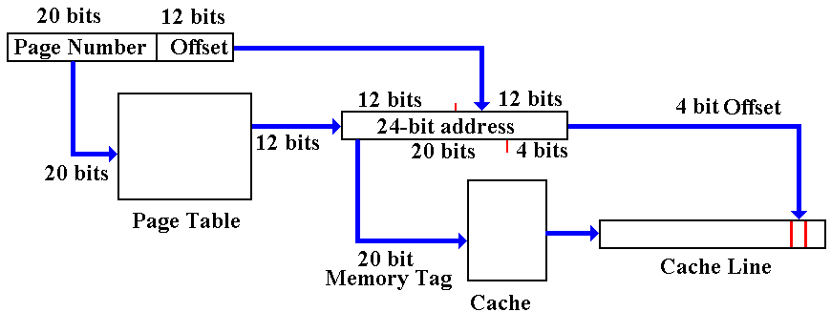
We start with a 32–bit logical address.
The virtual memory system uses a page table to produce a 24–bit physical address.
The cache uses a 24–bit address to find a cache line and produce a 4–bit offset.
This is a lot of work for a process that is supposed to be fast.
The Virtually Mapped Cache
Suppose that we turn this around, using the high order 28 bits as a virtual tag.
If the addressed item is in the cache, it is found immediately.
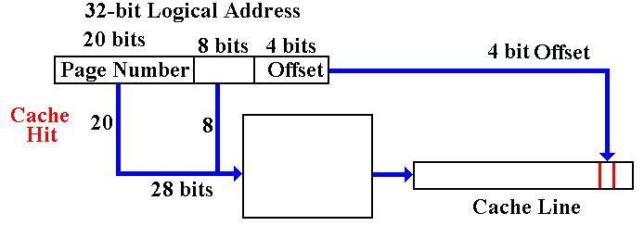
A Cache Miss accesses the Virtual Memory system.
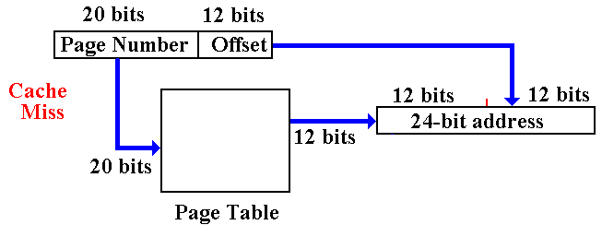
More on Virtual Memory: Can It Work?
When there is a cache miss, the addressed item is not in any cache line.
The virtual memory system must become active. Is the addressed item in main memory, or must it be retrieved from the backing store (disk)?
The page table is accessed. If the page is present in memory, the page table has the
high–order 12 bits of that page’s physical address.
But wait! The page table is in memory.
Does this imply two memory accesses for each memory reference?
This is where the TLB (Translation Look–aside Buffer) comes in.
It is a cache for a page table, more accurately called the “Translation Cache”.
The TLB is usually implemented as a split associative cache.
One associative cache for instruction pages, and
One associative cache for data pages.
A page table entry in main memory is accessed only if the TLB has a miss.
Memory Segmentation
Memory paging divides the address space into a number of equal sized blocks,
called pages. The page sizes are fixed for convenience of addressing.
Memory segmentation divides the program’s address space into logical segments, into which logically related units are placed. As examples, we conventionally have code segments, data segments, stack segments, constant pool segments, etc.
Each segment has a unique logical name. All accesses to data in a segment must be through a <name, offset> pair that explicitly references the segment name.
For addressing convenience, segments are usually constrained to contain an integral number of memory pages, so that the more efficient paging can be used.
Memory segmentation facilitates the use of security techniques for protection.
All data requiring a given level of protection can be grouped into a single segment,
with protection flags specific to giving that exact level of protection.
All code requiring protection can be placed into a code segment and also protected.
It is not likely that a given segment will contain both code and data. For this reason,
we may have a number of distinct segments with identical protection.

