Modulo–4 Up–Down Counter
This is a counter with input.
If X = 0, the device counts up: 0, 1, 2, 3, 0, 1, 2, 3, etc.
If X = 1, the device counts down: 0, 3, 2, 1, 0, 3, 2, 1, etc.

Step 1a: Derive the state diagram and state table for the circuit.
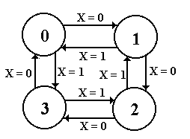
Note two transitions between the state pairs: one is up and one is down.
Step 1b: Derive the State Table

Present State | Next State
 | X = 0 | X = 1
0 | 1 | 3
1 | 2 | 0
2 | 3 | 1
3 | 0 | 2

This is just a restatement of the state diagram.
Note: Two columns for the “Next State”.

Step 2: Count the States and
Determine the Flip–Flop Count

Count the States
There are four states for any modulo–4 counter. N = 4
The states are simple: 0, 1, 2, and 3.

Calculate the Number of Flip–Flops Required
Let P be the number of flip–flops.
Solve 2^{P-1} < N ≤ 2^{P}. So 2^{P-1} < 4 ≤ 2^{P} and P = 2.
We need two flip–flops.
Step 3: Assign a unique P-bit binary number
(state vector) to each state.
Here P = 2, so we are assigning two–bit binary numbers.
Vector is denoted by the binary number Y₁Y₀.
State | 2-bit Vector
 | Y₁ Y₀
0 | 0 0
1 | 0 1
2 | 1 0
3 | 1 1
Each state has a unique 2–bit number assigned.
Any other assignment would be absurd.
Step 4: Derive the state transition table
and the output table.

There is no computed output, hence no output table.

The state transition table uses the 2–bit state vectors
Present State |  | Next State
 |  | X = 0 | X = 1
0 | 00 | 01 | 11
1 | 01 | 10 | 00
2 | 10 | 11 | 01
3 | 11 | 00 | 10

Step 5:Separate the state transition table into P tables,
one for each flip-flop.
Flip–Flop 1
Flip-Flop 1
PS | Next State: Y₁
Y₁Y₀ | X = 0 | X = 1
0 0 | 0 | 1
0 1 | 1 | 0
1 0 | 1 | 0
1 1 | 0 | 1
Flip–Flop 0
Flip-Flop 0: Y₀
PS | Next State
Y₁Y₀ | X = 0 | X = 1
0 0 | 1 | 1
0 1 | 0 | 0
1 0 | 1 | 1
1 1 | 0 | 0
Step 6: Decide on the types of flip-flops to use.
When in doubt, use all JK’s.

Here is the excitation table for a JK flip–flop
Q(T) | Q(T+1) | J | K
0 | 0 | 0 | d
0 | 1 | 1 | d
1 | 0 | d | 1
1 | 1 | d | 0

Step 7: Derive the input table for each flip-flop
Flip–Flop 1
 | X = 0 |  |  | X = 1
Y₁Y₀ | Y₁ | J₁ | K₁ | Y₁ | J₁ | K₁
0 0 | 0 | 0 | d | 1 | 1 | d
0 1 | 1 | 1 | d | 0 | 0 | d
1 0 | 1 | d | 0 | 0 | d | 1
1 1 | 0 | d | 1 | 1 | d | 0
Flip–Flop 0
 | X = 0 |  |  | X = 1
Y₁Y₀ | Y₀ | J₀ | K₀ | Y₁ | J₀ | K₀
0 0 | 1 | 1 | d | 1 | 1 | d
0 1 | 0 | d | 1 | 0 | d | 1
1 0 | 1 | 1 | d | 1 | 1 | d
1 1 | 0 | d | 1 | 0 | d | 1
Question: How do we produce equations for the J’s and K’s?
Step 8: Derive the input equations for each flip-flop
The equations are based on the present state and the input.
The input X produces a complication.

The simplest match procedure will lead to two equations
for each flip–flop input: one for X = 0 and one for X = 1.

Use the “combine rule”
The rule for combining expressions derived separately
for X = 0 and X = 1 is
$\overline{X}$•(expression for X= 0) + X•(expression for X = 1).

Rationale: Let F(X) = A•$\overline{X}$ + B•X
When X = 0, F(X) = A and when X = 1, F(X) = B.
Input Equations for Flip–Flop 1

 | X = 0 |  |  | X = 1
Y₁Y₀ | Y₁ | J₁ | K₁ | Y₁ | J₁ | K₁
0 0 | 0 | 0 | d | 1 | 1 | d
0 1 | 1 | 1 | d | 0 | 0 | d
1 0 | 1 | d | 0 | 0 | d | 1
1 1 | 0 | d | 1 | 1 | d | 0
J₁ = Y₀ J₁ = Y₀’
K₁ = Y₀ K₁ = Y₀’

Apply the “combine rule”
J₁ = X’•Y₀ + X•Y₀’ = X ⊕ Y₀
K₁ = X’•Y₀ + X•Y₀’ = X ⊕ Y₀
Input Equations for Flip–Flop 0

 | X = 0 |  |  | X = 1
Y₁Y₀ | Y₀ | J₀ | K₀ | Y₁ | J₀ | K₀
0 0 | 1 | 1 | d | 1 | 1 | d
0 1 | 0 | d | 1 | 0 | d | 1
1 0 | 1 | 1 | d | 1 | 1 | d
1 1 | 0 | d | 1 | 0 | d | 1
J₀ = 1 J₀ = 1
K₀ = 1 K₀ = 1
Apply the “Combine Rule”
J₀ = X’•1 + X•1 = 1
K₀ = X’•1 + X•1 = 1
Neither J₀ nor K₀ depend on X. But Y₀ does not depend on X.
Step 9: Summarize the equations by
writing them in one place.

Here they are.
J₁ = X ⊕ Y₀ K₁ = X ⊕ Y₀
J₀ = 1 K₀ = 1

Step 10: Draw the Circuit
As designed, it is:
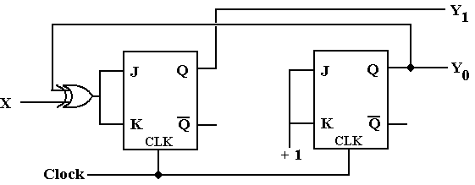
Step 10: Draw the Circuit
Implemented with T Flip–Flops, it is:
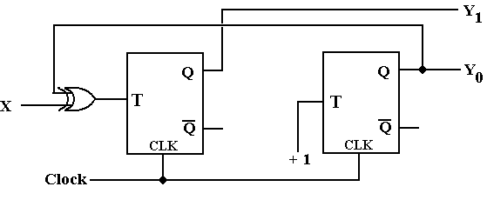

One could also use a 4–register “one hot” design, with the input X
used to determine the direction of the shift.

