Sample Design:
A Controller for a Simple Traffic Light

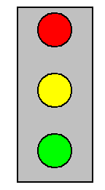
Assumption: Two Linked Pairs of Traffic Lights
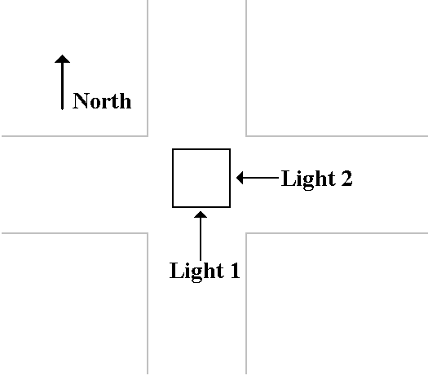
If one light is Green, the “cross light” must be Red.
Assumed Cycling Rules

One Light Cross Light Comments
Green Red Traffic moving on one street
Yellow Red Traffic on cross street must wait
for this light to turn red.
Red Red Both lights are red for about
one second.
Red Green Cross traffic now moves.
This is the basic sequence for a traffic light without turn signals or
features such as an “advanced green”, etc.
Name the States

State | Light 1 | Light 2 | Alias
0 | Red | Red | RR
1 | Red | Green | RG
2 | Red | Yellow | RY
3 | Red | Red | RR
4 | Green | Red | GR
5 | Yellow | Red | YR

Step 1a: State Diagram for the System
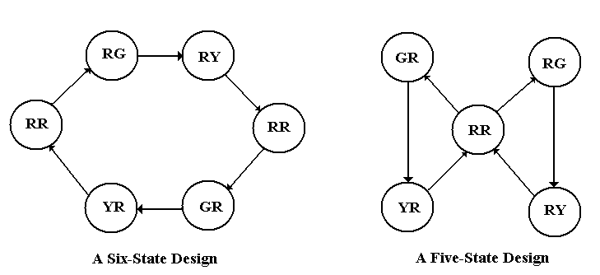
Notation: L₁L₂, so RG ⇒ Light 1 is Red and Light 2 is Green
The six–state design is more easily implemented.
Step 1b: Define the State Table
Present State |  | Next State
Number | Alias | Number | Alias
0 | RR | 1 | RG
1 | RG | 2 | RY
2 | RY | 3 | RR
3 | RR | 4 | GR
4 | GR | 5 | YR
5 | YR | 0 | RR
At the moment, this is just a modulo–6 counter with unusual output.
We shall add some additional circuitry to allow for safety constraints.
The choice of Red – Red as state 0 is arbitrary, but convenient.
Step 2: Count the States and
Determine the Flip–Flop Count
There are six states, so we have N = 6.

Solve 2^{P–1} < N ≤ 2^{P} for P, the number of flip–flops.

2^{P–1} < 6 ≤ 2^{P} gives P = 3, because 2² < 6 ≤ 2³.

We denote the states by Q₂Q₁Q₀, because the symbol “Y” is taken to
indicate the color Yellow.
Step 3: Assign a 3–bit Binary Number
to Each State
This is a modified counter, so the assignments are quite obvious.
State | Q₂ | Q₁ | Q₀
0 | 0 | 0 | 0
1 | 0 | 0 | 1
2 | 0 | 1 | 0
3 | 0 | 1 | 1
4 | 1 | 0 | 0
5 | 1 | 0 | 1
We have two possible additional states: 6 and 7.
Normally, these are ignored, but we consider them due to
safety constraints.
Redefine the State Diagram to Add Safety
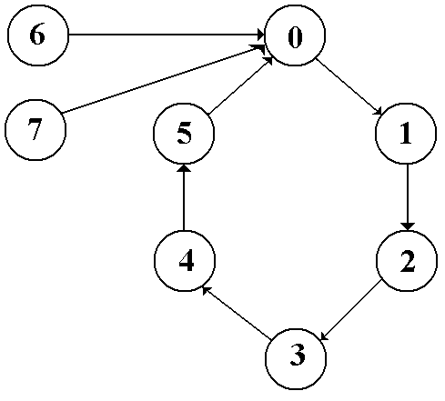
States 6 and 7 should never be entered. Each is “RR” for safety.
Step 4a: Derive the Output Equations.
 | Alias | Q₂Q₁Q₀ | R1 | G1 | Y1 | R2 | G2 | Y2
0 | RR | 0 0 0 | 1 | 0 | 0 | 1 | 0 | 0
1 | RG | 0 0 1 | 1 | 0 | 0 | 0 | 1 | 0
2 | RY | 0 1 0 | 1 | 0 | 0 | 0 | 0 | 1
3 | RR | 0 1 1 | 1 | 0 | 0 | 1 | 0 | 0
4 | GR | 1 0 0 | 0 | 1 | 0 | 1 | 0 | 0
5 | YR | 1 0 1 | 0 | 0 | 1 | 1 | 0 | 0
6 | RR | 1 1 0 | 1 | 0 | 0 | 1 | 0 | 0
7 | RR | 1 1 1 | 1 | 0 | 0 | 1 | 0 | 0
Here are the output equations
G1 = Q₂•Q₁’•Q₀’ G2 = Q₂’•Q₁’•Q₀
Y1 = Q₂•Q₁’•Q₀ Y2 = Q₂’•Q₁•Q₀’
R1 = (G1 + Y1)’ R2 = (G2 + Y2)’
Step 4a: Derive the Output Equations.
(page 2)
Here are the equations again.
G1 = Q₂•Q₁’•Q₀’ G2 = Q₂’•Q₁’•Q₀
Y1 = Q₂•Q₁’•Q₀ Y2 = Q₂’•Q₁•Q₀’
R1 = (G1 + Y1)’ R2 = (G2 + Y2)’
We derive the Green and Yellow signals, which are easier.
We stipulate that if a light is not Green or Yellow, it must be Red.
Now add a safety constraint: If a light is Green or Yellow, the
cross light must be Red.
R1 = (G1 + Y1)’ + G2 + Y2, and
R2 = (G2 + Y2)’ + G1 + Y1
These equations may lead to a light showing two colors.
This is obviously an error situation.
Step 4b: Derive the State Transition Table.
Present State |  | Next State
 | Q₂Q₁Q₀ | Q₂Q₁Q₀
0 | 0 0 0 | 0 0 1
1 | 0 0 1 | 0 1 0
2 | 0 1 0 | 0 1 1
3 | 0 1 1 | 1 0 0
4 | 1 0 0 | 1 0 1
5 | 1 0 1 | 0 0 0
6 | 1 1 0 | 0 0 0
7 | 1 1 1 | 0 0 0

Step 5: Separate the Table into Three Tables

Q₂ |  |  | Q₁ |  |  | Q₀
PS | NS |  | PS | NS |  | PS | NS
Q₂Q₁Q₀ | Q₂ |  | Q₂Q₁Q₀ | Q₁ |  | Q₂Q₁Q₀ | Q₀
0 0 0 | 0 |  | 0 0 0 | 0 |  | 0 0 0 | 1
0 0 1 | 0 |  | 0 0 1 | 1 |  | 0 0 1 | 0
0 1 0 | 0 |  | 0 1 0 | 1 |  | 0 1 0 | 1
0 1 1 | 1 |  | 0 1 1 | 0 |  | 0 1 1 | 0
1 0 0 | 1 |  | 1 0 0 | 0 |  | 1 0 0 | 1
1 0 1 | 0 |  | 1 0 1 | 0 |  | 1 0 1 | 0
1 1 0 | 0 |  | 1 1 0 | 0 |  | 1 1 0 | 0
1 1 1 | 0 |  | 1 1 1 | 0 |  | 1 1 1 | 0
Color added to emphasize the transitions of interest.
Step 6: Select the Flip–Flops to Use
Use JK flip–flops. What a surprise!

The excitation table for a JK flip-flop is given again.
Q(T) | Q(T + 1) |  | J | K
0 | 0 |  | 0 | d
0 | 1 |  | 1 | d
1 | 0 |  | d | 1
1 | 1 |  | d | 0

Step 7: Derive the Input Tables
Flip-Flop 2 |  |  |  |  | Flip-Flop 1 |  |  |  |  | Flip-Flop 0
PS | NS | Input |  |  | PS | NS | Input |  |  | PS | NS | Input
Q₂Q₁Q₀ | Q₂ | J₂ | K₂ |  | Q₂Q₁Q₀ | Q₁ | J₁ | K₁ |  | Q₂Q₁Q₀ | Q₀ | J₀ | K₀
0 0 0 | 0 | 0 | d |  | 0 0 0 | 0 | 0 | d |  | 0 0 0 | 1 | 1 | d
0 0 1 | 0 | 0 | d |  | 0 0 1 | 1 | 1 | d |  | 0 0 1 | 0 | d | 1
0 1 0 | 0 | 0 | d |  | 0 1 0 | 1 | d | 0 |  | 0 1 0 | 1 | 1 | d
0 1 1 | 1 | 1 | d |  | 0 1 1 | 0 | d | 1 |  | 0 1 1 | 0 | d | 1
1 0 0 | 1 | d | 0 |  | 1 0 0 | 0 | 0 | d |  | 1 0 0 | 1 | 1 | d
1 0 1 | 0 | d | 1 |  | 1 0 1 | 0 | 0 | d |  | 1 0 1 | 0 | d | 1
1 1 0 | 0 | d | 1 |  | 1 1 0 | 0 | d | 1 |  | 1 1 0 | 0 | 0 | d
1 1 1 | 0 | d | 1 |  | 1 1 1 | 0 | d | 1 |  | 1 1 1 | 0 | d | 1

Step 8: Derive the Input Equations
Here they are
J₂ = Q₁ • Q₀ J₁ = Q₂’ • Q₀ J₀ = Q₂’ + Q₁’
K₂ = Q₁ + Q₀ K₁ = Q₂ + Q₀ K₀ = 1

There is no need to summarize the equations.

Step 10: Draw the Circuit
