Multiplexers and Demultiplexers:
Description and Design Issues

Edward L. Bosworth, Ph.D.
TSYS School of Computer Science
Columbus State University
Columbus, GA 31907
Multiplexers and Demultiplexers

Multiplexer – MUX
Associates One of Many Inputs to a Single Output

Demultiplexer – DEMUX
Associates One Input with One of Many Outputs

Circuit Inputs Control Outputs
Signals
Multiplexer 2^{N} N 1
Demultiplexer 1 N 2^{N}

Sample: 4–to–1 MUX and 1–to–4 DEMUX

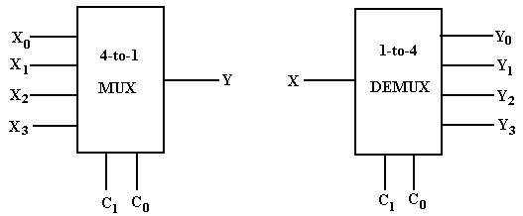

My Notation: X for Input
C for Control Signals
Y for Output

The Multiplexer Equation
Illustrated for a 4–to–1 MUX

Truth table Denote the multiplexer output by M

C₁ | C₀ | M
0 | 0 | X₀
0 | 1 | X₁
1 | 0 | X₂
1 | 1 | X₃

Equation Form
Here is another form of the equation that is better when X is used as an input.
Build a 4–to–1 MUX

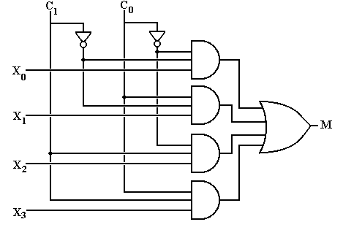
But what about an enable input for a multiplexer?
What does it mean for the output of the MUX to be 0?
Multiplexer Attached to a Bus Line
To control a multiplexer’s connection to a common bus, we use a tri–state buffer and not an enable input to the MUX. Here I use “E” as the tri–state control.
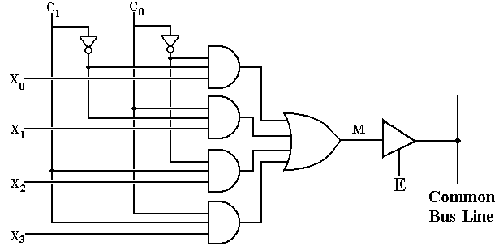
When E = 1, the selected MUX input is placed on the bus.
When E = 0, the MUX is detached from the bus; another source feeds the bus.
A 1–to–4 DEMUX

C₁ | C₀ | Selected Output
0 | 0 | Y₀ = X  Other outputs 0
0 | 1 | Y₁ = X  Other outputs 0
1 | 0 | Y₂ = X  Other outputs 0
1 | 1 | Y₃ = X  Other outputs 0

Build a 1–to–4 DEMUX
With an Enable

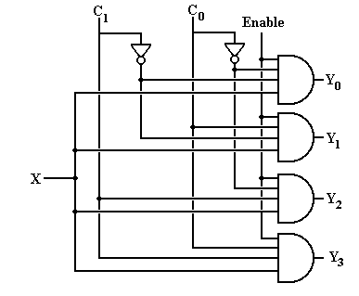
If Enable = 0, all outputs are 0.
Using A 2^{N}–to–1 MUX
for a Boolean Function of N Boolean Variables

Theorem 1: Any Boolean function of N Boolean variables, N > 0, can be
constructed by a multiplexer with 2^{N} inputs (usually labeled
I_{K}, I_{K-1}, … I₁, I₀) and N control lines, labeled C_{N-1} … C₀.

Method: Express the Boolean function of N Boolean variables in Canonical
Sum of Products and then match the desired function to the
Multiplexer Equation for a 2^{N}–to–1 MUX.

Example: F2(X, Y, Z) = X•Y + X•Z + Y•Z

Step 1: This is a function of three Boolean variables. We must use a
2³–to–1 MUX, also called a 8–to–1 MUX.

Using A 2^{N}–to–1 MUX
(page 2)

Step 2: Convert F2(X, Y, Z) = X•Y + X•Z + Y•Z to Canonical SOP.
Every product term must have a literal for each variable.
A literal is either the variable or its complement.

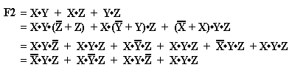

Note that all four terms have a literal for each of the three variables X, Y, and Z.

Using A 2^{N}–to–1 MUX
(page 3)

Step 3: Convert the function to a form with all 2^{N} product terms.
Here we convert F2 to have all eight possible product terms.

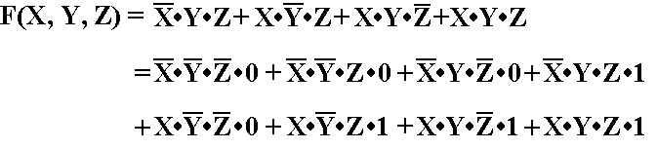

Using A 2^{N}–to–1 MUX
(page 4)
Step 4: Write the Multiplexer Equation for an 8–to–1 MUX.

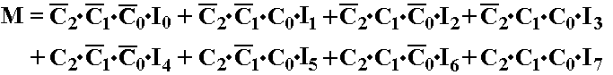

Step 5: Rewrite the equation with C₂ = X, C₁ = Y, and C₀ = Z.
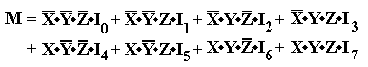
NOTE: Here I use I₀, I₁, …, I₇ as the MUX inputs because I am using X
to denote one of the Boolean variables.
Using A 2^{N}–to–1 MUX
(page 5)
Step 6: Match the two expressions
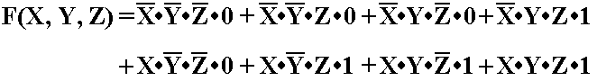
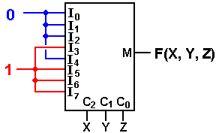
I₀ = 0 I₁ = 0 I₂ = 0 I₃ = 1
I₄ = 0 I₅ = 1 I₆ = 1 I₇ = 1

with C₂ = X, C₁ = Y, and C₀ = Z.

Using A 2^{N}–to–1 MUX
(Using either a Σ list or a Π list)
For a Σ list, connect the listed inputs to 1 and the others to 0.
For a Π list, connect the listed inputs to 0 and the others to 1.
F(X, Y, Z) = Σ(3, 5, 6, 7) = Π(0, 1, 2, 4)
We try this with a common circuit emulator, such as Multi–Media Logic,
and find that we need to think a bit more.
An Eight–to–One MUX in Multi–Media
Here is the circuit element selected in the Multi–Media Logic tool.
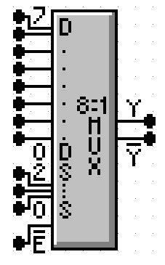
This is an 8–to–1 MUX with inputs labeled 7 through 0, or equivalently X₇ through X₀. This is expected.
The selector (control) lines are as expected; 2 through 0.
In my notes, I use M for the output of the Multiplexer. This figure uses the symbol Y (not a problem) and notes that real multiplexers also output the complement.
The only issue here is the enable. Note that the MUX is enabled low; this signal must be set to ground in order for the multiplexer to function as advertised.

Commercial Multiplexer: Enabled and Not Enabled
At top, the output is X₃. At bottom, the output is 0.
Carry–Out of a Full Adder
Here is a screen shot of my implementation of F(X, Y, Z) = Σ(3, 5, 6, 7).
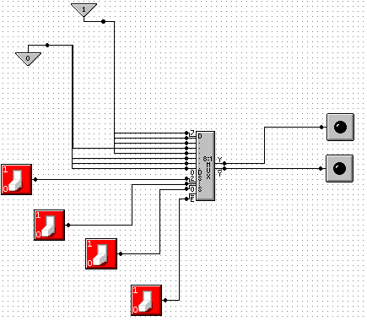
NOTE: Show simulation here.
Gray Codes: Minimal Effort Testing
Consider the above circuit with three basic inputs S₂, S₁, S₀.
How can one test all possible inputs with minimum switching?
One good answer is to use Gray Codes for input. Here are the 2–bit and 3–bit codes.
00 000
01 001
11 011
10 010
110
111
101
100
To generate an (N + 1)–bit code set from an N–bit code set.
1. Write out the N–bit codes with 0 as a prefix, then
2. Write out the N–bit codes in reverse with 1 as a prefix.
00, 01, 11, 10 becomes 000, 001, 011, 010, 110, 111, 101, and 100
Testing the Carry–Out Circuit
If the Enable switch is set to 1, the output is always 0. Y’ = 1.
Set the Enable switch to 0 and generate the following sequence.
Start with S₂ = 0, S₁ = 0, S₀ = 0. 0 0 0
Click S₀ to get 0 0 1
Click S₁ to get 0 1 1
Click S₀ to get 0 1 0
Click S₂ to get 1 1 0
Click S₀ to get 1 1 1
Click S₁ to get 1 0 1
Click S₀ to get 1 0 0

Where are the Decoders?
One will note that the Multi–Media Logic tool does not provide a decoder circuit.
Fortunately, a 1–to–2^{N} demultiplexer can be made into an N–to–2^{N} decoder.
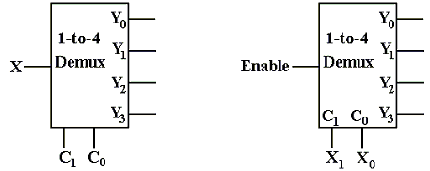
Look at the circuit to the left. The control signals C₁,C₀ select the output to receive the input X. This is exactly equivalent to a decoder.
In the circuit at right, the selected output gets the input, now called “Enable”.
For the demultiplexers we use, the other outputs get a logic 1.
We can fabricate an active low decoder.
The MUX as an Active–Low Decoder
Here is the 2–to–4 Demultiplexer as an 2–to–4 active low decoder.
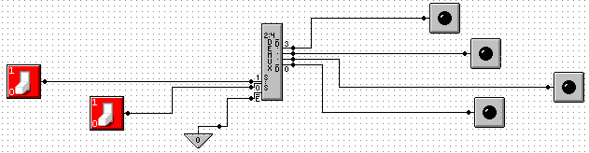
Here is an answer to one of the homework problems: use a 2–to–4 decoder for XOR.
The function is either Σ(1, 2) or Π(0, 3).
