Design with Multiplexers
Consider the following design, taken from the 5th edition of my textbook.
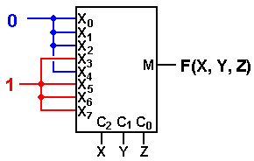
This is a correct implementation of the Carry–Out of a Full Adder.
In terms of Boolean expressions, this is F(X, Y, Z) = Σ(3, 5, 6, 7).
We try this with a common circuit emulator, such as Multi-Media Logic,
and find that we need to think about more.
An Eight–to–One MUX in Multi–Media
Here is the circuit element selected in the Multi–Media Logic tool.
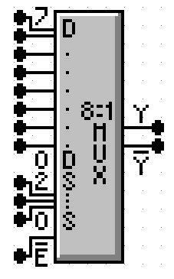
This is an 8–to–1 MUX with inputs labeled 7 through 0, or equivalently X₇ through X₀. This is expected.
The selector (control) lines are as expected; 2 through 0.
In my notes, I use M for the output of the Multiplexer. This figure uses the symbol Y (not a problem) and notes that real multiplexers also output the complement.
The only issue here is the enable. Note that the MUX is enabled low; this signal must be set to ground in order for the multiplexer to function as advertised.

Carry–Out of a Full Adder
Here is a screen shot of my implementation of F(X, Y, Z) = Σ(3, 5, 6, 7).
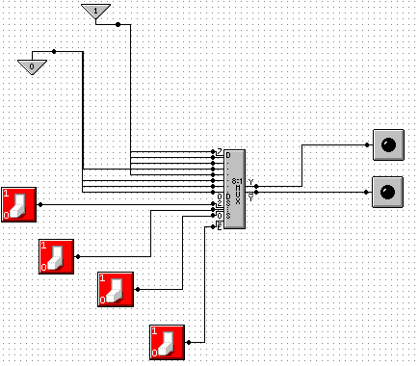
NOTE: Show simulation here.
Gray Codes: Minimal Effort Testing
Consider the above circuit with three basic inputs S₂, S₁, S₀.
How can one test all possible inputs with minimum switching?
One good answer is to use Gray Codes for input. Here are the 2–bit and 3–bit codes.
00 000
01 001
11 011
10 010
110
111
101
100
To generate an (N + 1)–bit code set from an N–bit code set.
1. Write out the N–bit codes with 0 as a prefix, then
2. Write out the N–bit codes in reverse with 1 as a prefix.
00, 01, 11, 10 becomes 000, 001, 011, 010, 110, 111, 101, and 100
Testing the Carry–Out Circuit
If the Enable switch is set to 1, the output is always 0. Y’ = 1.
Set the Enable switch to 0 and generate the following sequence.
Start with S₂ = 0, S₁ = 0, S₀ = 0. 0 0 0
Click S₀ to get 0 0 1
Click S₁ to get 0 1 1
Click S₀ to get 0 1 0
Click S₂ to get 1 1 0
Click S₀ to get 1 1 1
Click S₁ to get 1 0 1
Click S₀ to get 1 0 0

Design with Decoders
We now look at another circuit from my textbook. This shows the implementation of a Full Adder with an active high decoder and two OR gates. The outputs are:
F1 the Sum
F2 the Carry–Out
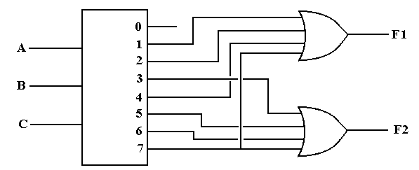
F1(A, B, C) = Σ(1, 2, 4, 7) = Π(0, 3, 5, 6)
F2(A, B, C) = Σ(3, 5, 6, 7) = Π(0, 1, 2, 4)
PROBLEM: Almost all commercial decoders are active low.
Active Low Decoders
First, let’s use 3–to–8 decoders to describe the difference between
active high and active low.
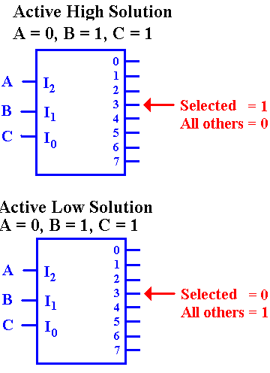
In the active–high decoder, the active output
is set to +5 volts (logic 1), while the other
outputs are set to 0 volts (logic 0).

In the active–low decoder, the active output
is set to 0 volts (logic 0), while the other
outputs are set to +5 volts (logic 1).

Enabled Low, Active Low Decoders
All commercial decoders have an enable input; most are enabled low.
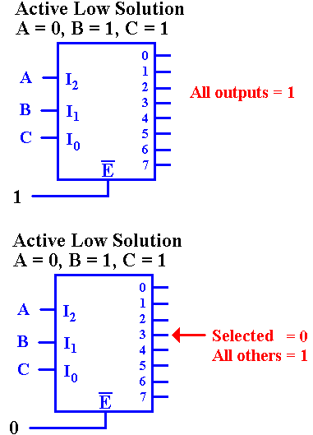
Since the decoder is enabled low, when the input
signal E’ = 1, none of the decoder outputs are active. Since the decoder is active low, this means that all of the outputs are set to logic 1 (+5 volts).

Since the decoder is enabled low, when the input signal E’ = 0, the decoder is enabled and the selected output is active. Since the decoder is active low, this means that the selected output is set to logic 0, and all other outputs are set to logic 1.

Why Active Low / Enabled Low?
This is a conjecture, but it makes sense to me.
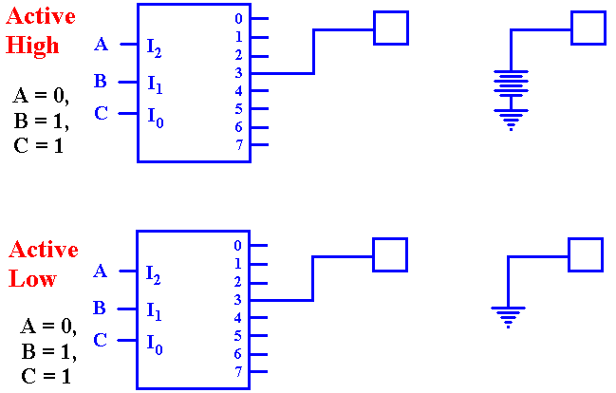
The active–high decoder is providing power to the device it enables.
The active–low decoder is just providing a path to ground for the device it enables.
It is likely that this approach yields a faster circuit.
Back To Active High: A Look At F2
Seeking a gate that outputs 1 if at least one of its inputs is 1, we are led to the OR gate.

Active Low: F2(X, Y, Z) = Π(0, 1, 2, 4)
F2 is 1 if and only if none of the outputs Y₀, Y₁, Y₂, or Y₄ are selected. Specifically, each of those outputs must be a logic 1. This leads to an AND gate implementation.
Full Adder Implemented with a 3–to–8 Decoder
The sum is at top: F(X, Y, Z) = Π(0, 3, 5, 6)
The carry–out is at bottom: F(X, Y, Z) = Π(0, 1, 2, 4)
Where are the Decoders?
One will note that the Multi–Media Logic tool does not provide a decoder circuit.
Fortunately, a 1–to–2^{N} demultiplexer can be made into an N–to–2^{N} decoder.
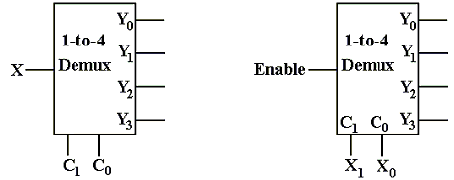
Look at the circuit to the left. The control signals C₁,C₀ select the output to receive the input X. This is exactly equivalent to a decoder.
In the circuit at right, the selected output gets the input, now called “Enable”.
For the demultiplexers we use, the other outputs get a logic 1.
We can fabricate an active low decoder.
The MUX as an Active–Low Decoder
Here is the 2–to–4 Demultiplexer as an 2–to–4 active low decoder.
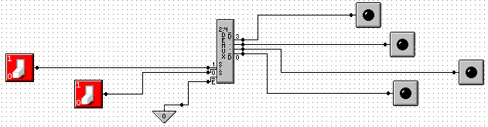
Here is an answer to one of the homework problems: use a 2–to–4 decoder for XOR.
The function is either Σ(1, 2) or Π(0, 3).
