Modern Computers (Circa 2007)
Computing machines are very common in a modern industrialized society.
The number of functions performed by these devices is almost endless.
Here is a partial list.
1. General numerical computation, involving both integers and real numbers.
2. Device automation and control.
3. Message switching, including routers and firewalls on the Internet.
4. Computer–generated graphics.
5. Graphics–based computer games.
6. Computer–enhanced video.
(How about those extra lines superimposed on football fields?)
Computers come in two broad classes:
General purpose these are adaptable to a wide variety of programs.
Special purpose these are designed for one purpose only; e.g. routers.
Special–purpose computers are usually limited to high volume markets. It is often easier to adapt a general–purpose computer to do the job.
General Purpose Computers
This course will focus on general purpose computers, also called “Stored Program Computers” or “Von Neumann Machines”.
In a stored program computer, a program and its starting data are read into the primary memory of a computer and then executed. Early computers had no memory into which programs could be stored.
The first stored program computer designed was the EDVAC, designed by John Von Neumann (hence the name), John Mauchley, and J. Presper Eckert. The
“Electronic Discrete Variable Automatic Computer” was described in a paper, published on June 30, 1945 with Von Neumann as the sole author.
The first stored program computer to become operational was the EDSAC (Electronic Delay Storage Automatic Computer), completed May 6, 1949. This was developed by Maurice Wilkes of Cambridge University in England.
The first stored program computer that contained all of the components of a modern computer was the MIT Whirlwind, first demonstrated on April 20, 1951. It was the first to use magnetic core memory.
Components of a Stored Program Computer
The four major components of a modern stored program computer are:
1. The Central Processing Unit (CPU)
2. The Primary Memory (also called “core memory” or “main memory”)
3. The Input / Output system
4. One or more system busses to allow the components to communicate.
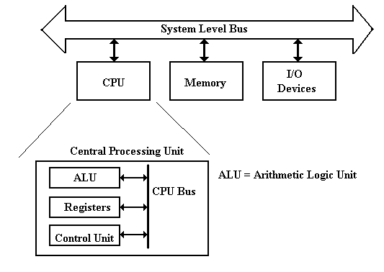
Major Components Defined
The system memory (of which this computer has 512 MB) is used for transient storage of programs and data. This is accessed much like an array, with the memory address serving the function of an array index.
The Input / Output system (I/O System) is used for the computer to save data and programs and for it to accept input data and communicate output data.
Technically the hard drive is an I/O device.
The Central Processing Unit (CPU) handles execution of the program.
It has four main components:
1. The ALU (Arithmetic Logic Unit), which performs all of the arithmetic
and logical operations of the CPU, including logic tests for branching.
2. The Control Unit, which causes the CPU to follow the instructions
found in the assembly language program being executed.
3. The register file, which stores data internally in the CPU. There are user
registers and special purpose registers used by the Control Unit.
4. A set of 3 internal busses to allow the CPU units to communicate.
A System Level Bus, which allows the top–level components to communicate.
Reality Intrudes (Part 1 of Many)
The design on the previous slide is logically correct, but IT WON’T WORK.
IT IS TOO SLOW. Problem: A single system level bus cannot handle the load.
Modern gamers demand fast video; this requires a fast bus to the video chip.
The memory system is always a performance bottleneck. We need a dedicated memory bus in order to allow acceptable performance.
Here is a refinement of the above diagram.
This design is getting closer to reality. At least, it acknowledges two of the devices requiring high data rates in access to the CPU.
Reality Intrudes (Part 2 of Many)
We now turn to commercial realities, specifically legacy I/O devices.
When upgrading a computer, most users do not want to buy all new I/O devices (expensive) to replace older devices that still function well.
The I/O system must provide a number of busses of different speeds, addressing capabilities, and data widths, to accommodate this variety of I/O devices.
Here we show the main I/O bus connecting the CPU to the I/O Control Hub (ICH), which is connected to two I/O busses:
one for slower (older) devices
one for faster (newer) devices.
The Memory Component
The memory stores the instructions and data for an executing program.
Memory is characterized by the smallest addressable unit:
Byte addressable the smallest unit is an 8–bit byte.
Word addressable the smallest unit is a word, usually 16 or 32 bits in length.
Most modern computers are byte addressable, facilitating access to character data.
Logically, computer memory should be considered as an array.
The index into this array is called the address or “memory address”.
A logical view of such a byte addressable memory might be written in code as:
Const MemSize =
byte Memory[MemSize] // Indexed 0 … (MemSize – 1)
The CPU has two registers dedicated to handling memory.
The MAR (Memory Address Register) holds the address being accessed.
The MBR (Memory Buffer Register) holds the data being written to the
memory or being read from the memory. This is sometimes
called the Memory Data Register.
The Simplistic Physical View of Memory
I call this the “linear view”, as memory is still modeled as one large linear array.
The N–bit address selects one of the 2^{N} entities, numbered 0 through (2^{N} – 1).
Read sequence: First address to MAR; command a READ.
then copy the contents of the MBR.
Write sequence: First address to MAR; data to the MBR.
then command a WRITE.
This is logically correct, but difficult to implement at an acceptable price.
Multi–Level Memory
What we want is a very large memory, in which each memory element is fabricated from very fast components. But fast means expensive.
What we can afford is a very large memory, in which each memory element is fabricated from moderately fast, but inexpensive, components.
Modern computers achieve good performance from a large, moderately fast, main memory by using two levels of cache memories, called L1 and L2. These work due to an observed property of programs, called the locality principle.
A typical arrangement would have a large L2 cache and a split L1 cache. The L1 cache has an Instruction Cache and a Data Cache.
Note that the Instruction Cache (I Cache) does not write back to the L2 cache.
Organization of Primary Memory
We turn our attention again to the primary memory. When we left it, we had a linear view with an N–to–2^{N} decoder.
We shall study decoders in a later class. At present, it should be obvious that construction of a 32–to–4,294,967,296 decoder would be very difficult.
Memory on all modern computers is obviously built from smaller chips. Each of these chips will be constructed from a number of smaller chips.
For example, a 1 GB memory might have four 256 MB memory modules.
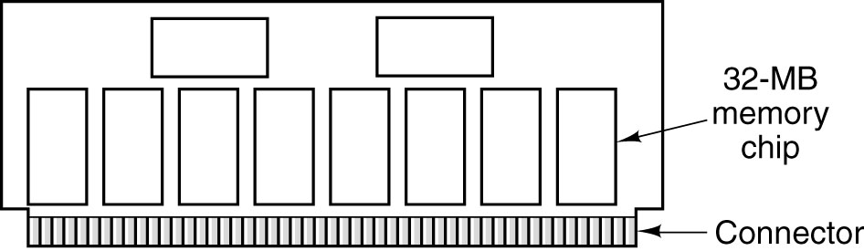
Each 32 MB chip would be organized as eight 32 Mb chips.
Each 32 Mb chip is organized as an 8,192–by–4,096 array.
Primary Memory
Also called “core memory”, “store”, or “storage”.
Beginning with the MIT Whirlwind and continuing for about 30 years, the
basic technology for primary memory involved “cores” of magnetic material.
Virtual Memory
All modern computer systems use virtual memory. At various times in the course, we shall give a precise definition, but here is the common setup.
In MS–Windows, the area of the system disk that handles virtual memory is called the paging file. My system has a 768 MB paging file.
The Central Processing Unit (CPU)
Traditionally, the CPU is considered as having four main components.
1. The Arithmetic Logic Unit
2. The three bus structure that feeds the ALU and accepts its results.
3. The control unit that interprets the machine language.
4. The register set, containing both general purpose (user) registers, and
special purpose registers. The latter include:
MAR the Memory Address Register.
MBR the Memory Buffer Register.
PC the Program Counter, pointing to the next instruction.
IR the Instruction Register, holding the current instruction.
Memory Creeps onto the CPU Chip
Modern computers, such as the P4, have placed both L1 caches and the L2 cache on the CPU chip itself. Here is a picture of the P4 chip, annotated by Intel.
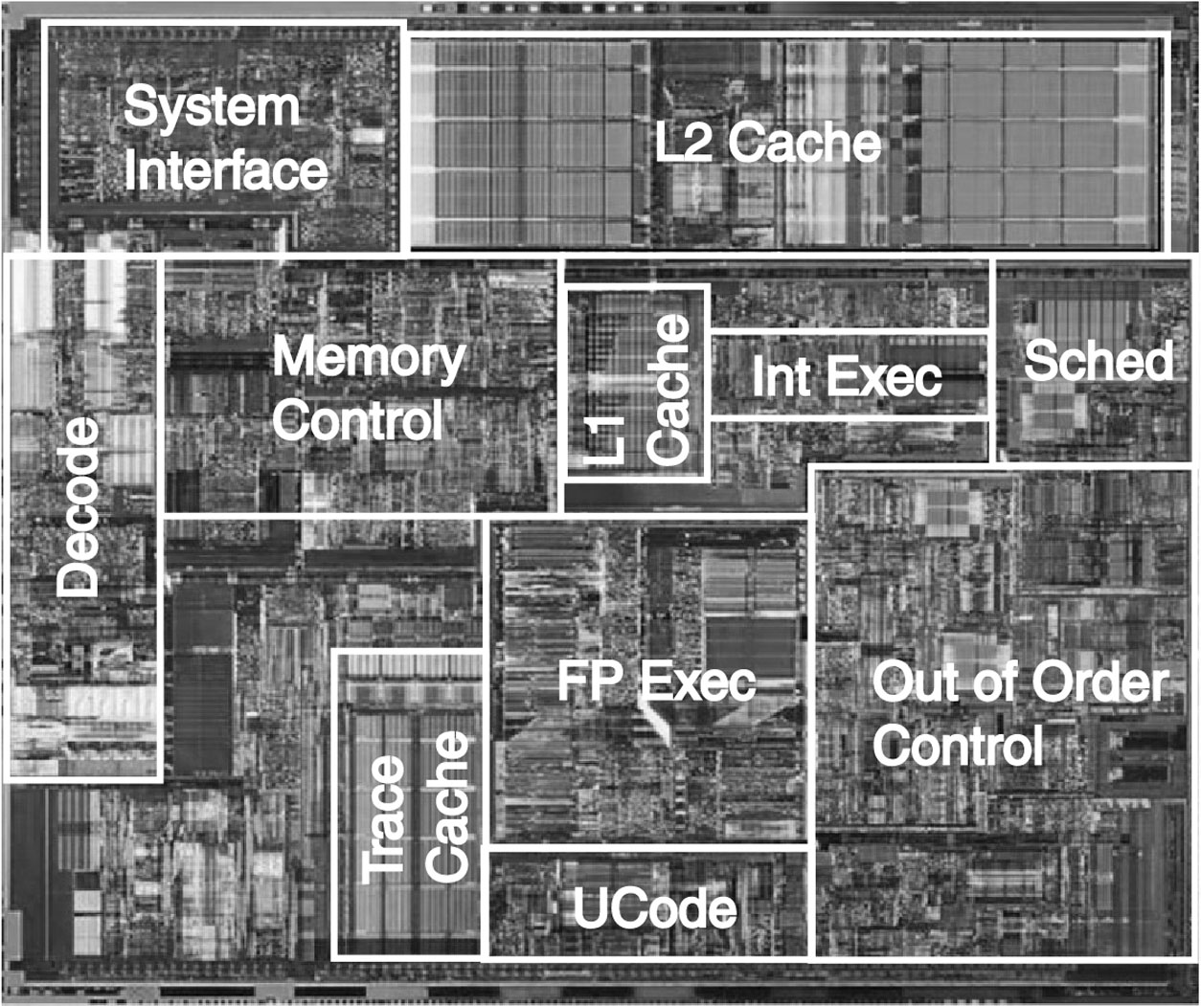
In older computers, the main difference between CPU registers and memory was that the registers were on the chip and memory was not. This no longer holds.
Memory on the CPU Chip (Part 2)
With two L1 caches (the I cache and the D cache) and the L2 cache on the CPU chip, we look for another difference to distinguish user registers from memory.
The main difference is historical. It has to do with the way that the assembly language program accesses the device.
There are register–specific instructions and memory–specific instructions.
A modern computer (Pentium series excepted) will have between 8 and 32 user registers. These store temporary results for computations.
The Pentium register set (EAX, EBX, ECX, and EDX) is rather unusual and would be cheerfully ignored were the Pentium not such an important design.
Modern computer architecture usually involves a series of design tradeoffs.
Question: Should we place more general–purpose registers on the CPU
chip or have a larger L1 Data Cache?
Answer: Each provides about the same improvement in performance.
Flip a coin or use some other criterion.
The ALU (Arithmetic Logic Unit)
The ALU performs all of the arithmetic and logical operations for the CPU.
These include the following:
Arithmetic: addition, subtraction, negation, etc.
Logical: AND, OR, NOT, Exclusive OR, etc.
This symbol has been used for the ALU since the mid 1950’s.
It shows to inputs and one output.
The reason for two inputs is the fact that many operations, such as addition and logical AND, are dyadic; that is, they take two input arguments.
Historical Summary
Reflecting on the last 60 years of the history of computing machines, we see a development constrained by the available technology and economics.
We see a constant move towards devices with
less cost and physical size
more performance and reliability (longer time between failures).
As an example, the ENIAC seldom functioned for more than a few hours continuously before it suffered a failure.
Memory technology is a good example. We have four stages.
1. No memory (ENIAC).
2. Very unreliable memory, such as mercury delay lines and Williams tubes.
3. Very reliable memory, specifically magnetic core memory.
4. Very reliable and inexpensive memory, specifically solid state devices.
We now begin a look at the computer from a logical view.

