Overview of
Computer Architecture

The IBM System/360

Edward L. Bosworth, Ph.D.
TSYS Department of Computer Science
Columbus State University
Columbus, GA
bosworth_edward@colstate.edu
The Term “Architecture”
The introduction of the IBM System/360 produced the creation and
definition of the term “computer architecture”.
According to IBM [R10]
“The term architecture is used here to describe the attributes
of a system as seen by the programmer, i.e., the conceptual
structure and functional behavior, as distinct from the
organization of the data flow and controls, the logical design,
and the physical implementation.”
The IBM engineers realized that “logical structure (as seen by the programmer)
and physical structure (as seen by the engineer) are quite different. Thus, each
may see registers, counters, etc., that to the other are not at all real entities.”
In more modern terms, we speak of the “Instruction Set Architecture”, or
ISA, of a family of computers. This isolates the logical structure of a CPU
in the family from its physical implementation.
In other words, it makes sense to speak of “programming an IBM S/370”
without specifying the model number.
Architecture, Organization, and Implementation
The basic idea behind the IBM System/360 was a family of computers that
shared the same architecture but had different organization.
For example, each of the computers in the family had 16 general purpose
32–bit registers, numbered 0 through 15. These were logical constructs.
The organization of the different models called for registers to be realized
in rather different ways.
Model 30 Dedicated storage locations in main memory
Models 40 and 50 A dedicated core array, distinct from main memory.
Models 60, 62, and 70 True data flip–flops, implemented as transistors.
In general, two models with the same organization will have the same
implementation in hardware.
The major exception to this is the pair of computers: IBM 709 and IBM 7090.
The IBM 709 and IBM 7090 share the same organization. The IBM 709 was
implemented with vacuum tubes. The IBM 7090 had the identical organization,
but was implemented with transistors.
Strict Program Compatibility
This was the driving goal of the common architecture for the IBM S/360 family.
IBM issued a precise definition for its goal that all models in the S/360 family
be “strictly program compatible”; i.e., that they implement the same
architecture. [R10, page 19].
A family of computers is defined to be strictly program compatible if and
only if a valid program that runs on one model will run on any model.
There are a few restrictions on this definition.
1. The program must be valid. “Invalid programs, i.e., those which
violate the programming manual, are not constrained to yield
the same results on all models”.
2. The program cannot require more primary memory storage or types of
I/O devices not available on the target model.
3. The logic of the program cannot depend on the time it takes to execute,
unless the program explicitly tests for event completion.
The smaller models are slower than the bigger models in the family.
More Design Goals
Here are more goals for the S/360 architecture, taken from [R_10].
1. Since computers develop into families, any proposed design would
have to lend itself to growth and to successor machines.
2. Storage capacities of more than the commonly available
32,000 words would be required.
3. Certain types of problems require floating–point
word length of more than 36 bits.
4. Since the largest servicing problem is diagnosis of malfunction,
built–in hardware fault–locating aids are essential to reduce down–times.
5. The general addressing system would have to be able to refer to small
units of bits, preferably the unit used for characters.
6. The design had to yield a range of models with internal performance
“varying from approximately that of the IBM 1401 to well beyond
that of the IBM 7030 (Stretch)”.

Overview of Computer Architecture
Each computer in the IBM S/360 family is a Stored Program Computer, or
“von Neumann Machine”. The top–level logical architecture is as follows.
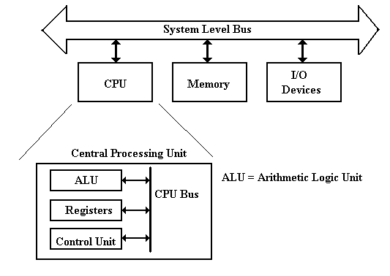
Recall that the actual architecture of a real machine will be somewhat different,
due to the necessity of keeping performance at an acceptable level.
The Fetch–Execute Cycle
This cycle is the logical basis of all stored program computers.
Instructions are stored in memory as machine language.
Instructions are fetched from memory and then executed.
The common fetch cycle can be expressed in the following control sequence.
MAR ← PC. // The PC contains the address of the instruction.
READ. // Put the address into the MAR and read memory.
IR ← MBR. // Place the instruction into the MBR.
This cycle is described in many different ways, most of which serve to highlight
additional steps required to execute the instruction. Examples of additional
steps are: Decode the Instruction, Fetch the Arguments, Store the Result, etc.
A stored program computer is often called a “von Neumann Machine”
after one of the originators of the EDVAC.
This Fetch–Execute cycle is often called the “von Neumann bottleneck”, as
the necessity for fetching every instruction from memory slows the computer.
The Dynamic–Static Interface
In order to understand the DSI, we must place it within the context of a compiler for a
higher–level language. Although most compilers do not emit assembly language, we
shall find it easier to under the DSI if we pretend that they do.
What does the compiler output? There are two options:
1. A very simple assembly language. This requires a sophisticated compiler.
2. A more complex assembly language. This may allow a simpler compiler,
but it requires a more complex control unit.
The ALU (Arithmetic Logic Unit)
The ALU performs all of the arithmetic and logical operations for the CPU.
These include the following:
Arithmetic: addition, subtraction, negation, etc.
Logical: AND, OR, NOT, Exclusive OR, etc.
This symbol has been used for the ALU since the mid 1950’s.
It shows two inputs and one output.
The reason for two inputs is the fact that many operations, such as addition and
logical AND, are dyadic; that is, they take two input arguments.
For operations with one input, such as logical NOT, one of the input busses will
be ignored and the contents of the other one used.
The Central Processing Unit (CPU)
The CPU has four main components:
1. The Control Unit (along with the IR) interprets the machine language instruction
and issues the control signals to make the CPU execute it.
2. The ALU (Arithmetic Logic Unit) that does the arithmetic and logic.
3. The Register Set (Register File) that stores temporary results related to the
computations. There are also Special Purpose Registers used by the Control Unit.
4. An internal bus structure for communication.
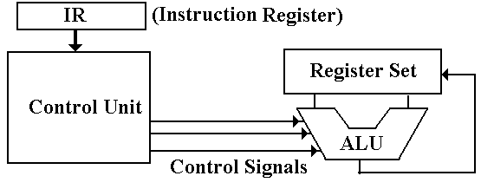
The function of the control unit is to decode the binary machine word in the IR
(Instruction Register) and issue appropriate control signals, mostly to the CPU.
Design of the Control Unit
There are two related issues when considering the design of the control unit:
1) the complexity of the Instruction Set Architecture, and
2) the microarchitecture used to implement the control unit.
In order to make decisions on the complexity, we must place the role of the control unit
within the context of what is called the DSI (Dynamic Static Interface).
The ISA (Instruction Set Architecture) of a computer is the set of assembly language
commands that the computer can execute. It can be seen as the interface between the
software (expressed as assembly language) and the hardware.
A more complex ISA requires a more complex control unit.
At some point in the development of computers, the complexity of the control unit
became a problem for the designers. In order to simplify the design, the developers of the
control unit for the IBM–360 elected to make it a microprogrammed unit.
This design strategy, which dates back to the Manchester Mark I in the early 1950’s,
turns the control unit into an extremely primitive computer that interprets the contents
of the IR and issues control signals as appropriate.
The Micro–Programmed Control Unit
In a micro–programmed control unit, the control signals correspond to bits in a
micro–memory, which are read into a micro–MBR and emitted.
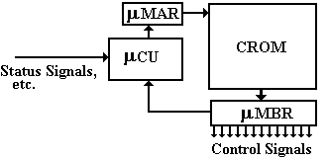
The micro–control unit ( μCU )
1) places an address into the micro–Memory Address Register ( μMAR ),
2) the control word is read from the Control Read–Only Memory (CROM),
3) into the micro–Memory Buffer Register, and
4) the control signals are issued.
The Micro–Programmed Control Unit
The goal of the System/360 micro–programmed control unit [R_51] was to “help
design a fixed instruction set capable of reaching across a compatible line
of machines in a wide range of performances”.
The same authors [R_51] go on to note that “the use of microprogramming
has, however, made it feasible for the smaller models of SYSTEM/360 to
provide the same comprehensive instruction set as the larger models”.
Tucker [R_51] notes that “There has been much talk, but little success, in
providing higher–level languages for micro–programs. There seem to be a
number of factors which contribute to this. Primarily, almost no inefficiency
is tolerated in micro–programs”.
Tucker goes on to speak of the “micro–programmer who can justifiably spend
hours trying to squeeze a cycle out of his code and who may make changes
to the data path to do so”.
Tucker notes that the System/360 Model 30 is micro–programmed to run
IBM 1401 programs in their native form. This was an additional inducement
to those owning an IBM 1401 to “move up”.
Handling Legacy Software
During the introduction of the System/360, IBM underestimated the large customer
investment in legacy software especially at the assembly language level.
In order to prevent mass defection of customers to Honeywell, which was offering its
model H–200 that would run IBM 1401 assembly language programs, IBM was forced
to develop some sort of simulator to run on the System/360.
It was understood that a software simulator of the IBM 1401 running on any System/360
model would be unacceptably slow.
IBM was “spared mass defection of former customers” when engineers working on the
Model 30 suggested the use of an extra control store on the micro–programmed control
unit to allow the Model 30 to execute IBM 1401 instructions in native mode [R_62].
Stuart Tucker and Larry Moss led the effort to provide the ability on the System/360
Model 30 to execute native mode software for both the IBM 1401 and IBM 700 series.
Moss termed their work as “emulation” [R_63].
The emulators they designed worked well enough so that many customers never
converted legacy software and instead ran it for many years on System/360
hardware using emulation. This was a great marketing success for IBM.
The Register File
There are two sets of registers, called “General Purpose” and “Special Purpose”.
The origin of the register set is simply the need to have some sort of memory on the
computer and the inability to build what we now call “main memory”.
When reliable technologies, such as magnetic cores, became available for main memory,
the concept of CPU registers was retained.
Registers are now implemented as a set of flip–flops physically located on the CPU chip.
These are used because access times for registers are two orders of magnitude faster than
access times for main memory: 1 nanosecond vs. 80 nanoseconds.
General Purpose Registers
These are mostly used to store intermediate results of computation. The System/360
architecture calls for sixteen 32–bit registers, numbered 0 through 15. While these
might be called “general purpose”, a few of the registers have dedicated uses.
Registers 0 and 1 can be used as temporary registers, but calls to supervisor routines
will destroy their contents. Register 0 cannot be used as a base register or index register.
Register 2 can be used as a temporary and possibly as a base register.
The TRT (Translate and Test) instruction will change the value of this register.
Registers 13, 14, and 15 are used by the control programs and subprograms.
More on the General Purpose Registers
There are two important concepts discussed in the previous slide.
1. That only registers 3 through 12 of the sixteen registers are to be viewed
as truly general purpose.
2. That the use of some hardware resources evolves by consent of the software
designers. There is nothing in the hardware architecture that restricts the
use of registers 0, 1, 13, 14, and 15.
The restricted use of these registers is a design decision by the system
programmers to facilitate the design of system software.
These ten registers, R3 – R12, can be used for binary integer arithmetic, and for
the computation of the effective address of a memory storage element.
The System/360 and subsequent machines use base–displacement addressing with
an optional indexing.
The index value is stored in the index register, a general purpose register that
is being used as an index. We shall discuss indexing later.
A base address is stored in the base register, a general purpose register that
is being used as the base register. We shall discuss base registers later.
The Register File
Special Purpose Registers
These are often used by the control unit in its execution of the program.
IR the Instruction Register. This holds the machine language version of
the instruction currently being executed.
MAR the Memory Address Register. This holds the address of the memory word
being referenced. All execution steps begin with PC → MAR.
MBR the Memory Buffer Register, also called MDR (Memory Data Register).
This holds the data being read from memory or written to memory.
PSW the Program Status Word, contains a collection of logical bits that
characterize the status of the program execution.
Bit 12 of the PSW is the ASCII bit; the S/360 will use ASCII if this is set.
The feature was never used; in the S/370 and later it has another meaning.
PC the Program Counter, so called because it does not count anything.
It is also called the IP (Instruction Pointer), a much better name.
The PC points to the memory location of the instruction to be executed next.
The System/360 architecture calls for this to be stored in the 24 low–order
bits of the 64–bit PSW.
Design Decisions: The Data Format
Apparently, there were two main options for the size of the basic storage cell.
2^{N} the size would be 4, 8, 16, 32, or 64 bits.
3•2^{N} the size would be 6, 12, 24, or 48 bits.
Character size, 6 vs. 4/8
At the time, the character set of existing IBM computers comprised 64 characters,
inherited from the punch card codes of the day.
Decimal digits required 4 bits to encode; general alphanumeric characters required 6 bits.
On option was to use 6 bits to encode everything. This wasted 2 bits for each
encoding of a decimal digit.
Another option was 4 bits for digits and 8 bits for alphanumeric characters,
thus wasting 2 bits for every alphanumeric character.
The option of 4 bits for digits and 6 bits for alphanumeric characters would require the
basic addressable unit to be a multiple of 12 bits. This was thought overly complex.
In the end, all of the “6 options” were rejected, because the designers realized that
committing to a 6–bit character encoding was “short–sighted” [R_10].
IBM 029 Punch Card Codes
Here is a card punched with each of the 64 characters available under this format.
Note the lack of lower case letters; the IBM Mainframe assembler reflects this.
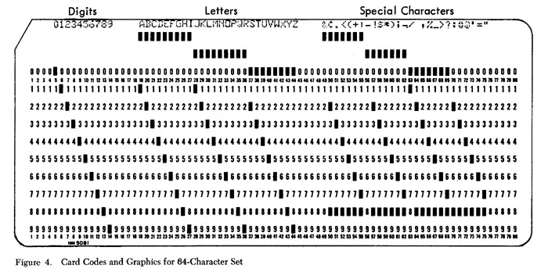
This is the complete set of characters to which the designers thought it would be
“short sighted” to commit. They held out for a larger character set.
Data Types
We must recall that, in the world of the IBM System/360, there are three
major classes of numeric data.
1. Binary Integer Data.
This format calls for use of two’s–complement binary integers, in
lengths of 16 or 32 bits.
A variant used in addressing calls for 12–bit unsigned integers.
2. Packed Decimal Data
This is also called “decimal data”. It calls for the use of (N + 1) hexadecimal
digits to store an N–digit decimal number in (N + 1)/2 bytes.
Remember that N must be an odd integer.
I use the term “fixed point” to reference data of this sort. IBM occasionally seems
to expand the term “fixed point” to include binary integer data.
3. Floating Point Data
These are real numbers without a fixed decimal point.
Floating–Point Arithmetic
Earlier IBM models had used 48–bit representations of all floating–point numbers.
The choice for the S/360 family was narrowed to two options [R_10]:
1. One representation based on the use of 48 bits.
2. Two representations: 32 bits (single precision) and 64 bits (double precision).
The article noted a lack of experimental data on the required precision.
IBM decided to offer both single precision and double precision.
The IBM System/370 apparently introduced a third format, extended precision.
The rationale for the choice is stated in [R_10].
“The user of the large models is expected to employ 64–bit words most
of the time. The user of the smaller models will find the 32–bit length
advantageous in most of his work. All floating–point models have
both lengths and operate identically”.
We shall study the details of the two floating–point implementations at a later time.
Integer Arithmetic
As we shall see later, the IBM System/360 provides for two integer sizes:
half words (16 bits) and full words (32 bits).
The designers had to choose the method for representing negative integers.
The two’s–complement method was chosen.
In addition to the obvious advantage of a single representation of zero, the
designers make a number of claims for the superiority of two’s–complement.
1. Its utility in address arithmetic, “particularly in the large models, where
address arithmetic has its own hardware” rather than sharing the ALU.
2. The simplification of the indexing hardware for address computations.
3. The claim that the smaller models, which used bit–serial arithmetic,
would compute more efficiently with two’s–complement integers.
4. The fact that conversion from floating–point to integer representation
involves “truncation … in the same direction”.
Decimal Data
The choice of format for decimal data is explained as follows [R_10],
“The established commercial rounding convention made the use
of complement notation awkward for decimal data; therefore,
absolute–value–plus–sign is used here”.
As we have seen, the hexadecimal digit D is used for negative numbers and
the hexadecimal digit C for non–negative numbers.
As opposed to binary integer data, which comes in fixed sizes, the designers
of the System/360 opted for variable–length decimal fields.
“Since the fields of business records vary substantially in length,
coding efficiency (and hence tape speed, file capacity, CPU speed, etc.)
can be gained by operating directly on variable–length fields”.
Note the concern for speed in reading data from magnetic tapes.
The designers noted that a fixed–length format might be preferable for larger models
in the series, as they would be expected to have a greater memory capacity.
The designers give two reasons for the choice of variable–length format.
1. The small commercial users would expect the format, and
2. The larger systems are usually I/O limited, so the decreased CPU efficiency
does not present a bottleneck.
Decimal Accumulators vs. Storage–To–Storage Operations
The System/360 family architecture provides a set of registers for integer data.
The designers then faced the option of creating a special register set for decimal
data. Note that the 32–bit (4 byte) general purpose registers would not work, as
they would limit the decimal numbers to seven digits each.
The packed decimal format specified for the System/360 and later calls for no
more than 31 decimal digits (16 bytes) in the Packed Decimal Format.
One choice would be to create a number of 128–bit (16 byte) registers specifically
for packed decimal arithmetic. The article calls these “decimal accumulators”.
There are a number of reasons cited for the decision not to use decimal accumulators.
1. “For the smaller model, using core storage for local registers, addition to an
accumulator is no faster than addition to a programmer–specified location”.
2. In the decimal accumulator model, “addition of two arbitrary operands and
storage of the result becomes LOAD, ADD, STORE, however, and this
operation is substantially slower for the smaller models than the MOVE ADD
sequence appropriate to storage–storage operation”.
3. Business arithmetic “rarely occur in strings [sequences of execution] where
intermediate results are profitably held in accumulators”.
ASCII vs. EBCDIC
It is a little–known fact that the early System/360 models could be run in either
ASCII or EBCDIC mode. As it was very rare, the ASCII mode has been dropped.
The designers of the System/360 give some good reasons against “the adoption of
ASCII as the only internal code for System/360”.
To quote the designers of the System/360
“The reasons against such exclusive adoption was the widespread use of the
BCD code derived from and easily translated to the IBM [029] card code”.
Note that they argue only against the exclusive adoption of ASCII.

Consider the IBM 029 punch codes and compare them to the EBCDIC.
Character | EBCDIC | Punch Card Codes
0 through 9 | F0 through F9 | 0 through 9
A through I | C1 through C9 | 12–1 through 12–9
J through R | D1 through D9 | 11–1 through 11–9
S through Z | E2 through E9 | 0–2 through 0–9

Memory Timings
Memory Access Time
Defined in terms of reading from memory. It is the time between the address
becoming stable in the MAR and the data becoming available in the MBR.
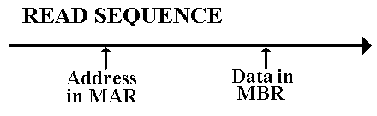
Memory Cycle Time
Less used, this is defined as the minimum time between two independent
memory accesses.
Two Components of Memory Timings
These are 1) the time to decode the memory address so that the correct cell is
addressed, and 2) the time to access the addressed cell.
The System/360 Memory Descriptions
This table shows the range of memory capacities and performance found in
the original family of the System/360.
In this table, memory performance is characterized by cycle time, which is the
minimum time between two independent writes to the same memory unit.
Model | Capacity | Actual Memory  Word Size | Cycle Time
30 | 8 to 64 KB | 8 bits | 2.0 μsec
40 | 16 to 256 KB | 16 bits | 2.5 μsec
50 | 32 to 256 KB | 32 bits | 2.0 μsec
60 | 128 to 512 KB | 64 bits | 2.0 μsec
62 | 256 to 512 KB | 64 bits | 1.0 μsec
70 | 256 to 512 KB | 64 bits | 1.0 μsec
Consider the fact that the Assembler had to be run on a System/360 – Model 30.
This required that the Assembler execute in a very small amount of memory.
As a result, the Assembler is not very sophisticated, and the structure required
of standard assembly language programs is rather rigid.
Word Addressing in a Byte Addressable Machine
Each 8–bit byte has a distinct address.
A 16–bit half–word at address Z contains bytes at addresses Z and Z + 1.
A 32–bit full–word at address Z contains bytes at addresses
Z, Z + 1, Z + 2, and Z + 3.
Note that assembly language refers to addresses, rather than variables. We just
pretend to be handling variables; these are a construct of high–level languages.
There are two strategies for storing a multiple–byte entry in a byte–addressable
computer. Following a story in Gulliver’s Travels (not a children’s book),
we call these strategies “Big Endian” and “Little Endian”.
The IBM System/360 assembler (the two variants are called “Assembler H”
and “HLASM”) will align all data storage as follows:
16–bit half words are stored at even addresses,
32–bit full words are stored at addresses that are multiples of 4, and
64–bit double words are stored at addresses that are multiples of 8.
Big–Endian vs. Little–Endian Addressing
The value in the register is 0x01020304; in IBM notation it is X’01020304’.

Address Big-Endian Little-Endian
Z 01 04
Z + 1 02 03
Z + 2 03 02
Z + 3 04 01

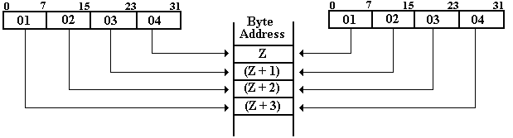
Example: “Core Dump” at Address 0x200
Note: Powers of 256 are 256⁰ = 1, 256¹ = 256,
256² = 65536, 256³ = 16,777,216
Suppose one has the following memory map as a result of a core dump.
The memory is byte addressable.
Address | 0x200 | 0x201 | 0x202 | 0x203
Contents | 02 | 04 | 06 | 08
What is the value of the 32–bit long integer stored at address 0x200?
This is stored in the four bytes at addresses 0x200, 0x201, 0x202, and 0x203.
Big Endian: The number is 0x02040608. Its decimal value is
2•256³ + 4•256² + 6•256¹ + 8•1 = 33,818,120
Little Endian: The number is 0x08060402. Its decimal value is
8•256³ + 6•256² + 4•256¹ + 2•1 = 134,611,970.
NOTE: Read the bytes backwards, not the hexadecimal digits.
Example 2: “Core Dump” at Address 0x200
Note: Powers of 256 are 256⁰ = 1, 256¹ = 256,
256² = 65536, 256³ = 16,777,216
Suppose one has the following memory map as a result of a core dump.
The memory is byte addressable.
Address | 0x200 | 0x201 | 0x202 | 0x203
Contents | 02 | 04 | 06 | 08
What is the value of the 16–bit integer stored at address 0x200?
This is stored in the two bytes at addresses 0x200 and 0x201.
Big Endian The value is 0x0204.
The decimal value is 2•256 + 4 = 516
Little Endian: The value is 0x0402.
The decimal value s 4•256 + 2 = 1,026
Note: The bytes at addresses 0x202 and 0x203 are not part of this
16–bit integer.
Input/Output System
The System/360 designers opted for a uniform logical architecture for I/O and
not for a uniform method of implementation.
The smaller models were designed to use the CPU hardware for I/O functions.
The larger models were designed to use independent execution units, called
“I/O Channels” for I/O. Each I/O Channel could operate concurrently with the
CPU and with any other I/O Channel.
The designers note that “such large–machine channels often each contain
more components than an entire small system”.
The System/360 architecture calls for the Channel to be an independently
operating entity, without regard to its actual implementation.
The CPU creates a “channel program”, which comprises a small number of
“channel commands” (SEARCH, READ, WRITE, or READ FOR CHECK).
In the smaller System/360 models, the Channel is a logical device, and “the flow
of data and control information is time–shared between the CPU and the channel
function”. The Channel is viewed as a “conceptual entity”.
On the larger systems, the Channel is implemented with distinctly separate hardware.
The System/360 Model 40 from 1964
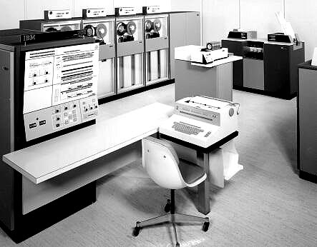
This is a picture of one of the original S/360 smaller models.
The System/360 Model 91 from 1968
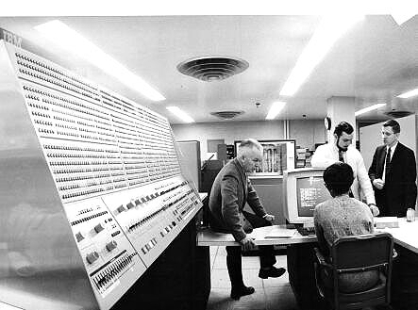
I believe that this model is the largest S/360 built. It was rated at 16.6 MIPS.
The System/360 Model 91 from 1968
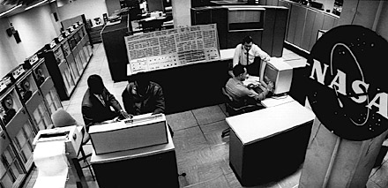
This is a Model 91 at NASA’s Goddard Space Flight Center
Installing a System/360 Model 91
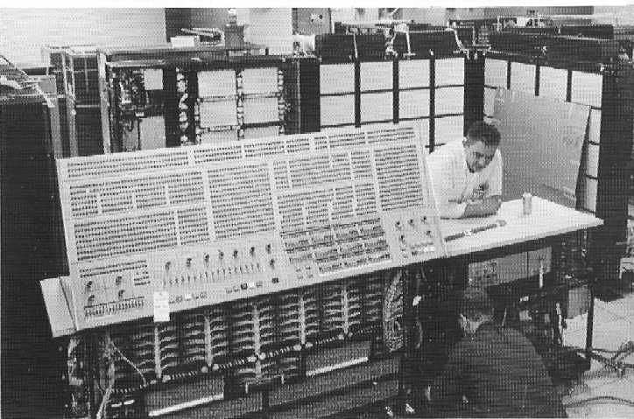
This shows a 1969 installation at Columbia in New York City
A Smaller S/360: The Model 22 in 1971
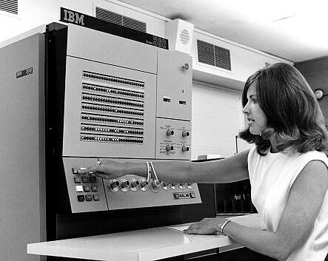
Again, note the omnipresent control panel.
A Typical System/370 Installation
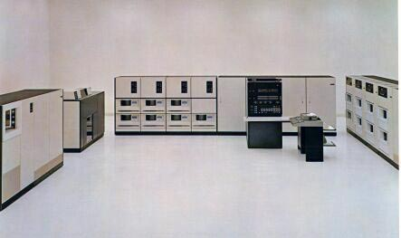
Note the large number of disk drives.

The Z–Series 990
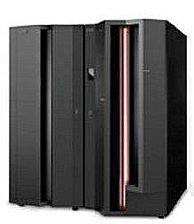
The machine we run on probably looks like this one.
References
NOTE: The reference numbers in this set of slides are those from the
original textbook. For that reason, they are out of order.
R_11 Mark D. Hill, Norman P. Jouppi, & Gurindar S. Sohi, Readings in Computer
Architecture, Morgan Kaufmann Publishers, 2000, ISBN 1 – 55860 – 539 – 8.
R_10 G. M. Amdahl, G. A. Blaauw, & F. P. Brooks, Architecture of the IBM
System/360, IBM Journal of Research and Development, April 1964.
Reprinted in R_11.
R_12 D. W. Anderson, F. J. Sparacio, R. M. Tomasulo, The IBM System/360
Model 91: Machine Philosophy and Instruction–Handling,
IBM Journal of Research and Development, January 1967. Reprinted in R_11.
R_46 C. J. Bashe, W. Buchholz, et. al., The Architecture of IBM’s Early
Computers, IBM J. Research & Development, Vol. 25(5),
pages 363 – 376, September 1981.
R50 P. M. Davies, Readings in Microprogramming, IBM Systems Journal, 1972
(Number 1), pages 16 – 40.
R_51 S. G. Tucker, Microprogram Control for System/360, IBM Systems Journal,
Volume 6, No. 4 (1967), pages 222 – 241.
R_62 M.A. McCormack, T.T. Schansman, and K.K. Womack, “1401 Compatibility
Feature on the IBM System/360 Model 30,” Communications of the ACM,
v. 8, n. 12, 1965, pp. 773-776.
R_63 S.G. Tucker, "Emulation of Large Systems," Communications of the ACM,
v. 8, n. 12, 1965, pp. 753-761.
Web Sites of Interest
R_45 http://www–03.ibm.com/ibm/history/exhibits/
R_41 http://www.columbia.edu/acis/history/

