Chapter 28: Virtual Storage Access Method (VSAM)
Author’s Note: This chapter is copied almost verbatim from the material in
Chapter 19 of the textbook by Peter Abel. It is used by permission.
Virtual Storage Access Method (VSAM) is a relatively recent file organization method
for users of IBM OS/VS and DOS/VS. VSAM facilitates both sequential and random
processing and supplies a number of useful utility programs.
The term file is somewhat ambiguous since it may reference an I/O device or the records
that the device processes. To distinguish a collection of records, IBM OS literature uses
the term data set. VSAM provides three types of data sets:
1. Key-sequenced Data Set (KSDS). KSDS maintains records in sequence of key, such as
employee or part number, and is equivalent to indexed sequential access method (ISAM).
2. Entry-sequenced Data Set (ESDS). ESDS maintains records in the sequence in which
they were initially entered and is equivalent to sequential organization.
3. Relative-Record Data Set (RRDS). RRDS maintains records in order of relative record
number and is equivalent to direct file organization.
Both OS/VS and DOS/VS handle VSAM the same way and use similar support programs
and macros, although OS has a number of extended features.
Thorough coverage of assembler VSAM would require an entire textbook. However, this
chapter supplies enough information to enable you to code programs that create, retrieve,
and update a VSAM data set. For complete details, see the IBM Access Methods Services
manual and the IBM DOS/VSE Macros or OS/VS Supervisor Services manuals.
In the table below, RBA stands for “Relative Byte Address”, the byte’s displacement
from the start of the data set.
Feature | Key–Sequenced | Entry–Sequenced | Relative–Record
 | KSDS | ESDS | RRDS
Record sequence | By key | In sequence in  which entered | In sequence of  relative record  number
Record length | Fixed or variable | Fixed or variable | Fixed only
Access of records | By key via  index or RBA | By RBA | By relative  record number
Change of address | Can change record  RBA | Cannot change  record RBA | Cannot change  relative record  number
New records | Distributed free  space for records | Space at end of  data set. | Empty slot in  data set.
Recovery of space | Reclaim space if  record is deleted. | No delete, but can  overwrite old record. | Can reuse  deleted space.
Figure 28–1 Features of VSAM organization methods
CONTROL INTERVALS
For all three types of data sets, VSAM stores records in groups (one or more) of control
intervals. You may select the control interval size, but if you allow VSAM to do so, it
optimizes the size based on the record length and the type, of disk device being used. The
maximum size of a control interval is 32,768 bytes. At the end of each control interval is
control information that describes the data records:
Rec–1 | Rec–2 | Rec–3 | …. | Control Information
A control interval contains one or more data records, and a specified number of control intervals comprise a control area. VSAM addresses a data record by relative byte address (RBA)-its displacement from the start of the data set. Consequently, the first record of a data set is at RBA 0, and if records are 500 bytes long, the second record is at RBA 500.
The list in Fig. 28–1 compares the three types of VSAM organizations.
ACCESS METHOD SERVICES (AMS)
Before physically writing (or "loading") records in a VSAM data set, you first catalog its
structure. The IBM utility package, Access Method Services (AMS), enables you to
furnish VSAM with such details about the data set as its name, organization type, record
length, key location, and password (if any). Since VSAM subsequently knows the
physical characteristics of the data set, your program need not supply as much detailed
information as would a program accessing an ISAM file.
The following describes the more important features of AMS. Full details are in the IBM
OS/VS and DOS/VS Access Methods Services manual. You catalog a VSAM structure
using an AMS program named IDCAMS, as follows:
OS: //STEP EXEC PGM=IDCAMS
DOS: //EXEC IDCAMS,SIZE=AUTO
Immediately following the command are various entries that DEFINE the data set. The
first group under CLUSTER provides required and optional entries that describe all the
information that VSAM must maintain for the data set. The second group, DATA, creates
an entry in the catalog for a data component, that is, the set of all control area and
intervals for the storage of records. The third group, INDEX, creates an entry in the
catalog for a KSDS index component for the handling of the KSDS indexes.
Figure 28–2 provides the most common DEFINE CLUSTER entries. Note that to
indicate continuation, a hyphen (–) follows every entry except the last. The following
notes apply to the figure.
Note: SYMBOL MEANING
[ ] Optional entry, may be omitted
{ } Select one of the following options
( ) You must code these parentheses
| "or", indicates one of the choices listed in the brackets
{A | B} means to select either A or B
Cluster Level
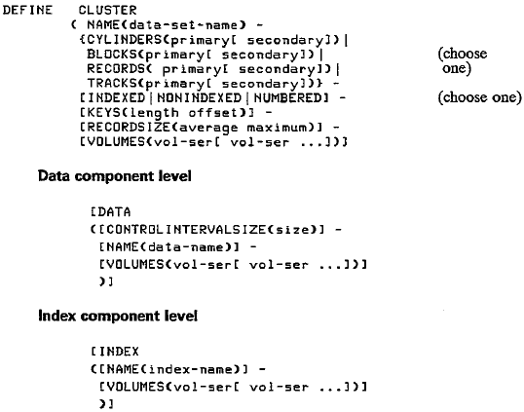
Figure 28–2 Entries for defining a VSAM data set
• DEFINE CLUSTER (abbreviated DEF CL) provides various parameters all contained
within parentheses.
• NAME is a required parameter that supplies the name of the data set. You can code
the name up to 44 characters with a period after each 8 or fewer characters, as
EMPLOYEE.RECORDS.P030. The name corresponds to job control, as follows:
OS: //FILEVS DD DSNAME=EMPLOYEE.RECORDS.P030 ...
DOS: // DLBL FILEVS,'EMPLOYEE.RECDRDS.P030',0,VSAM
The name FILEVS in this example is whatever name you assign to the file definition
(ACB) in your program, such as
filename ACB DDNAME=FILEVS
• BLOCKS. You may want to load the data set on an FBA device (such as 3310 or
3370) or on a CKD device (such as 3350 or 3380). For FBA devices, allocate the
number of 512–byte BLOCKS for the data set. For CKD devices, the entry
CYLINDERS (or CYL) or TRACKS allocates space. The entry RECORDS allocates
space for either FBA or CKD. In all cases, indicate a primary allocation for a
generous expected amount of space and an optional secondary allocation for
expansion if required.
• Choose one entry to designate the type of data set: INDEXED designates
key–sequenced, NONINDEXED is entry–sequenced, and NUMBERED is
relative–record.
• KEYS for INDEXED only defines the length (from 1 to 255) and position of the key
in each record. For example, KEYS (6 0) indicates that the key is 6 bytes long
beginning in position 0 (the first byte).
• RECORDSIZE (or RECSZ) provides the average and maximum lengths in bytes of
data records. For fixed–length records and for RRDS, the two entries are identical.
For example, code (120b120) for l20–byte records.
• VOLUMES (or VOL) identifies the volume serial number(s) of the DASD volume(s)
where the data set is to reside. You may specify VOLUMES at any of the three
levels; for example, the DATA and INDEX components may reside on different
volumes.
DEFINE CLUSTER supplies a number of additional specialized options described in the IBM AMS manual.
ACCESSING AND PROCESSING
VSAM furnishes two types of accessing, keyed and addressed, and three types of
processing, sequential, direct, and skip sequential. The following chart shows the legal
accessing and processing by type of organization:
Type | Keyed Access | Addressed Access
KSDS | Sequential  Direct  Skip sequential | Sequential  Direct
ESDS |  | Sequential  Direct
RRDS | Sequential  Direct  Skip sequential
In simple terms, keyed accessing is concerned with the key (for KSDS) and relative
record number (for RRDS). For example, if you read a KSDS sequentially, VSAM
delivers the records in sequence by key (although they may be in a different sequence
physically).
Addressed accessing is concerned with the RBA. For example, you can access a record in
an ESDS using the RBA by which it was stored. For either type of accessing method, you
can process records sequentially or directly (and by skip sequential for keyed access).
Thus you always use addressed accessing for ESDS and keyed accessing for RRDS and
may process either type sequentially or directly. KSDS, by contrast, permits both keyed
access (the normal) and addressed access, with both sequential and direct processing.
KEY–SEQUENCED DATA SETS
A key-sequenced data set (KSDS) is considerably more complex than either ESDS or
RRDS but is more useful and versatile. You always create ("load") a KSDS in ascending
sequence by key and may process a KSDS directly by key or sequentially. Since KSDS
stores and retrieves records according to key, each key in the data set must be unique.
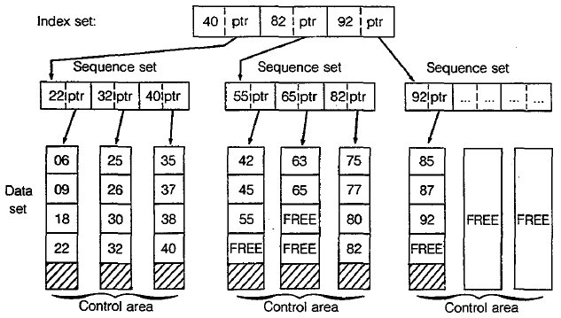
Figure 28–3 Key–sequenced organization
'Figure 28–3 provides a simplified view of a key-sequenced data set. The control
intervals that contain the data records are depicted vertically, and for this example three
control intervals comprise a control area. A sequence set contains an entry for each
control interval in a control area. Entries within a sequence set consist of the highest key
for each control interval and the address of the control interval; the address acts as a
pointer to the beginning of the control interval. The highest keys for the first control area
are 22, 32, and 40, respectively. VSAM stores each high key along with an address
pointer in the sequence set for the first control area.
At a higher level, an index set (various levels depending on the size of the data set)
contains high keys and address pointers for the sequence sets. In Fig. 28–3, the highest
key for the first control area is 40. VSAM stores this value in the index set along with
an address pointer for the first sequence.
When a program wants to access a record in the data set directly, VSAM locates the
record first by means of the index set and then the sequence set. For example, a program
requests access to a record with key 63. VSAM first checks the index set as follows:
RECORD KEY INDEX SET ACTION
63 40 Record key high, not in first control area.
63 82 Record key low, in second control area.
VSAM has determined that key 63 is in the second control area. It next examines the
sequence set for the second control area to locate the correct control interval.
These are the steps:
RECORD KEY SEQUENCE SET ACTION
63 55 Record key high, not in
first control interval.
63 65 Record key low, in second control interval.
VSAM has now determined that key 63 is in the second control interval of the second
control area. The address pointer in the sequence set directs VSAM to the correct control
interval. VSAM then reads the keys of the data set and locates key 63 as the first record
that it delivers to the program.
Free Space
You normally allow a certain amount of free space in a data set for VSAM to insert new
records. When creating a key–sequenced data set, you can tell VSAM to allocate free
space in two ways:
1. Leave space at the end of each control interval.
2. Leave some control intervals vacant.
If a program deletes or shortens a record, VSAM reclaims the space by shifting to the left
all following records in the control interval. If the program adds or lengthens a record,
VSAM inserts the record in its correct space and moves to the right all following records
in the control interval. VSAM updates RBAs and indexes accordingly.
A control interval may not contain enough space for an inserted record. In such a case,
VSAM causes a control interval split by removing about half the records to a vacant
control interval in the same control area. Although records are now no longer physically
in key order, for VSAM they are logically in sequence. The updated sequence set
controls the order for subsequent retrieval of records.
If there is no vacant control interval in a control area, VSAM causes a control area split,
using free space outside the control area. Under normal conditions, such a split seldom
occurs. To a large degree, a VSAM data set is self-organizing and requires reorganization
less often than an ISAM file.
ENTRY·SEQUENCED DATA SETS
An entry-sequenced data set (ESDS) acts like sequential file organization but has the
advantages of being under control of VSAM, some use of direct processing, and
password facilities. Basically, the data set is in the sequence in which it is created, and
you normally (but not necessarily) process from the start to the end of the data set.
Sequential processing of an ESDS by RBA is known as addressed access, which is the
method you use to create the data set. You may also process ESDS records directly by
RBA. Since ESDS is not concerned with keys, the data set may legally contain duplicate
records.
Assume an ESDS containing records with keys 001, 003, 004, and 006. The data set
would appear as follows:
| 001 | 003 | 004 | 006 |
You may want to use ESDS for tables that are to load into programs, for small files that
are always in ascending sequence, and for files extracted from a KSDS that are to be
sorted.
RELATIVE-RECORD DATA SETS
A relative-record data set (RRDS) acts like direct file organization but also has the
advantages of being under control of VSAM and offering keyed access and password
facilities. Basically, records in the data set are located according to their keys. For
example, a record with key 001 is in the first location, a record with key 003 is in the
third location, and so forth. If there is no record with key 002, that location is empty,
and you can subsequently insert the record.
Assume an RRDS containing records with keys 001, 003, 004, and 006. The data set
would appear as follows:
| 001 | ... | 003 | 004 | ... | 006 |
Since RRDS stores and retrieves records according to key, each key in the data set must
be unique.
You may want to use RRDS where you have a small to medium-sized file and keys are
reasonably consecutive so that there are not large numbers of spaces. One example
would be a data set with keys that are regions or states, and contents are product sales
or population and demographic data.
You could also store keys after performing a computation on them. As a simple example,
imagine a data set with keys 101, 103, 104, and 106. Rather than store them with those
keys, you could subtract 100 from the key value and store the records with keys 001, 003,
004, and 006.
VSAM MACRO INSTRUCTIONS
VSAM uses a number of familiar macros as well as a few new ones to enable you to
retrieve, add, change, and delete records. In the following list, for macros marked with an
asterisk, see the IBM DOS/VS or OS/VS Supervisor and I/O Macros manual for details.
• To relate a program and the data:
ACB (access method control block)
EXLST (exit list)
• To connect and disconnect a program and a data set:
OPEN (open a data set)
CLOSE (close a data set)
TCLOSE (temporary close)
• To define requests for accessing data:
RPL (request parameter list)
• To request access to a file:
GET (get a record)
PUT (write or rewrite a record)
POINT* (position VSAM at a record)
ERASE (erase a record previously retrieved with a GET)
ENDREQ* (end a request)
• To manipulate the information that relates a program to the data:
GENCB* (generate control block)
MODCB* (modify control block)
SHOWCB (show control block)
TESTCB* (test control block)
A program that accesses a VSAM data set requires the usual OPEN to connect the
data set and CLOSE to disconnect it, the GET macro to read records, and PUT to
write or rewrite records. An important difference in the use of macros under VSAM
is the RPL (Request for Parameter List) macro. As shown in the following relationship,
a GET or PUT specifies an RPL macro name rather than a file name. The RPL in
turn specifies an ACB (Access Control Block) macro, which in its turn relates
to the job control entry for the data set:
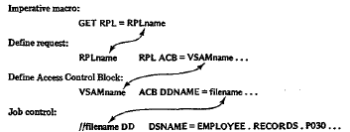
The ACB macro is equivalent to the OS DCB or DOS DTF file definition macros. As
well, the OPEN macro supplies information about the type of file organization, record
length, and key. Each execution of OPEN, CLOSE, GET, PUT, and ERASE causes
VSAM to check its validity and to insert a code into register 15 that you can check.
A return code of X'00' means that the operation was successful. You can use the
SHOWCB macro to determine the exact cause of the error.
THE ACB MACRO: ACCESS METHOD CONTROL BLOCK
The ACB macro identifies a data set that is to be processed. Its main purpose is to
indicate the proposed type of processing (sequential or direct) and the use of exit
routines, if any. The DEFINE CLUSTER command of AMS has already stored much of
the information about the data set in the VSAM catalog. When a program opens the data
set via the ACB, VSAM delivers this information to virtual storage.
Entries for an ACB macro may be in any sequence, and you may code only those that
you need. Following is the general format, which you code like a DCB or DTF,
with a comma following each entry and a continuation character in column 72.
All operands are optional.
ACB AM=VSAM +
DDNAME=filename, +
EXLST=address +
MACRF=([ADR][,KEY]
[,DIR][,SEQ][,SKP]
[,IN][,OUT]
[,NRM][,AIX]) +
STRND=number
name The name indicates the symbolic address for the ACB when assembled.
If you omit the DDNAME operand from the ACB definition, this name
should match the filename in your DLBL or DD job statement.
AM=VSAM Code this parameter if your installation also uses VTAM;
otherwise, the assembler assumes VSAM.
DDNAME This entry provides the name of your data set that the program is to
process. This name matches the filename in your DLBL
or DD job statement.
EXLST The address references a list of your addresses of routines that provide
exits. Use the EXLST macro to generate the list, and enter its name as
the address. A common use is to code an entry for an end–of–file exit for
sequential reading. If you have no exit routines, omit the operand.
MACRF The options define the type of processing that you plan.
In the following, an underlined entry is a default:
ADR|KEY Use ADR for addressed access (KS and ES)
and KEY for keyed access (KS and RR).
DIR|SEQ|SKP DIR provides direct processing, SEQ
provides sequential processing, and SKP
means skip sequential (for KS and RR).
IN|OUT IN retrieves records and OUT permits retrieval,
insertion, add–to–end, or update for keyed
access and retrieval, update, or
add–to–end for addressed access.
NRM|AIX The DDNAME operand supplies the name of
the data set (or path). NRM means normal
processing of the data set, whereas AIX means
that this is an alternate index.
Other MACRF options are RST|NRS for resetting catalog
information and NUB|UBF for user buffers.
STRNO The entry supplies the total number of RPLs (request parameter
lists) that your program will use at the same time (the default is 1).
ACB also has provision for parameters that define the number and size of buffers;
however, the macro has standard defaults.
In the program example in Fig. 28–4, the ACB macro VSMFILOT has only two entries
and allows the rest to default. Access is keyed (KEY), processing is sequential (SEQ),
and the file is output (OUT). There is no exit list, STRNO defaults to 1, and MACRF
defaults to NRM (normal path).
The assembler does not generate an I/O module for an ACB, nor does the linkage editor
include one. Instead, the system dynamically generates the module at execute time.
THE RPL MACRO: REQUEST PARAMETER UST
The request macros GET, PUT, ERASE, and POINT require a reference to an RPL
macro. For example, the program in Fig. 28–4 issues the following GET macro:
GET RPL=RPLISTIN
The operand supplies the name of the RPL macro that contains the information needed to
access a record. If your program is to access a data set in different ways, you can code an
RPL macro for each type of access; each RPL keeps track of its location in the data set.
The standard format for RPL is as follows. The name for the RPL macro is the one that
you code in the GET or PUT operand. Every entry is optional. (ELB: Note the
non–blank character in column 72 to indicate continuation on the next line.)
Name field | Operation | Operands | Column 72
RPLname | RPL | AM=VSAM,  ACB=address,  AREA=address,  AREALEN=length,  ARG=address,  KEYLEN=length,  OPTCD=(options),  RECLEN = length | +  +  +  +  +  +  +
AM The entry VSAM specifies that this is a VSAM (not VTAM)
control block.
ACB The entry gives the name of the associated ACE that
defines the data set.
AREA The address references an I/O work area in which a record
is available for output or is to be entered on input.
AREALEN The entry supplies the length of the record area.
ARG The address supplies the search argument-a key, including
a relative record number or an RBA.
KEYLEN The length is that of the key if processing by generic key.
(For normal keyed access, the catalog supplies the key length.)
OPTCD Processing options are SEQ, SKP, and DIR; request options are UPD
(update) and NUP (no update). For example, a direct update
would be (DIR,UPD).
RECLEN For writing a record, your program supplies the length to VSAM, and
for retrieval, VSAM supplies the length to your program. If records are
variable length, you can use the SHOWCB and TESTCB macros to
examine the field (see the IBM Supervisor manual).
THE OPEN MACRO
The OPEN macro ensures that your program has authority to access the specified data set
and generates VSAM control blocks.
[label] OPEN address [,address ...... ]
The operand designates the address of one or more ACBs, which you may code either as
a macro name or as a register notation (registers 2–12); for example:
OPEN VSFILE
or LA 6,VSFILE
OPEN (6)
You can code up to 16 filenames in one OPEN and can include both ACB names and
DCB or D1F names. Note, however, that to facilitate debugging, avoid mixing them in
the same OPEN. OPEN sets a return code in register 15 to indicate success (zero) or
failure (nonzero), which your program can test:
X'00' Opened all ACBs successfully.
X'04' Opened all ACBs successfully but issued a
warning message for one or more.
X'08' Failed to open one or more ACBs.
On a failed OPEN or CLOSE, you can also check the diagnostics following program
execution for a message such as OPEN ERROR X'6E', and check Appendix K
of the IBM Supervisor manual for an explanation of the code.
THE CLOSE MACRO
The CLOSE macro completes any I/O operations that are still outstanding, writes any
remaining output buffers, and updates catalog entries for the data set.
[label ] CLOSE address [,address ... ]
You can code up to 16 names in one CLOSE and can include both ACB names
and DCB or DTF names. CLOSE sets a return code in register 15 to indicate
success or failure, which your program can test:
X'00' Closed all ACBs successfully.
X'04' Failed to close one or more ACBs successfully.
X'08' Insufficient virtual storage space for close routine
or could not locate modules.
THE REQUEST MACROS: GET. PUT. ERASE
The VSAM request macros are GET, PUT, ERASE, POINT, and ENDREQ. For each
of these, VSAM sets register 15 with a return code to indicate success or failure of the
operation, as follows:
X'00' Successful operation.
X'04' Request not accepted because of an active request from
another task on the same RPL.
End-of-file also causes this return code.
X'08' A logical error; examine the specific error code in the RPL.
X'0C' Uncorrectable I/O error; examine the specific error code in the RPL.
The GET Macro
GET retrieves a record from a data set. The operand specifies the address of an RPL that
defines the data set being processed. The entry may either (1) cite the address by name
or (2) use register notation, any register 2–12, in parentheses.
You may use register 1; its use is more efficient, but GET does not preserve its address.
1. GET RPL=RPLname
2. LA reg,RPLname
GET RPL=(reg)
The RPL macro provides the address of your work area where GET is to deliver an input
record. Register 13 must contain the address of a save area defined as 18·fullwords.
Under sequential input, GET delivers the next record in the data set. The OPTCD entry in
the RPL macro would appear, for example, as OPTCD=(KEY,SEQ) or
OPTCD=(ADR,SEQ). You have to provide for end–of–file by means of an EXLST
operand in the associated ACB macro; see Fig. 28–4 for an example.
For non–sequential accessing, GET delivers the record that the key or relative record
number specifies in the search argument field. The OPTCD entry in the RPL macro
would appear, for example, as OPTCD = (KEY,SKP) or OPTCD= (KEY,DIR), or as
an RBA in the search argument field, as OPTCD = (ADR,DIR).
You also use GET to update or delete a record.
The PUT Macro
PUT writes or rewrites a record in a data set. The operand of PUT specifies the address
of an RPL that defines the data set being processed. The entry may either (1) cite the
address by name or (2) use register notation, any register 2-12, in parentheses. You may
use register 1; its use is more efficient, but PUT does not preserve its address.
1. PUT RPL=RPLname
2. LA reg,RPLname
PUT RPL=(reg)
The RPL macro provides the address of your work area containing the record that
PUT is to add or update in the data set. Register 13 must contain the address of a
save area defined as 18 fullwords.
To create (load) or extend a data set, use sequential output. The OPTCD entry in the
RPL macro would appear, for example, as OPTCD=(SEQ or SKP). SKP means
"skip sequential" and enables you to start writing at any specific record.
For writing a KSDS or RRDS, if OPTCD contains any of the following, PUT stores
a new record in key sequence or relative record sequence:
OPTCD=(KEY,SKP,NUP) Skip, no update
OPTCD=(KEY,DIR,NUP) Direct, no update
OPTCD=(KEY,SEG,NUP) Sequential, no update
Note that VSAM does not allow you to change a key in a KSDS (delete the record and
write a new one). To change a record, first GET it using OPTCD= UFD, change its
contents (but not the key), and PUT it, also using OPTCD=UFD. To write a record
in ESDS, use OPTCD=(ADR, ….).
The ERASE Macro
The purpose of the ERASE macro is to delete a record from a KSDS or an RRDS.
To locate an unwanted record, you must previously issue a GET with an RPL
specifying OPTCD=(UFD...).
[label] ERASE RPL=address or =(register)
For ESDS, a common practice is to define a delete byte in the record. To "delete" a
record, insert a special character such as X'FF'; all programs that process the data set
should bypass all records containing the delete byte. You can occasionally rewrite
the data set, dropping all deletes.
THE EXLST MACRO
If your ACB macro indicates an EXLST operand, code a related EXLST macro. EXLST provides an optional list of addresses for user exit routines that handle end–of–file and error analysis. All operands in the macro are optional.
When VSAM detects the coded condition, the program enters your exit
routine. Register 13 must contain the address of your register save area. For example,
if you are reading sequentially, supply an end–of–data address (EODAD) in the EXLST macro-see the ACB for VSMFILIN in Fig. 28–4.

Name field | Operation | Operands | Column 72
[label] | EXLST | AM=VSAM,  EODAD=address,  LERAD=address,  SYNAD=address | +  +  +
Here are explanations of the operands for EXLST:
VSAM Indicates a VSAM control block.
EODAD Supplies the address of your erid-of-data routine. You may also read
sequentially backward, and VSAM enters your routine when reading
past the first record. The request return code for this condition is X'04'.
LERAD Indicates the address of the routine that analyzes logical errors that
occurred during GET, PUT, POINT, and ERASE. The request return
code for this condition is X'08'.
SYNAD Provides the address of your routine that analyzes physical I/O errors
on GET, PUT, POINT, ERASE, and CLOSE. The request return code
for this condition is X'OC'.
Other operands are EXCPAD and JRNAD.
THE SHOWCB MACRO
The original program in Fig. 28–4 contained an error that caused it to fail on a PUT
operation. The use of the SHOWCB macro in the error routine for PUT (R30PUT)
helped determine the actual cause of the error.
The purpose of SHOWCB is to display fields in an ACB, EXLST, or RPL.
Code SHOWCB following a VSAM macro where you want to identify errors that
VSAM has detected. The SHOWCB in the PUT error routine in Fig. 28–4 is as follows:
SHOWCB RPL=RPLISTOT,AREA=FDBKWD,FIELDS=(FDBK),LENGTH=4
….
FDBKWD DC F'O'
AREA Designates the name of a fullword where VSAM is to place an error code.
FIELDS Tells SHOWCB the type of display; the keyword FDBK (feedback) causes
a display of error codes for request macros.
LENGTH Provides the length of the area in bytes.
On a failed request, VSAM stores the error code in the rightmost byte of the fullword
area. These are some common error codes:
X‘08’ Attempt to store a record with a duplicate key.
X‘0C’ Out-of-sequence or duplicate record for KSDS or RRDS.
X‘10’ No record located on retrieval.
X‘1C’ No space available to store a record.
Your program can test for the type of error and display a message. For nonfatal errors, it
could continue processing; for fatal errors, it could terminate.
The original error in Fig. 28–4 was caused by the fact that the RPL macro RPLISTOT did
not contain an entry for RECLEN; the program terminated on the first PUT error, with
register 15 containingX'08' (a "logical error"). Insertion of the SHOWCB macro in the
next run revealed the cause of the error in FDBKWD: 00006C. Appendix K of the IBM
Supervisor manual explains the error (in part) as follows: "The RECLEN value specified
in the RPL macro was [either] larger than the allowed maximum [or] equal to zero...."
Coding a RECLEN operand in the RPL macro solved the problem, and the program then
executed through to normal termination. One added point: Technically, after" each
SHOWCB, you should test register 15 for a successful or failed operation.
SAMPLE PROGRAM: LOADING A KEY-SEQUENCED DATA SET
The program in Fig. 28–4 reads records from the system reader and sequentially creates a
key-sequenced data set. A DEFINE CLUSTER command has allocated space for this
data set as INDEXED (KSDS), with three tracks, a 4-byte key starting in position 0, and
an 80–byte record size. The program loads the entire data set and closes it on completion.
For illustrative (but not practical) purposes, it reopens the data set and reads and prints
each record. The PUT macro that writes records into the data set is:
PUT RPL=RPLISTOT
RPLISTOT defines the name of the ACB macro (VSMFILOT), the address of the output
record, and its length. Although the example simply duplicates the record into the data
set, in practice you would probably define various fields and store numeric values as
packed or binary.
The ACB macro defines VSMFILOT for keyed accessing, sequential processing, and
output. The DDNAME, VSAMFIL, in this example relates to the name for the data set
in the DLBL job control entry (DD under OS).
For reading the data set, the GET macro is
GET RPL=RPLISTIN
RPLISTIN defines the name of the ACB macro (VSMFILIN), the address in which
GET is to read an input record, and the record length.

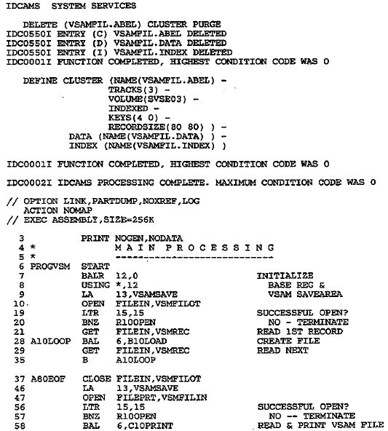
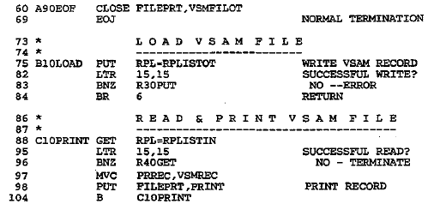
Figure 28–4 Loading a key–sequenced data set
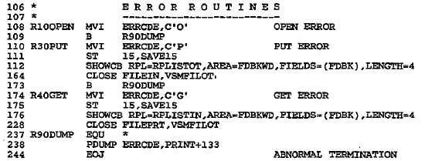
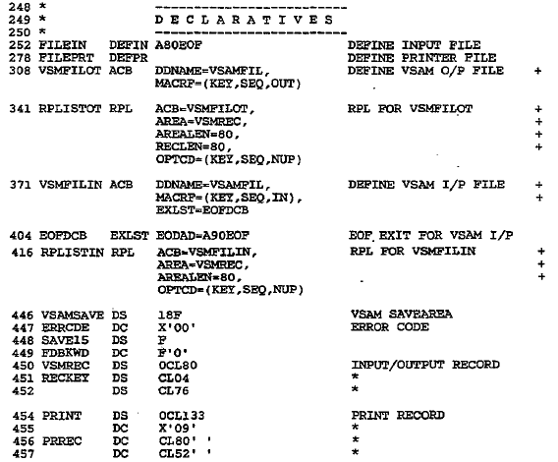
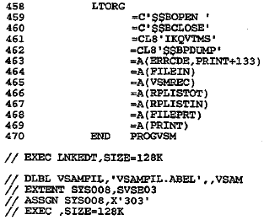
Figure 28–4 Loading a key–sequenced data set (continued)
The ACB macro defines VSMFILIN for keyed access, sequential processing, and input.
The DDNAME, VSAMFIL, relates to the name for the data set in the DLBL job control
entry. Note that there is an ACB and RPL macro for both input and output, but both
ACB macros specify the same DDNAME: VSAMFIL.
Error routines are for failures on OPEN, GET, and PUT. These rather primitive routines
supply an error code and the contents of the declaratives; in practice, you may want to
enlarge these routines. If you fail to provide error routines, your program may crash with
no clear cause.
During testing, you may have changed the contents of a VSAM data set and now want
to reload (re-create) the original data set. Except for updating with new keys, VSAM
does not permit overwriting records in a data set. You have to use IDCAMS to DELETE
and again DEFINE the data set as follows:
DELETE(data-set-name) CLUSTER PURGE …
DEFINE CLUSTER(NAME(data-set-name) ….)
Loading an ESDS
To convert the program in Fig. 19-4 from KSDS to ESDS, change DEFlNE CLUSTER
from INDEXED to NONINDEXED and delete the KEYS and INDEX entries.
Change the ACB MACRF from KEY to ADR, and change the RPL OPTCD from
KEY to ADR – that's all.
KEYED DIRECT RETRIEVAL
Key-sequenced data sets provide for both sequential and direct processing by key.
For direct processing, you must supply VSAM with the key of the record to be accessed.
If you use a key to access a record directly, it must be the same length as the keys in the
data set (as indicated in the KEYS operand of DEFINE CLUSTER), and the key must
actually exist in the data set. For example, if you request a record with key 0028 and
there is no such record, VSAM returns an error code in register 15.
Using the data set in Fig. 19-4, assume that a program is to access records directly. A user
enters record key numbers via a terminal, and the program is to display the record on the
screen. In this partial example, the RPL macro specifies the name (ARG) of the key to
be in a 4-byte field named KEYFLD. These are the specific coding requirements for the
ACB, RPL, and GET macros:
For updating a KSDS record, change the MACRF from IN to OUT, and change the
OPTCD from NUP to UPD. GET the record, make the required changes to it (but
not the key!), and PUT the record using the same RPL.
VSMFILE ACB DDNAME=name, +
MACRF=(KEY,DIR,IN)
RPLIST RPL ACB=VSMFILE, +
AREA=DCBREC, +
AREALEN=80, +
ARG=KEYFLD, +
OPTCD=(KEY,DIR,NUP)
KEYFLD DS CL4
DCBREC DS CL80
[Accept a key number from the terminal]
MVC KEYFLD,keyno
GET RPL=RPLI ST
LTR 15,15
BNZ error
[Display the record on the screen]
SORTING VSAM FILES
You can sort VSAM records into either ascending or descending sequence. You must first use DEFINE CLUSTER to allocate a vacant data set (NONINDEXED) for SORT to write the sorted data set. Here is a typical SORT specification:
// EXEC SORT,SIZE=256K
SORT FIELDS=(1,4,CH,A,9,4,PD,D)
RECORD TYPE=F,LENGTH=(150)
INPFIL VSAM
OUTFIL ESDS
END
/*
SORT causes the SORT program to load into storage and begin execution.
SORT FIELDS defines the fields to be sorted, indicated by major control to minor,
from left to right. In this example, the major sort field begins in position 1 (the first
position), is 4 bytes long, is in character (CH) format, and is to be sorted in ascending
(A) sequence. The minor sort field begins in position 9, is 4 bytes long, is in packed (PD)
format, and is to be sorted in descending (0) sequence. The example could be a sort of
departments in ascending sequence, and within each department are employee salaries
in descending sequence.
RECORD TYPE indicates fixed (F) length and record length (150 bytes).
INPFIL informs SORT that the input file is VSAM; SORT can determine the type
of data set from the VSAM catalog.
OUTFIL defines the type of output file, in this case entry-sequenced. This entry
should match the DEFINE CLUSTER for this data set, NONINDEXED.
Job control commands for SORTIN and SORTOUT provide the names of the data sets.
Since job control varies by operating system and by installation requirements, check
with your installation before attempting the SORT utility.
VSAM UTILITY PRINT
IDCAMS furnishes a convenient utility program named PRINT that can print the
contents of a VSAM, SAM, or ISAM data set. The following provides the steps for
OS and for DOS:
OS: //STEP EXEC PGM=IDCAMS
PRINT INFILE(filename) CHARACTER or HEX or DUMP
/*
DOS: // EXEC IDCAMS,SIZE=256K
PRINT INFILE(filename) CHARACTER or HEX or DUMP
/*
The options for PRINT indicate the format of the printout, in character, hexadecimal,
or both (DUMP prints hex on the left and character format on the right).
INFILE(fiIename) matches the name in the OS DD or DOS DLBL job statement with
any valid filename as long as the two are identical. The DD or DLBL statement notifies
VSAM which data set is to print.
PRINT lists KSDS and ISAM data sets in key sequence and lists ESDS, RRDS, and
SAM data sets in physical sequence. You can also print beginning and ending at a
specific record.
KEY POINTS
• A key-sequenced data set (KSDS) maintains records in sequence of key, such as
employee or part number, and is equivalent to indexed sequential access method.
• An entry-sequenced data set (ESDS) maintains records in the sequence in which they
were initially entered and is equivalent to sequential organization.
• A relative-record data set (RRDS) maintains records in order of relative record
number and is equivalent to direct file organization.
• For the three types of data sets, VSAM stores records in groups (one or more) of
control intervals. At the end of each control interval is control information that
describes the data records.
• Before physically writing (loading) records in a VSAM data set, you must first
catalog its structure. Access method services (AMS) enables you to furnish VSAM
with such details about the data set as its name, organization type, record length, key
location, and password (if any).
• VSAM furnishes two types of accessing, keyed and addressed, and three types of
processing, sequential, direct, and skip sequential.
• The most common errors in processing VSAM data sets occur because of the need to
match definitions in the program, job control, and the cataloged VSAM data set.
• The data-set-name in job control (such as CUSTOMER.INQUIRY) must agree with
the NAME(data–set–name) entry in DEFJNE CLUSTER. This name is the only one
by which VSAM recognizes the data set. VSAM relates the ACB DDNAME in the
program to the job control name and the job control name to the data-set-name.
• If a data set is cataloged as KSDS, ESDS, or RRDS, each program must access it
accordingly.
• For KSDS, the length and starting position of the key in a record must agree with the
KEYS entry in DEFINE CLUSTER and, for direct input, with the defined
ARG in the OPTCD.
• Every program that references the data set defines the fields with identical formats
and lengths in the same positions; the actual field names need not be identical. You may define as character any input field in a record that the program does not
reference. The simplest practice is to catalog all record definitions in the assembler
source library and COPY the definition into the program during assembly.
• After each OPEN, CLOSE, GET, PUT, and SHOWCB, test register 15 for success or
failure, and use SHOWCB (as well as TESTCB) as a debugging aid.

