Chapter 11 – Parallel Connections
As mentioned several times in previous chapters, data busses can be divided into serial and
parallel connections. The last part of the previous chapter described the method of noise
amelioration called “differential signaling”, in which each data line is doubled. Each of the
serial and parallel busses can be implemented using differential signaling. A serial bus would
use one pair of lines, while an N–bit parallel bus would use N pairs of lines (2N lines total).
Put simply, it is not the number of data lines that define the bus, but the number of bits that
are to be transmitted at once. As mentioned before, it would appear obvious that a parallel
data bus would give much better performance than any serial data bus. We shall return to the
tradeoff between serial and parallel connections when we discuss the ATA bus and SATA bus,
later in this chapter. For now, let’s look at parallel busses.
A typical computer contains a number of busses, at various levels. The CPU contains data
busses for its internal work. This chapter focuses on busses external to the CPU. Some early
designs used a single bus allowing the CPU to communicate with the other components.
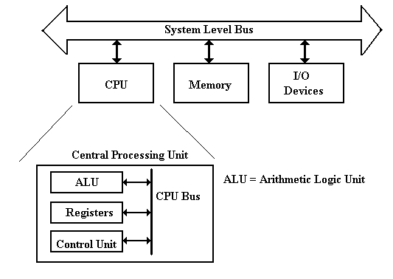
Reality Intrudes
The single–bus design is logically correct, but it no longer represents the actual organization of
any modern commercial computers. The problem is that the bus cannot handle the work load
associated with modern computers, especially the requirement for fast access to memory and
intense data rates to the graphics card. Here is a refinement of the above diagram. We now have
two fast busses, one each for the graphics card and the memory. I/O devices are relegated to the
system bus, operating at a slower speed.
This design is getting closer to reality.

We now turn to commercial realities, specifically legacy I/O devices. When upgrading a
computer, most users do not want to buy all new I/O devices (expensive) to replace older devices
that still function well. The I/O system must provide a number of busses of different speeds,
addressing capabilities, and data widths, to accommodate this variety of I/O devices.
Here we show the main I/O bus connecting the CPU to the I/O Control Hub (ICH), which
is connected to two I/O busses: one for slower (older) devices
one for faster (newer) devices.
The requirement to handle memory as well as a proliferation of I/O devices has lead to a new
design based on two controller hubs. One important function of each hub is to handle data
transfer between two busses that operate at different clock speeds. These hubs are:
1. The Memory Controller Hub or “North Bridge”
2. The I/O Controller Hub or “South Bridge”
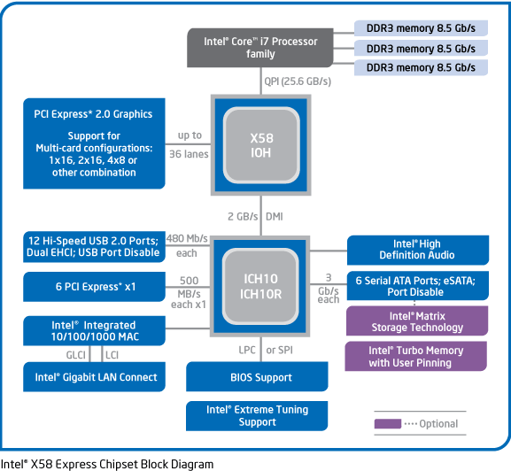
Such a design allows for grouping the higher–data–rate connections on the faster controller,
which is closer to the CPU, and grouping the slower data connections on the slower controller,
which is more removed from the CPU. The names “Northbridge” and “Southbridge” come from
analogy to the way a map is presented. In almost all chipset descriptions, the Northbridge is
shown above the Southbridge. In almost all maps, north is “up”.
It is worth note that, in later designs, much of the functionality of the Northbridge has been
moved to the CPU chip.
Backward Compatibility in System Buses
The early evolution of the Intel microcomputer line provides an interesting case study in the
effect of commercial pressures on system bus design. We focus on three of the earliest models,
the Intel 8086, Intel 80286, and Intel 80386. All three had 16–bit data lines.
The Intel 8086 had a 20–bit address line. It could address 1 MB of memory.
The Intel 80286 had a 24–bit address line. It could address 16 MB of memory.
The Intel 80386 had a 32–bit address line. It could address 4 GB of memory.
Here is a figure showing the growth of the address bus structure for these three designs. Note
that an old style (Intel 8086) bus interface card could be inserted into the 20–bit slot of either the
Intel 80286 or Intel 80386, and still function normally. The Intel 80286 interface, with its 24 bits
of address split into two parts, could fit the 24–bit (20 bits and 4 bits) slot of the Intel 80386.
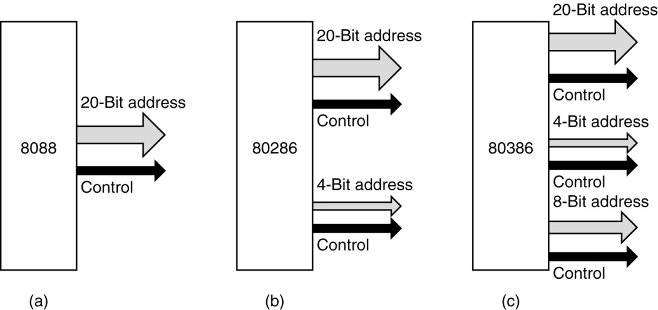
The Intel 80286 was marketed as the IBM PC/AT (Advanced Technology). Your author fondly
remembers his PC/AT from about 1986; it was his first computer with a hard disk (40 MB).
Detour: The IBM Micro–Channel Bus
The Micro–Channel Architecture was a proprietary bus created by IBM in the 1980’s for use on
their new PS/2 computers. It was first introduced in 1987, but never became popular. Later,
IBM redesigned most of these systems to use the PCI bus design (more on this later). The PS/2
line was seen by IBM as a follow–on to their PC/AT line, but was always too costly, typically
selling at a premium. In 1990, the author of this textbook was authorized to purchase a new
80386–class computer for his office. The choice was either an IBM MCA unit or a PC clone.
This was put out for bids. When the bids were received, the lowest IBM price was over $5,000,
while a compatible PC of the same power was $2,900.
According to Wikipedia
“Although MCA was a huge technical improvement over ISA, its introduction and
marketing by IBM was poorly handled. IBM did not develop a peripheral card
market for MCA, as it had done for the PC. It did not offer a number of peripheral
cards that utilized the advanced bus-mastering and I/O processing capabilities of
MCA. Absent a pattern, few peripheral card manufacturers developed such designs
on their own. Consequently customers were not provided many advanced capabilities
to justify the purchase of comparatively more expensive MCA systems and opted for
the plurality of cheaper ISA designs offered by IBM's competition.”
“IBM had patents on MCA system features and required MCA system manufacturers
to pay a license fee. As a reaction to this, in late 1988 the "Gang of Nine", led by
Compaq, announced a rival bus – EISA. Offering similar performance benefits, it
had the advantage of being able to accept older XT and ISA boards.”
“MCA also suffered for being a proprietary technology. Unlike their previous PC bus
design, the AT bus, IBM did not publicly release specifications for MCA and
actively pursued patents to block third parties from selling unlicensed
implementations of it, and the developing PC clone market did not want to pay
royalties to IBM in order to use this new technology. The PC clone makers instead
developed EISA as an extension to the existing old AT bus standard. The 16–bit AT
bus was embraced and renamed as ISA to avoid IBM's "AT" trademark. With few
vendors other than IBM supporting it with computers or cards, MCA eventually
failed in the marketplace.”
“While EISA and MCA battled it out in the server arena, the desktop PC largely
stayed with ISA up until the arrival of PCI, although the VESA Local Bus, an
acknowledged stopgap, was briefly popular.” [R92]
Notations Used for a Bus
We pause here in our historical discussion of bus design to introduce a few terms used to
characterize these busses. We begin with some conventions used to draw busses and their timing
diagrams. Here is the way that we might represent a bus with multiple types of lines.
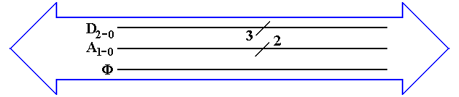
The big “double arrow” notation indicates a bus of a number of different signals. Some authors
call this a “fat arrow”. Lines with similar function are grouped together. Their count is denoted
with the “diagonal slash” notation. From top to bottom, we have
1. Three data lines D₂, D₁, and D₀
2. Two address lines A₁ and A₀
3. The clock signal for the bus Φ.
Not all busses transmit a clock signal; the system bus usually does.
Power and ground lines usually are not shown in this type of diagram. Note the a bus with only
one type of signal might be drawn as a thick line with the slash, as in the 3 – bit data bus above.
Maximum Bus Length
In general, bus length varies inversely as transmission speed, often measured in Hz; e.g., a
1 MHz bus can make one million transfers per second and a 2 GHz bus can make two billion.
Immediately we should note that the above is not exactly true of DDR (Double Data Rate) busses
which transfer at twice the bus speed; a 500 MHz DDR bus transfers 1 billion times a second.
Note that the speed in bytes per second is related to the number of bytes per transfer. A DDR
bus rated at 400 MHz and having 32 data lines would transfer 4 bytes 800 million times a
second, for a total of 3.20 billion bytes per second. Note that this is the peak transfer rate.
The relation of the bus speed to bus length is due to signal propagation time. The speed of light
is approximately 30 centimeters per nanosecond. Electrical signals on a bus typically travel at
2/3 the speed of light; 20 centimeters per nanosecond or 20 meters per microsecond.
A loose rule of thumb in sizing busses is that the signal should be able to propagate the entire
length of the bus twice during one clock period. Thus, a 1 MHz signal would have a one
microsecond clock period, during which time the signal could propagate no more than twenty
meters. This length is a round trip on a ten meter bus; hence, the maximum length is 10 meters.
Similarly, a 1 GHz signal would lead to a maximum bus length of ten centimeters.
The rule above is only a rough estimator, and may be incorrect in some details. Since the typical
bus lengths on a modern CPU die are on the order of one centimeter or less, we have no trouble.
Bus Classifications
It should be no surprise that, depending on the feature being considered, there are numerous
ways to characterize busses. We have already seen one classification, what might be called a
“mixed bus” vs. a “pure bus”; i.e., does the bus carry more than one type of signal. Most busses
are of the mixed variety, carrying data, address, and control signals. The internal CPU busses on
our design carry only data because they are externally controlled by the CPU Control Unit that
sends signals directly to the bus end points.
One taxonomy of busses refers to them as either point–to–point vs. shared. Here is a picture of
that way of looking at busses.
An example of a point–to–point bus might be found in the chapter on computer internal
memory, where we postulated a bus between the MBR and the actual memory chip set. Most
commonly, we find shared busses with a number of devices attached.
Another way of characterizing busses is by the number of “bus masters” allowed. A bus master
is a device that has circuitry to issue command signals and place addresses on the bus. This is in
distinction to a “bus slave” (politically incorrect terminology) that can only transfer data in
response to commands issued by a bus master. In the early designs, only the CPU could serve as
a bus master for the memory bus. More modern memory busses allow some input/output devices
(discussed later as DMA devices) to act as bus masters and transfer data to the memory.
Bus Clocks
Another way to characterize busses is whether the bus is asynchronous or synchronous. A
synchronous bus is one that has one or more clock signals associated with it, and transmitted
on dedicated clock lines. In a synchronous bus, the signal assertions and data transfers are
coordinated with the clock signal, and can be said to occur at predictable times.
An asynchronous bus is one without a clock signal. The data transfers and some control signal
assertions on such a bus are controlled by other control signals. Such a bus might be used to
connect an I/O unit with unpredictable timing to the CPU. The I/O unit might assert some sort of
ready signal when it can undertake a transfer and a done signal when the transfer is complete.
In order to understand these busses more fully, it would help if we moved on to a discussion of
the bus timing diagrams and signal levels.
Bus Signal Levels
Many times bus operation is illustrated with a timing diagram that shows the value of the digital
signals as a function of time. Each signal has only two values, corresponding to logic 0 and to
logic 1. The actual voltages used for these signals will vary depending on the technology used.
A bus signal is represented in some sort of trapezoidal form with rising edges and falling edges,
neither of which is represented as a vertical line. This convention emphasizes that the signal
cannot change instantaneously, but takes some time to move between logic high and low.
Here is a depiction of the bus clock, represented as a trapezoidal wave.
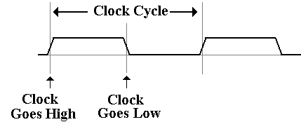
Here is a sample diagram, showing two hypothetical discrete signals. Here the discrete signal B#
goes low during the high phase of clock T1 and stays low. Signal A# goes low along with the
second half of clock T1 and stays low for one half clock period.
A collection of signals, such as 32 address lines or 16 data lines cannot be represented with such
a simple diagram. For each of address and data, we have two important states; the signals are
valid, and signals are not valid
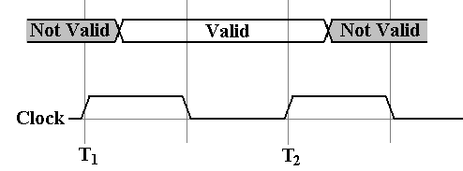
For example, consider the address lines on the bus. Imagine a 32–bit address. At some time
after T₁, the CPU asserts an address on the address lines. This means that each of the 32 address
lines is given a value, and the address is valid until the middle of the high part of clock pulse T2,
at which the CPU ceases assertion.
Having seen these conventions, it is time to study a pair of typical timing diagrams. We first
study the timing diagram for a synchronous bus. Here is a read timing diagram.
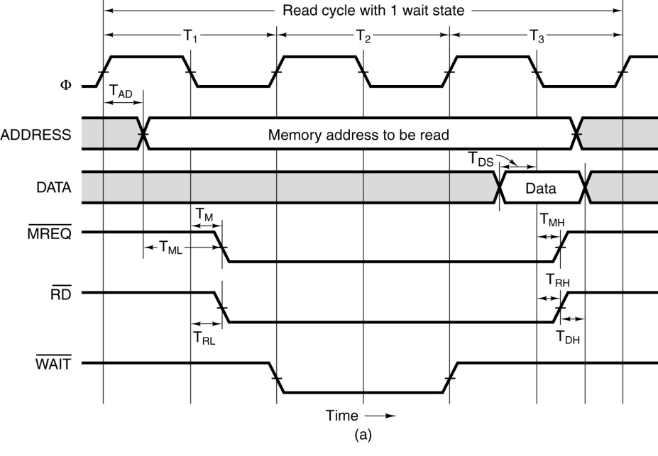
What we have here is a timing diagram that covers three full clock cycles on the bus. Note that
during the high clock phase of T₁, the address is asserted on the bus and kept there until the low
clock phase of T₃. Before and after these times, the contents of the address bus are not specified.
Note that this diagram specifies some timing constraints. The first is T_{AD}, the maximum allowed
delay for asserting the address after the clock pulse if the memory is to be read during the high
phase of the third clock pulse.
Note that the memory chip will assert the data for one half clock pulse, beginning in the middle
of the high phase of T₃. It is during that time that the data are copied into the MBR.
Note that the three control signals of interest ( ) are asserted low.
We also have another constraint T_{ML}, the minimum time that the address is stable before the
is asserted.
The purpose of the diagram above is to indicate what has to happen and when it has to happen in
order for a memory read to be successful via this synchronous bus. We have four discrete
signals (the clock and the three control signals) as well as two multi–bit values (memory address
and data).
For the discrete signals, we are interested in the specific value of each at any given time. For the
multi–bit values, such as the memory address, we are only interested in characterizing the time
interval during which the values are validly asserted on the data lines.
Note that the more modern terminology for the three control signals that are asserted low would
be MREQ#, RD#, and WAIT#. The reader will note that the figures in this chapter make use
of both styles for writing these control signals; translation to a uniform notation is bothersome.
The timing diagram for an asynchronous bus includes some additional information. Here the
focus is on the protocol by which the two devices interact. This is also called the “handshake”.
The bus master asserts MSYN# and the bus slave responds with SSYN# when done.
The asynchronous bus uses similar notation for both the discrete control signals and the
multi–bit values, such as the address and data. What is different here is the “causal arrows”,
indicating that the change in one signal is the causation of some other event. Note that the
assertion of MSYN# causes the memory chip to place data on the bus and assert SSYN#. That
assertion causes MSYN# to be dropped, data to be no longer asserted, and then SSYN# to drop.

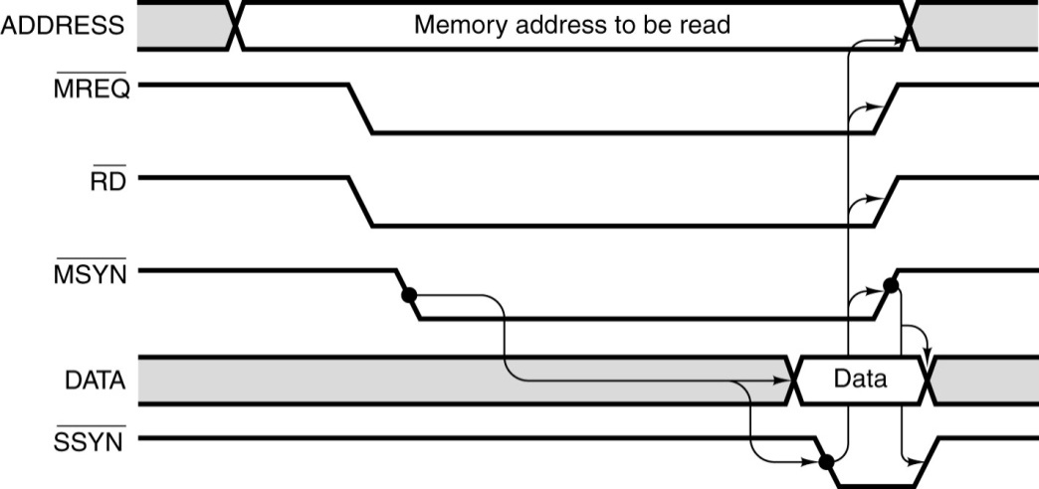
Multiplexed Busses
A bus may be either multiplexed or non–multiplexed. In a multiplexed bus, bus data and
address share the same lines, with a control signal to distinguish the use. A non–multiplexed
bus has separate lines for address and data. The multiplexed bus is cheaper to build in that it has
fewer signal lines. A non–multiplexed bus is likely faster.
There is a variant of multiplexing, possibly called “address multiplexing” that is seen on most
modern memory busses. In this approach, an N–bit address is split into two (N/2)–bit addresses,
one a row address and one a column address. The addresses are sent separately over a dedicated
address bus, with the control signals specifying which address is being sent.
Recall that most modern memory chips are designed for such addressing. The strategy is to
specify a row, and then to send multiple column addresses for references in that row. Some
modern chips transmit in burst mode, essentially sending an entire row automatically.
Here, for reference, is the control signal description from the chapter on internal memory.
CS# | RAS# | CAS# | WE# | Command / Action
1 | d | d | d | Deselect / Continue previous operation
0 | 1 | 1 | 1 | NOP / Continue previous operation
0 | 0 | 1 | 1 | Select and activate row
0 | 1 | 0 | 1 | Select column and start READ burst
0 | 1 | 0 | 0 | Select column and start WRITE burst

Modern Computer Busses
The next major step in evolution of the computer bus took place in 1992, with the introduction
by Intel of the PCI (Peripheral Component Interconnect) bus. By 1995, the bus was operating at
66 MHz, and supporting both a 32–bit and 64–bit address space.
According to Abbott [R64], “PCI evolved, at least in part, as a response to the shortcomings of
the then venerable ISA bus. … ISA began to run out of steam in 1992, when Windows had
become firmly established.” Revision 1 of the PCI standard was published in April 1993.
The PCI bus standard has evolved into the PCI Express standard, which we shall now discuss.
PCI Express
PCI Express (Peripheral Component Interconnect Express) is a computer expansion card
standard designed to replace the older PCI bus standard. The name is abbreviated as “PCIe”.
This is viewed as a standard for computer expansion cards, but really is a standard for the
communication link by which a compliant device will communicate over the bus.
According to Wikipedia, PCIe 3.0 (August 2007) is the latest standard. While an
outgrowth of the original PCI bus standard, the PCIe is not compatible with that standard at the
hardware level. The PCIe standard is based on a new protocol for electrical signaling.
This protocol is built on the concept of a lane, which was defined in Chapter 10 as a full–duplex
connection based on two pairs of lines, each implementing differential signaling.
As a brief review, one of the pairs of lines in a lane is called the signal transmitter and the other
pair the signal receiver. We shall denote the signals T and R. Each pair of lines carries two
voltages to represent the voltage V being transmitted, V₊ = V/2 and V– = –V/2. Here is another
depiction of a full–duplex lane.
A PCI connection can comprise from 1 to 32 lanes. A 16–lane PCI bus would be used as a
16–bit parallel bus, transmitting 16 bits at a time. There have been three standards so far:
Version Per Lane 16–Lane Slot
Version 1 250 MB/s 4 GB/s
Version 2 500 MB/s 8 GB/s
Version 3 1 GB/s 16 GB/s
The PCI express standard calls for a point–to–point bus (one device communicating with
exactly one other device), as opposed to the shared bus topology of earlier standards. The
CPU can communicate with a number of devices over a single shared bus. To do so via the
PCI express, the CPU must communicate via a device called a “host root complex”, which
connects the CPU to a number of PCI express busses, one bus for each device.
Interfaces to Disk Drives
The disk drive is not a stand–alone device. In order to function as a part of a system, the disk
must be connected to the motherboard through a bus. We shall discuss details of disk drives in
the next chapter. In this one, we focus on two popular bus technologies used to interface a disk:
ATA and SATA. Much of this material is based on discussions in chapter 20 of the book on
memory systems by Bruce Jacob, et al [R008].
The top–level organization is shown in the figure below. We are considering the type of bus
used to connect the disk drive to the motherboard; more specifically, the host controller on the
motherboard to the drive controller on the disk drive. While the figure suggests that the disk is
part of the disk drive, this figure applies to removable disks as well. The important feature is
the nature of the two controllers and the protocol for communication between them.
One of the primary considerations when designing a disk interface, and the bus to implement that
interface, is the size of the drive controller that is packaged with the disk. As Jacob [R008] put it:
“In the early days, before Large Scale Integration (LSI) made adequate computational
power economical to be put in a disk drive, the disk drives were ‘dumb’ peripheral
devices. The host system had to micromanage every low–level action of the disk
drive. … The host system had to know the detailed physical geometry of the disk
drive; e.g., number of cylinders, number of heads, number of sectors per track, etc.”
“Two things changed this picture. First, with the emergence of PCs, which eventually
became ubiquitous, and the low–cost disk drives that went into them, interfaces
became standardized. Second, large–scale integration technology in electronics
made it economical to put a lot of intelligence in the disk side controller”
As of Summer 2011, the four most popular interfaces (bus types) were the two varieties of ATA
(Advanced Technology Attachment, SCSI (Small Computer Systems Interface0, and the FC
(Fibre Channel). The SCSI and FC interfaces are more costly, and are commonly used on more
expensive computers where reliability is a premium. We here discuss the two ATA busses.
The ATA interface is now managed by Technical Committee 13 of INCITS (www.t13.org), the
International Committee for Information Technology Standards (www.incits.org). The interface
was so named because it was designed to be attached to the IBM PC/AT, the “Advanced
Technology” version of the IBM PC, introduced in 1984. To quote Jacob again:
“The first hard disk drive to be attached to a PC was Seagate’s ST506, a 5.25 inch
form factor 5–MB drive introduced in 1980. The drive itself had little on–board
control electronics; most of the drive logic resided in the host side controller.
Around the second half of the 1980’s, drive manufacturers started to move the
control logic from the host side and integrate it with the drive. Such drives became
known as IDE (Integrated Drive Electronics) drives.”
In recent years, the ATA standard has being explicitly referred to at the “PATA” (Parallel ATA)
standard to distinguish it from the SATA (Serial ATA standard) that is now becoming popular.
The original PATA standard called for a 40–wire cable. As the bus clock rate increased, noise
from crosstalk between the unshielded cables became a nuisance. The new design included 40
extra wires, all ground wires to reduce the crosstalk.
As an example of a parallel bus, we show a picture of the PDP–11 Unibus. This had 72 wires,
of which 56 were devoted to signals, and 16 to grounding. This bus is about 1 meter in length.
Figure: The Unibus of the PDP–11 Computer
Up to this point, we have discussed parallel busses. These are busses that transmit N data bits
over N data lines, such as the Unibus™ that used 16 data lines to transmit two bytes per transfer.
Recently serial busses have become popular; especially the SATA (Serial Advanced Technology
Attachment) busses used to connect internally mounted disk drives to the motherboard. There
are two primary motivations for the development of the SATA standard: clock skews and noise.
The problem of clock skew is illustrated by the following pair of figures. The first figure shows
a part of the timing diagram for the intended operation of the bus. While these figures may be
said to be inspired by actual timing diagrams, they are probably not realistic.
In the above figure, the control signals MREQ# and RD# are asserted simultaneously one half
clock time, after the address becomes valid. The two are simultaneously asserted for two clock
times, after which the data are read.
We now imagine what could go wrong when the clock time is very close to the gate delay times
found in the circuitry that generates these control signals. For example, let us assume a 1 GHz
bus clock with a clock time of one nanosecond. The timing diagram above calls for the two
control signals, MREQ# and RD#, to be asserted 0.5 nanoseconds (500 picoseconds) after the
address is valid. Suppose that the circuit for each of these is skewed by 0.5 nanoseconds, with
the MREQ# being early and the RD# being late.
What we have in this diagram is a mess, one that probably will not lead to a functional read
operation. Note that MREQ# and RD# are simultaneously asserted for only an instant, far too
short a time to allow any operation to be started. The MREQ# being early may or may not be a
problem, but the RD# being late certainly is. A bus with these skews will not work.
As discussed above, the ribbon cable of the PATA bus has 40 unshielded wires. These are
susceptible to cross talk, which limits the permissible clock rate. What happens is that crosstalk
is a transient phenomenon; the bus must be slow enough to allow its effects to dissipate.
We have already seen a solution to the problem of noise when we considered the PCI Express
bus. This is the solution adopted by the SATA bus. The standard SATA bus has a seven–wire
cable for signals and a separate five–wire cable for power. The seven–wire cable for data has
three wires devoted to ground (noise reduction) and four wires devoted to a serial lane, as
described above for PCI Express. As noted above in that discussion, the serial lane is relatively
immune to noise and crosstalk, while allowing for very good transmission speeds.
One might note that parallel busses are inherently faster than serial busses. An N–bit bus will
transmit data N times faster than a 1–bit serial bus. The experience seems to be that the data
transmission rate can be so much higher on the SATA bus than on a parallel bus, that the SATA
bus is, in fact, the faster of the two. Data transmission on these busses is rated in bits per second.
In 2007, according to Jacob “SATA controllers and disk drives with 3 Gbps are starting to
appear, with 6 Gbps on SATA’s roadmap.” The encoding used is called “8b/10b”, in which an
8–bit byte is padded with two error correcting bits to be transmitted as 10 bits. The two speeds
above correspond to 300 MB per second and 600 MB per second.

