Chapter 9A – Review of Basic Electronics
A traditional presentation of this material might have begun with a review of the basic
concepts of direct current electricity. Your author has elected to postpone that discussion
until this point in the course, at which time it is needed.
A Basic Circuit
We begin our discussion with a simple example circuit – a flashlight (or “electric torch” as
the Brits call it). This has three basic components: a battery, a switch, and a light bulb. For
our purpose, the flashlight has two possible states: on and off. Here are two diagrams.

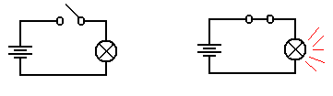
Light is Off Light is On

In the both figures, we see a light bulb connected to a battery via two wires and a switch.
When the switch is open, it does not allow electricity to pass and the light is not illuminated.
When the switch is closed, the electronic circuit is completed and the light is illuminated.

The figure above uses a few of the following basic circuit elements.
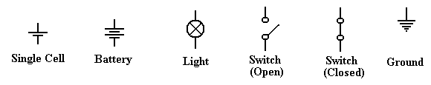

We now describe each of these elements and then return to our flashlight example. The first
thing we should do is be purists and note the difference between a cell and a battery, although
the distinction is quite irrelevant to this course. A cell is what one buys in the stores today
and calls a battery; these come in various sizes, including AA, AAA, C, and D. Each of
these cells is rated at 1.5 volts, due to a common technical basis for their manufacture.
Strictly speaking, a battery is a collection of cells, so that a typical flashlight contains one
battery that comprises two cells; usually AA, C, or D. An automobile battery is truly a
battery, being built from a number of lead-acid cells.
A light is a device that converts electronic current into visible light. This is not a surprise.
A switch is a mechanical device that is either open (not allowing transmission of current) or
closed (allowing the circuit to be completed). Note that it is the opposite of a door, which
allows one to pass only when open.
The Idea of Ground
Consider the above circuit, which suggests a two-wire design: one wire from the battery to
the switch and then to the light bulb, and another wire from the bulb directly to the battery.
One should note that the circuit does not require two physical wires, only two distinct paths
for conducting electricity. Consider the following possibility, in which the flashlight has a
metallic case that also conducts electricity.
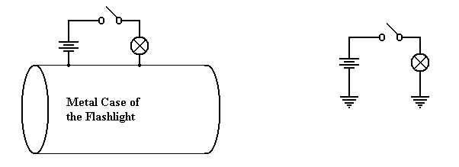
Physical Connection Equivalent Circuit
Consider the circuit at left, which shows the physical connection postulated. When the
switch is open, no current flows. When the switch is closed, current flows from the battery
through the switch and light bulb, to the metallic case of the flashlight, which serves as a
return conduit to the battery. Even if the metallic case is not a very good conductor, there
is much more of it and it will complete the circuit with no problem.
In electrical terms, the case of the battery is considered as a common ground, so that the
equivalent circuit is shown at right. Note the new symbol in this circuit – this is the ground
element. One can consider all ground elements to be connected by a wire, thus completing
the circuit. In early days of radio, the ground was the metallic case of the radio – an
excellent conductor of electricity. Modern automobiles use the metallic body of the car itself
as the ground. Although iron and steel are not excellent conductors of electricity, the sheer
size of the car body allows for the electricity to flow easily.
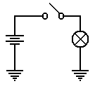
To conclude, the circuit at left will be our representation of a
flashlight. The battery provides the electricity, which flows through
the switch when the switch is closed, then through the light bulb, and
finally to the ground through which it returns to the battery.

As a convention, all switches in diagrams will be shown in the open
position unless there is a good reason not to.
The student should regard the above diagram as showing a switch which is not necessarily
open, but which might be closed in order to allow the flow of electricity. The convention of
drawing a switch in the open position is due to the fact that it is easier to spot in a diagram.
Voltage, Current, and Resistance
It is now time to become a bit more precise in our discussion of electricity. We need to
introduce a number of basic terms, many of which are named by analogy to flowing water.
The first term to define is current, usually denoted in equations by the symbol I. We all
have an intuitive idea of what a current is. Imagine standing on the bank of a river and
watching the water flow. The faster the flow of water, the greater the current; flows of water
are often called currents.
In the electrical terms, current is the flow of electrons, which are one of the basic building
blocks of atoms. While electrons are not the only basic particles that have charge, and are
not the only particle that can bear a current; they are the most common within the context of
electronic digital computers. Were one interested in electro-chemistry he or she might be
more interested in the flow of positively charged ions.
All particles have one of three basic electronic charges: positive, negative, or neutral. Within
an atom, the proton has the positive charge, the electron has the negative charge, and the
neutron has no charge. In normal life, we do not see the interior of atoms, so our experience
with charges relates to electrons and ions. A neutral atom is one that has the same number of
protons as it has electrons. However, electrons can be quite mobile, so that an atom may gain
or lose electrons and, as a result, have too many electrons (becoming a negative ion) or too
few electrons (becoming a positive ion). For the purposes of this course, we watch only the
electrons and ignore the ions.
An electric charge, usually denoted by the symbol Q, is usually associated with a large
number of electrons that are in excess of the number of positive ions available to balance
them. The only way that an excess of electrons can be created is to move the electrons from
one region to another – robbing one region of electrons in order to give them to another.
This is exactly what a battery does – it is an electron “pump” that moves electrons from the
positive terminal to the negative terminal. Absent any “pumping”, the electrons in the
negative terminal would return to the positive region, which is deficient in electrons, and
cause everything to become neutral. But the pumping action of the battery prevents that.
Should one provide a conductive pathway between the positive and negative terminals of a
battery, the electrons will flow along that pathway, forming an electronic current.
To clarify the above description, we present the following diagram, which shows a battery, a
light bulb, and a closed switch. We see that the flow of electrons within the battery is only a
part of a larger, complete circuit.

Materials are often classified by their abilities to conduct electricity. Here are two common
types of materials.
Conductor A conductor is a substance, such as copper or silver, through which
electrons can flow fairly easily.
Insulator An insulator is a substance, such as glass or wood, that offers
significant resistance to the flow of electrons. In many of our
circuit diagrams we assume that insulators do not transmit electricity
at all, although they all do with some resistance.
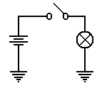
The voltage is amount of pressure in the voltage pump. It is quite
similar to water pressure in that it is the pressure on the electrons that
causes them to move through a conductor. Consider again our
flashlight example. The battery provides a pressure on the electrons
to cause them to flow through the circuit. When the switch is open,
the flow is blocked and the electrons do not move. When the switch
is closed, the electrons move in response to this pressure (voltage)
and flow through the light bulb. The light bulb offers a specific
resistance to these electrons; it heats up and glows.
As mentioned above, different materials offer various abilities to transmit electric currents.
We have a term that measures the degree to which a material opposes the flow of electrons;
this is called resistance, denoted by R in most work. Conductors have low resistance (often
approaching 0), while insulators have high resistance. In resistors, the opposition to the flow
of electrons generates heat – this is the energy lost by the electrons as they flow through the
resistor. In a light bulb, this heat causes the filament to become red hot and emit light.
An open switch can be considered as a circuit element of extremely high resistance.
Summary
We have discussed four terms so far. We now should mention them again.
Charge This refers to an unbalanced collection of electrons. The term used
for denoting charge is Q. The unit of charge is a coulomb.
Current This refers to the rate at which a charge flows through a conductor.
The term used for denoting current is I. The unit of current is an ampere.
Voltage This refers to a force on the electrons that causes them to move. This force
can be due to a number of causes – electro-chemical reactions in batteries
and changing magnetic fields in generators. The term used for denoting
voltage is V or E (for Electromotive Force). The unit of current is a volt.
Resistance This is a measure of the degree to which a substance opposes the flow of
electrons. The term for resistance is R. The unit of resistance is an ohm.
Ohm’s Law and the Power Law
One way of stating Ohm’s law (named for Georg Simon Ohm, a German teacher who
discovered the law in 1827) is verbally as follows.
The current that flows through a circuit element is directly proportional to the
voltage across the circuit element and inversely proportional to the resistance
of that circuit element.
What that says is that doubling the voltage across a circuit element doubles the current flow
through the element, while doubling the resistance of the element halves the current.
Let’s look again at our flashlight example, this time with the switch shown as closed.
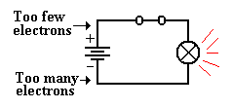
The chemistry of the battery is pushing electrons away
from the positive terminal, denoted as “+” through the
battery towards the negative terminal, denoted as “–“.
This causes a voltage across the only resistive element
in the circuit – the light bulb. This voltage placed across the light bulb causes current to
flow through it.
In algebraic terms, Ohm’s law is easily stated: E = I•R, where
E is the voltage across the circuit element,
I is the current through the circuit element, and
R is the resistance of the circuit element.
Suppose that the light bulb has a resistance of 240 ohms and has a voltage of 120 volts
across it. Then we say E = I•R or 120 = I•240 to get I = 0.5 amperes.
As noted above, an element resisting the flow of electrons absorbs energy from the flow it
obstructs and must emit that energy in some other form. Power is the measure of the flow of
energy. The power due to a resisting circuit element can easily be calculated.
The power law is states as P = E•I, where
P is the power emitted by the circuit element, measured in watts,
E is the voltage across the circuit element, and
I is the current through the circuit element.
Thus a light bulb with a resistance of 240 ohms and a voltage of 120 volts across it has
a current of 0.5 amperes and a power of 0.5 • 120 = 60 watts.
There are a number of variants of the power law, based on substitutions from Ohm’s law.
Here are the three variants commonly seen.
P = E•I P = E² / R P = I²•R
In our above example, we note that a voltage of 120 volts across a resistance of 60 ohms
would produce a power of P = (120)² / 240 = 14400 / 240 = 60 watts, as expected.
The alert student will notice that the above power examples were based on AC circuit
elements, for which the idea of resistance and the associated power laws become more
complex (literally). Except for a few cautionary notes, this course will completely ignore
the complexities of alternating current circuits.
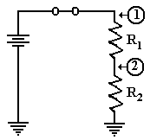
Resistors in Series
There are very many interesting combinations of resistors found
in circuits, but here we focus on only one – resistors in series;
that is one resistor placed after another. In this figure, we
introduce the symbol for a resistor.
Consider the circuit at right, with two resistors having
resistances of R₁ and R₂, respectively. One of the basic laws of
electronics states that the resistance of the two in series is
simply the sum: thus R = R₁ + R₂. Let E be the voltage provided by the battery. Then the
voltage across the pair of resistors is given by E, and the current through the circuit elements
is given by Ohm’s law as I = E / (R₁ + R₂). Note that we invoke another fundamental law
that the current through the two circuit elements in series must be the same.
Again applying Ohm’s law we can obtain the voltage drops across each of the two resistors.
Let E₁ be the voltage drop across R₁ and E₂ be that across R₂. Then
E₁ = I•R₁ = R₁•E / (R₁ + R₂), and
E₂ = I•R₂ = R₂•E / (R₁ + R₂).
It should come as no surprise that E₁ + E₂ = R₁•E / (R₁ + R₂) + R₂•E / (R₁ + R₂)
= (R₁ + R₂)•E / (R₁ + R₂) = E.
If, as is commonly done, we assign the ground state as having zero voltage, then the voltages
at the two points in the circuit above are simple.
1) At point 1, the voltage is E, the full voltage of the battery.
2) At point 2, the voltage is E₂ = I•R₂ = R₂•E / (R₁ + R₂).
Before we present the significance of the above circuit, consider two special cases.
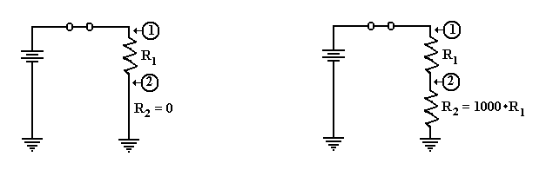
In the circuit at left, the second resistor is replaced by a conductor having zero resistance.
The voltage at point 2 is then E₂ = 0•E / (R₁ + 0) = 0. As point 2 is directly connected to
ground, we would expect it to be at zero voltage.
Suppose that R₂ is much bigger than R₁. Let R₁ = R and R₂ = 1000•R. We calculate the
voltage at point 2 as E₂ = R₂•E / (R₁ + R₂) = 1000•R•E / (R + 1000•R) = 1000•E/1001, or
approximately E₂ = (1 – 1/1000)•E = 0.999•E. Point 2 is essentially at full voltage.
Putting a Resistor and Switch in Series
We now consider an important circuit that is related to the above circuit. In this circuit the
second resistor, R₂, is replaced by a switch that can be either open or closed.
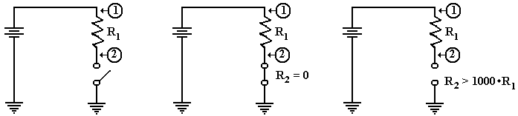
The Circuit Switch Closed Switch Open
The circuit of interest is shown in the figure at left. What we want to know is the voltage at
point 2 in the case that the switch is closed and in the case that the switch is open. In both
cases the voltage at point 1 is the full voltage of the battery.
When the switch is closed, it becomes a resistor with no resistance; hence R₂ = 0. As we
noted above, this causes the voltage at point 2 to be equal to zero.
When the switch is open, it becomes equivalent to a very large resistor. Some say that the
resistance of an open switch is infinite, as there is no path for the current to flow. For our
purposes, it suffices to use the more precise idea that the resistance is very big, at least 1000
times the resistance of the first resistor, R₁. The voltage at point 2 is the full battery voltage.
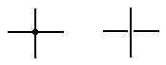
Before we present our circuit, we introduce a notation used in
drawing two wires that appear to cross. If a big dot is used at
the crossing, the two wires are connected. If there is a gap, as in the right figure, then the wires do not connect.
Here is a version of the circuit as we shall use it later.
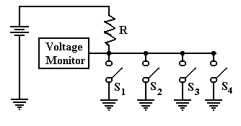
In this circuit, there are four switches attached to the wire. The voltage is monitored by
another circuit that is not important at this time. If all four switches are open, then the
voltage monitor registers full voltage. If one or more of the switches is closed, the monitor
registers zero voltage. This is the best way to monitor a set of switches.
Back to Tri–State Buffers
We use the above verbiage to present a new view of tri–state buffers. Consider the following
two circuits, which have been used previously in this chapter. Suppose that the battery is
rated at five volts. In the circuit at left, point A is at 5 volts and point B is at 0 volts. In the
circuit at right, point B is clearly at 0 volts, but the status of point A is less clear.
What is obvious about the circuit at right is that there is no current flowing through it and no
power being emitted by the light bulb. For this reason, we often say that point A is at 0 volts,
but it is better to say that there is no specified voltage at that point. This is equivalent to the
third state of a tri–state buffer; the open switch is not asserting anything at point A.
Perhaps the major difference between the two circuits is that we can add another battery to
the circuit at right and define a different voltage at point A. As long as the switch remains
open, we have no conflict. Were the switch to be closed, we would have two circuits trying
to force a voltage at point A. This could lead to a conflict.
Device Polling
Here is a more common use of tri–state buffers. Suppose a number of devices, each of which
can signal a central voltage monitor by asserting logic zero (0 volts) on a line. Recalling that
a logic AND outputs 0 if any of its inputs are 0, we could implement the circuit as follows.
Suppose we wanted to add another device. This would require pulling the 4–input AND gate
and replacing it with a 5–input AND gate. Continual addition of devices would push the
technology beyond the number of inputs a normal gate will support.
The tri–state solution avoids these problems. This circuit repeats the one shown above with
the switches replaced by tri–state buffers, which should be viewed as switches.
One should note that additional devices can be added to this circuit merely by attaching
another tri–state switch. The only limit to extensibility of this circuit arises from timing
considerations of signal propagation along the shared line.
Analysis of the Four–Tristate Circuit
In order to analyze the circuit at the bottom of the previous page, we refer back to the circuit
on the page before that. We need to understand the voltage at the monitor, which is assumed
to be the input to a digital gate in the control logic of the CPU. While a precise discussion of
this circuit involves treating resistors in parallel, such is not needed to be accurate here.
First, assume that none of the tri–states are enabled. In that case, the circuit is equivalent to
the one in the next figure.
The voltage at point 2 is the full
battery voltage, as the resistance
between that point and ground is
essentially infinite.
E₂ = E / (1 + R₁/R₂)
E₂ ≈ E • (1 – R₁/R₂),
but R₁/R₂ ≈ 0.
Now consider the situation in which one of the tri–state buffers is enabled. Tri–state 2 has
been chosen arbitrarily.
Now there is a direct path of zero
resistance between point 2 and
ground. The voltage at that point
drops to 0, with the entire
voltage drop being across
the resistor R.

Finally consider the situation in which more than one of the tri–state buffers is enabled.
As before, the choice is arbitrary.
Again, there is a direct path of
zero resistance between point 2
and ground. The fact that there
are two such paths has no
practical consequences. The
only criterion is one or more
path of zero resistance.

Notations Used for a Bus
We pause here in our historical discussion of bus design to introduce a few terms used to characterize these busses. We begin with some conventions used to draw busses and their timing diagrams. Here is the way that we might represent a bus with multiple types of lines.
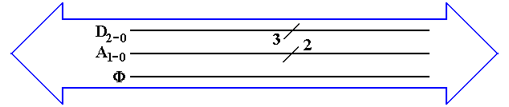
The big “double arrow” notation indicates a bus of a number of different signals. Some authors call this a “fat arrow”. Lines with similar function are grouped together. Their count is denoted with the “diagonal slash” notation. From top to bottom, we have
1. Three data lines D₂, D₁, and D₀
2. Two address lines A₁ and A₀
3. The clock signal for the bus Φ.
Not all busses transmit a clock signal; the system bus usually does.
Power and ground lines usually are not shown in this type of diagram. Note the a bus with only one type of signal might be drawn as a thick line with the slash, as in the 3 – bit data bus above.
Maximum Bus Length
In general, bus length varies inversely as transmission speed, often measured in Hz; e.g., a
1 MHz bus can make one million transfers per second and a 2 GHz bus can make two billion.
Immediately we should note that the above is not exactly true of DDR (Double Data Rate) busses which transfer at twice the bus speed; a 500 MHz DDR bus transfers 1 billion times a second.
Note that the speed in bytes per second is related to the number of bytes per transfer. A DDR bus rated at 400 MHz and having 32 data lines would transfer 4 bytes 800 million times a second, for a total of 3.20 billion bytes per second. Note that this is the peak transfer rate.
The relation of the bus speed to bus length is due to signal propagation time. The speed of light is approximately 30 centimeters per nanosecond. Electrical signals on a bus typically travel at
2/3 the speed of light; 20 centimeters per nanosecond or 20 meters per microsecond.
A loose rule of thumb in sizing busses is that the signal should be able to propagate the entire length of the bus twice during one clock period. Thus, a 1 MHz signal would have a one microsecond clock period, during which time the signal could propagate no more than twenty meters. This length is a round trip on a ten meter bus; hence, the maximum length is 10 meters. Similarly, a 1 GHz signal would lead to a maximum bus length of ten centimeters.
The rule above is only a rough estimator, and may be incorrect in some details. Since the typical bus lengths on a modern CPU die are on the order of one centimeter or less, we have no trouble.
Bus Classifications
It should be no surprise that, depending on the feature being considered, there are numerous ways to characterize busses. We have already seen one classification, what might be called a “mixed bus” vs. a “pure bus”; i.e., does the bus carry more than one type of signal. Most busses are of the mixed variety, carrying data, address, and control signals. The internal CPU busses on our design carry only data because they are externally controlled by the CPU Control Unit that sends signals directly to the bus end points.
One taxonomy of busses refers to them as either point–to–point vs. shared. Here is a picture of that way of looking at busses.
An example of a point–to–point bus might be found in the chapter on computer internal memory, where we postulated a bus between the MBR and the actual memory chip set. Most commonly, we find shared busses with a number of devices attached.
Another way of characterizing busses is by the number of “bus masters” allowed. A bus master is a device that has circuitry to issue command signals and place addresses on the bus. This is in distinction to a “bus slave” (politically incorrect terminology) that can only transfer data in response to commands issued by a bus master. In the early designs, only the CPU could serve as a bus master for the memory bus. More modern memory busses allow some input/output devices (discussed later as DMA devices) to act as bus masters and transfer data to the memory.
Bus Clocks
Another way to characterize busses is whether the bus is asynchronous or synchronous. A synchronous bus is one that has one or more clock signals associated with it, and transmitted on dedicated clock lines. In a synchronous bus, the signal assertions and data transfers are coordinated with the clock signal, and can be said to occur at predictable times.
An asynchronous bus is one without a clock signal. The data transfers and some control signal assertions on such a bus are controlled by other control signals. Such a bus might be used to connect an I/O unit with unpredictable timing to the CPU. The I/O unit might assert some sort of ready signal when it can undertake a transfer and a done signal when the transfer is complete.
In order to understand these busses more fully, it would help if we moved on to a discussion of the bus timing diagrams and signal levels.
Bus Signal Levels
Many times bus operation is illustrated with a timing diagram that shows the value of the digital signals as a function of time. Each signal has only two values, corresponding to logic 0 and to logic 1. The actual voltages used for these signals will vary depending on the technology used.
A bus signal is represented in some sort of trapezoidal form with rising edges and falling edges, neither of which is represented as a vertical line. This convention emphasizes that the signal cannot change instantaneously, but takes some time to move between logic high and low. Here is a depiction of the bus clock, represented as a trapezoidal wave.
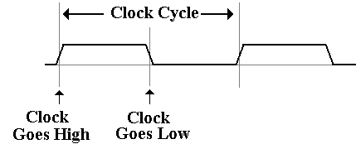
Here is a sample diagram, showing two hypothetical discrete signals. Here the discrete signal B# goes low during the high phase of clock T1 and stays low. Signal A# goes low along with the second half of clock T1 and stays low for one half clock period.
A collection of signals, such as 32 address lines or 16 data lines cannot be represented with such a simple diagram. For each of address and data, we have two important states; the signals are valid, and signals are not valid
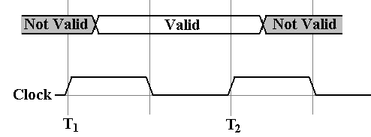
For example, consider the address lines on the bus. Imagine a 32–bit address. At some time after T₁, the CPU asserts an address on the address lines. This means that each of the 32 address lines is given a value, and the address is valid until the middle of the high part of clock pulse T2, at which the CPU ceases assertion.
Having seen these conventions, it is time to study a pair of typical timing diagrams. We first study the timing diagram for a synchronous bus. Here is a read timing diagram.
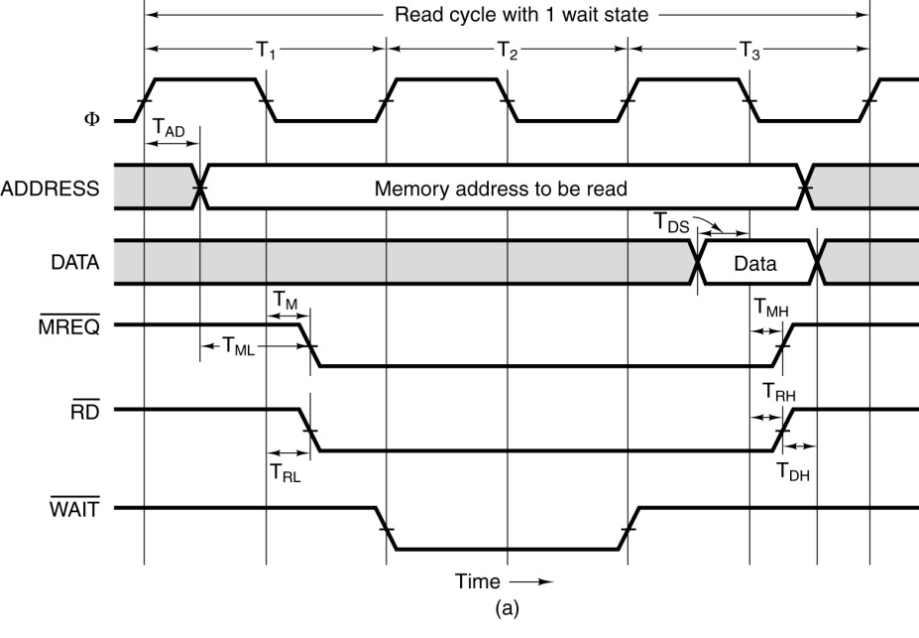
What we have here is a timing diagram that covers three full clock cycles on the bus. Note that during the high clock phase of T₁, the address is asserted on the bus and kept there until the low clock phase of T₃. Before and after these times, the contents of the address bus are not specified. Note that this diagram specifies some timing constraints. The first is T_{AD}, the maximum allowed delay for asserting the address after the clock pulse if the memory is to be read during the high phase of the third clock pulse.
Note that the memory chip will assert the data for one half clock pulse, beginning in the middle of the high phase of T₃. It is during that time that the data are copied into the MBR.
Note that the three control signals of interest ( ) are asserted low. We also have another constraint T_{ML}, the minimum time that the address is stable before the is asserted.
The purpose of the diagram above is to indicate what has to happen and when it has to happen in order for a memory read to be successful via this synchronous bus. We have four discrete signals (the clock and the three control signals) as well as two multi–bit values (memory address and data).
For the discrete signals, we are interested in the specific value of each at any given time. For the multi–bit values, such as the memory address, we are only interested in characterizing the time interval during which the values are validly asserted on the data lines.
Note that the more modern terminology for the three control signals that are asserted low would be MREQ#, RD#, and WAIT#. The reader will note that the figures in this chapter make use
of both styles for writing these control signals; translation to a uniform notation is bothersome.
The timing diagram for an asynchronous bus includes some additional information. Here the focus is on the protocol by which the two devices interact. This is also called the “handshake”. The bus master asserts MSYN# and the bus slave responds with SSYN# when done.
The asynchronous bus uses similar notation for both the discrete control signals and the
multi–bit values, such as the address and data. What is different here is the “causal arrows”, indicating that the change in one signal is the causation of some other event. Note that the assertion of MSYN# causes the memory chip to place data on the bus and assert SSYN#. That assertion causes MSYN# to be dropped, data to be no longer asserted, and then SSYN# to drop.

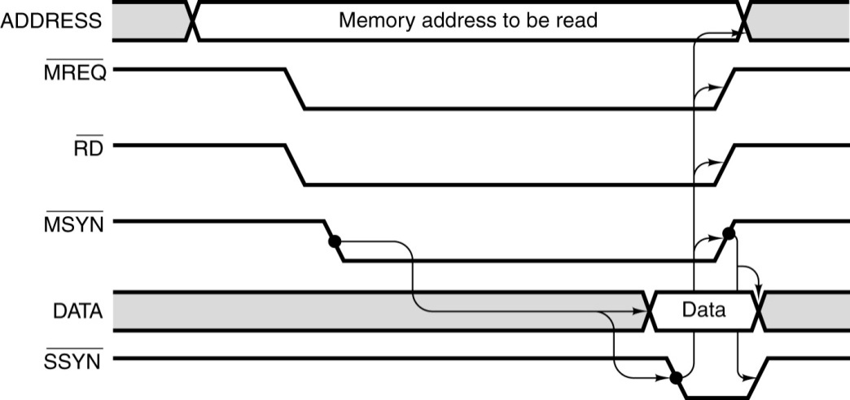
Multiplexed Busses
A bus may be either multiplexed or non–multiplexed. In a multiplexed bus, bus data and address share the same lines, with a control signal to distinguish the use. A non–multiplexed bus has separate lines for address and data. The multiplexed bus is cheaper to build in that it has fewer signal lines. A non–multiplexed bus is likely faster.
There is a variant of multiplexing, possibly called “address multiplexing” that is seen on most modern memory busses. In this approach, an N–bit address is split into two (N/2)–bit addresses, one a row address and one a column address. The addresses are sent separately over a dedicated address bus, with the control signals specifying which address is being sent.
Recall that most modern memory chips are designed for such addressing. The strategy is to specify a row, and then to send multiple column addresses for references in that row. Some modern chips transmit in burst mode, essentially sending an entire row automatically.
Here, for reference, is the control signal description from the chapter on internal memory.
CS# | RAS# | CAS# | WE# | Command / Action
1 | d | d | d | Deselect / Continue previous operation
0 | 1 | 1 | 1 | NOP / Continue previous operation
0 | 0 | 1 | 1 | Select and activate row
0 | 1 | 0 | 1 | Select column and start READ burst
0 | 1 | 0 | 0 | Select column and start WRITE burst

PCI Express
PCI Express (Peripheral Component Interconnect Express) is a computer expansion card standard designed to replace the older PCI bus standard. The name is abbreviated as “PCIe”. This is viewed as a standard for computer expansion cards, but really is a standard for the communication link by which a compliant device will communicate over the bus.
According to Wikipedia, PCIe 3.0 (August 2007) is the latest standard. While an outgrowth of the original PCI bus standard, the PCIe is not compatible with that standard at the hardware level. The PCIe standard is based on a new protocol for electrical signaling.
This protocol is built on the concept of a lane, which we must define. A PCI connection can comprise from 1 to 32 lanes. Here are some capacity quotes from Wikipedia
Per Lane 16–Lane Slot
Version 1 250 MB/s 4 GB/s
Version 2 500 MB/s 8 GB/s
Version 3 1 GB/s 16 GB/s
What is a Lane?
A lane is pair of point–to–point serial links, in other words the lane is a full–duplex link, able to communicate in two directions simultaneously. Each of the serial links in the pair handles one of the two directions.
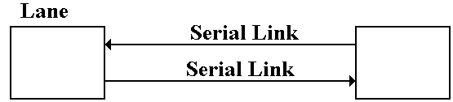
By definition, a serial link transmits one bit at a time. By extension, a lane may transmit two bits at any one time, one bit in each direction. One may view a parallel link, transmitting multiple bits in one direction at any given time, as a collection of serial links. The only difference is that a parallel link must provide for synchronization of the bits sent by the individual links.
Data Transmission Codes
The PCIe standard is byte oriented, in that it should be viewed logically as a full–duplex byte stream. What is actually transmitted? The association of bits (transmitted or received) with bytes is handled at the Data Link layer. Suppose a byte is to be transmitted serially.
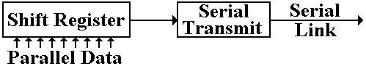
The conversion from byte data to bit–oriented data for serial transmission is done by a shift register. The register takes in eight bits at a time and shifts out one bit at a time. The bits, as shifted out, are still represented in standard logic levels. The serial transmit unit takes the standard logic levels as input, and converts them to voltage levels appropriate for serial transmission.
Three Possible Transmission Codes
The serial transmit unit sends data by asserting a voltage on the serial link. The simplest method would be as follows.
To transmit a logic 1, assert +5 volts on the transmission line.
To transmit a logic 0, assert 0 volts on the transmission line.
There are very many problems with this protocol. It is not used in practice for any purpose other than transmitting power. The two main difficulties are as follows. The first problem is that of transmitting power. If the average voltage (over time) asserted by a transmitter on a line is not zero, then the transmitter is sending power to the receiver. This is not desirable. The answer to this is to develop a protocol such that the time–averaged voltage on the line is zero. Such a protocol might call for enough changes in the voltage level to allow for data framing. Standard methods for link management use codes that avoid these problems. Two of the more common methods used are NRZ and NRZI.
Non–Return–to–Zero coding transmits by asserting the following voltages:
For a logic 1, it asserts a positive voltage (3.0 – 5.0 volts) on the link.
For a logic 0, it asserts a negative voltage (–3.0 to –5.0 volts).
Non–Return–to–Zero–Invert is a modification of NRZ, using the same voltage levels.
The Problem of Noise
One problem with these serial links is that they function as antennas. They will pick up any stray electromagnetic radiation if in the radio range.
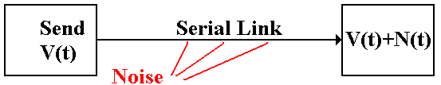
In other words, the signal received at the destination might not be what was actually transmitted. It might be the original signal, corrupted by noise. The solution to the problem of noise is based on the observation that two links placed in close proximity will receive noise signals that are almost identical. To make use of this observation, we use differential transmitters [ R94] to send the signals and differential receivers to reconstruct the signals.
In differential transmission, rather than asserting a voltage on a single output line, the transmitter asserts two voltages: +V/2 and –V/2. A +6 volt signal would be asserted as two: +3 volts and –3 volts. A –8 volt signal would be asserted as two: –4 volts and +4 volts.
Here are the standard figures for a differential transmitter and differential receiver. The standard receiver is an analog subtractor, here giving V/2 – (–V/2) = V.
Differential Transmitter Differential Receiver
Noise in a Differential Link
We now assume that the lines used to transmit the differential signals are physically close together, so that each line is subject to the same noise signal.
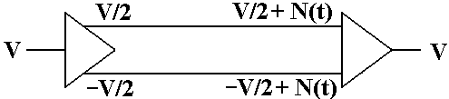
Here the received signal is the difference of the two voltages input to the differential receiver. The value received is ( V/2 +N(t) ) – ( –V/2 + N(t) ) = V, the desired value.
Ground Offsets in Standard Links
All voltages are measured relative to a standard value, called “ground”. Here is the complete version of the simple circuit that we want to implement.
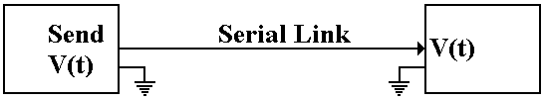
Basically, there is an assumed second connection between the two devices. This second connection fixes the zero level for the voltage.
There is no necessity for the two devices to have the same ground. Suppose that the ground for the receiver is offset from the ground of the transmitter.
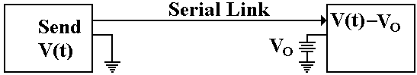
The signal sent out as +V(t) will be received as V(t) – V_{O}. Here again, the subtractor in the differential receiver handles this problem.
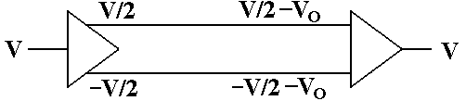
The signal originates as a given voltage, which can be positive, negative, or 0. The signal is transmitted as the pair (+V/2, –V/2). Due to the ground offset, the signal is taken in as
(+V/2 – V_{O}, –V/2 – V_{O}), interpreted as (+V/2 – V_{O}) – (–V/2 – V_{O}) = +V/2 – V_{O} + V/2 + V_{O} = V.
The differential link will correct for both ground offset and line noise at the same time.

