Chapter 3 – The Computer: Functional Units and Functioning
In this chapter, we examine the functional units of a typical stored program computer in a bit
more detail. We shall discuss the standard fetch–execute cycle and some of its standard
modifications as seen in modern commercial computers. We shall then follow the lead of Dr.
Rob Williams and give a brief overview of the memory system of a computer. Detailed
consideration of the memory system will be postponed until chapters 6 and 12.
The idea of a stored program computer probably originated with Charles Babbage (1792 – 1871),
the English mathematician claimed by some to be the “father of the computer”. Babbage
designed two mechanical computers, the difference engine and the analytical engine. It is the
analytical engine that displays the properties of a stored program computer. The design, as
described in an 1842 report (http://www.fourmilab.ch/babbage/sketch.html) by L. F. Menebrea,
calls for a five-component machine comprising the following.
1) The Store A memory fabricated from a set of counter wheels.
This was to hold 1,000 50-digit numbers.
2) The Mill Today, we would call this the Arithmetic-Logic Unit
3) Operation Cards Selected one of four operations: addition, subtraction,
multiplication, or division.
4) Variable Cards Selected the memory location to be used by the operation.
5) Output Either a printer or a punch.
The first electronic computing machines followed the same logical design, but were realized with
vacuum tubes, electronic wires, and various unreliable memory technologies. While these
served as platforms for much valuable work, our only interest here is as a stepping stone. As
mentioned before, the major advance in computer technology came with the integrated circuit,
introduced early in the 1970’s. Even those early designs using the smaller integrated circuits had
the problem of excessive wiring, which was difficult to install and test. The picture below shows
the “rats nest” of wiring on a typical computer backplane, used to connect the components.
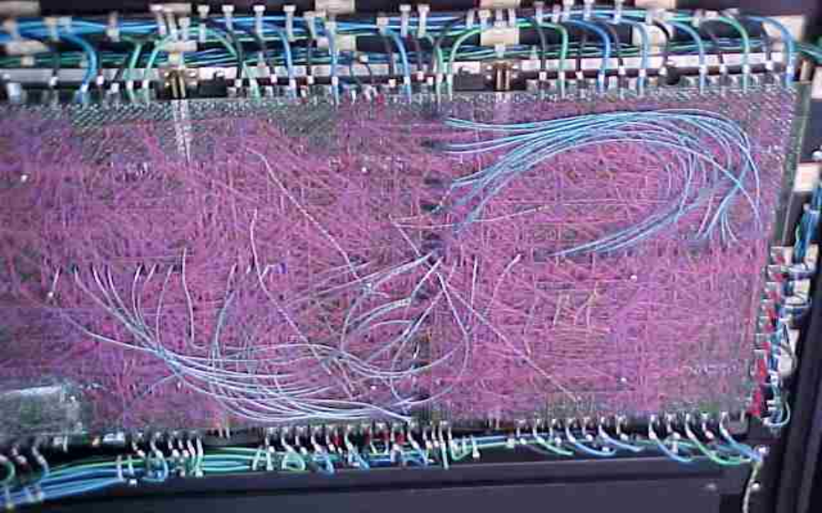
Figure: The Backplane of a PDP–10 (Model 1090)
The Motherboard
While the early integrated circuits represented a significant advance in computer design, it was
not until the introduction of VLSI (Very Large Scale Integrated) circuits that a significant step
was made. By definition, a VLSI circuit chip contains at least 100,000 transistors, corresponding
to about 30,000 to 50,000 digital circuit elements. At this level of complexity, most of the
interconnections could be placed on the chips, leaving a rather modest number of connections
required among the chips. Even then, these connections were no longer implemented as wires,
but as traces etched onto a large circuit board, called the motherboard.
Here is a picture of the motherboard of modern computers.
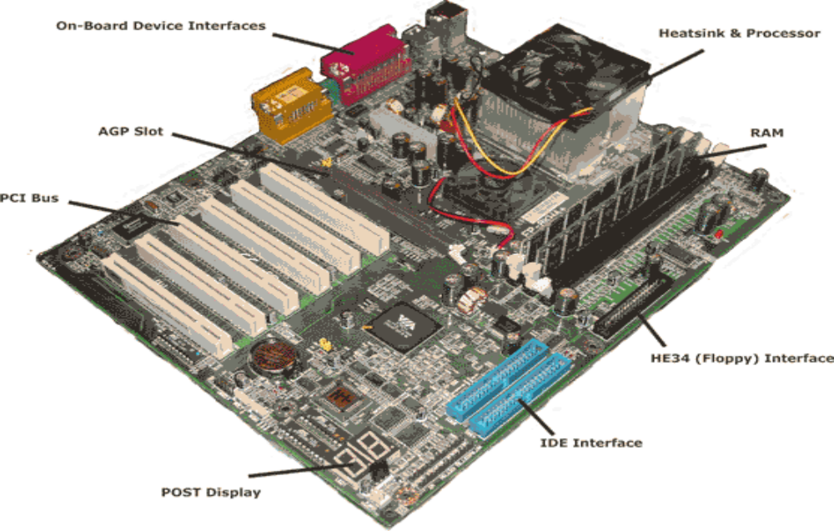
At this resolution, the reader might be able to see the aluminum traces used to connect the
insertion slots into which the components are placed. These traces greatly simplified the
manufacture of a motherboard by removing the necessity of a tangle of wiring, as seen in the
picture of the PDP–10 backplane. Note the RAM at the upper right. There seem to be two
memory modules, each a DIMM (Dual In–line Memory Module) with parity memory.
We shall discuss the structure of modern memory in chapter 8. As we have mentioned the term
“parity memory” here, we might as well explain a bit before moving on. A typical modern
memory module will be byte oriented, while the individual chips in the module will be bit
oriented. One would expect to see a memory module comprising eight memory chips, one for
each of the bits in an 8–bit byte. Close inspection of the memory modules above shows that each
has nine chips, thus storing nine bits for each byte. The extra bit is a parity bit, used for error
detection. Consider the entry PD₇D₆D₅D₄D₃D₂D₁D₀ . The eight bits, D₇D₆D₅D₄D₃D₂D₁D₀, store
the byte. The value of the parity bit, P, is determined by the parity convention used. The
number of 1 bits in the byte are counted; the byte 0101 0111 would have five. In even parity
memory, the requirement is that the nine bits stored have an even count of 1 bits; the above byte
(the ASCII code for “W”) would be stored as 1 0101 0111. In odd parity, the above byte
would be stored as 0 0101 0111. This is a simple error detection scheme.
We have already mentioned Moore’s Law. Another consequence of the progress predicted by
this law is the increase in the amount of memory that can be placed on a single DIMM. This
increase is driving new connection techniques with increased pin count. As a consequence, one
cannot confidently say how many pins are to be found on a DIMM without knowing the year of
its manufacture. The following picture shows both sides of a reasonably modern DIMM.
A quick count shows eight memory chips on the module; this is non–parity memory.
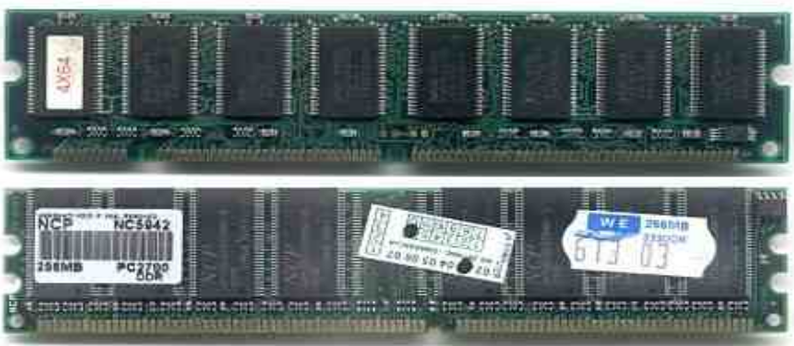
Note the pins at the bottom of the DIMM. These pins are inserted into a slot (socket) on the
motherboard. A quick count of the pins shows the number to be “quite a few”. The next picture
shows an enlargement of the area of the motherboard with the DIMM slots.
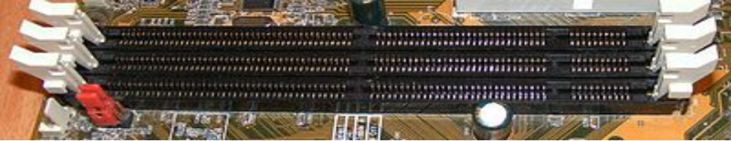
The final figure of this sequence on memory shows how the DIMM are inserted. The DIMM in
this figure does support parity memory. The smaller chip is a memory controller on the DIMM.
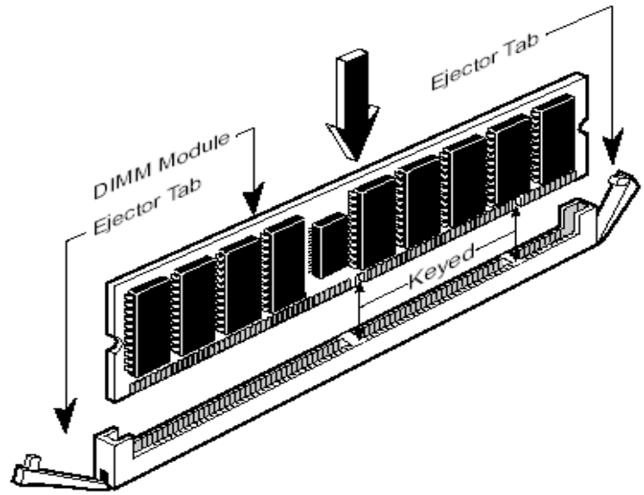

The manner of attachment of the CPU to the motherboard requires some discussion. Early CPU
chips, such as the Intel 8086, were connected as simple Dual In–Line chips. This chip has forty
pins, twenty in a row on each side.
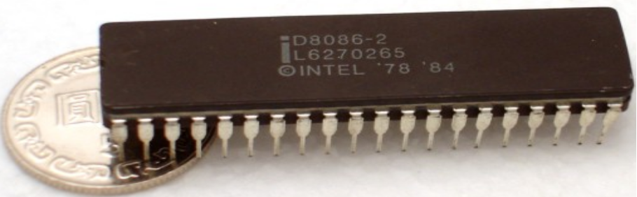
As the complexity of the Central Processing Unit grew, the number of pins to connect it to the
motherboard grew. Fairly soon, the dual–in–line approach was no longer sufficient and the
design had to move to a square array of pins on the bottom of the chip. The following picture
shows an early model Pentium with a later model socket. These figures just illustrate the
concept; the CPU chip will not fit into this socket.
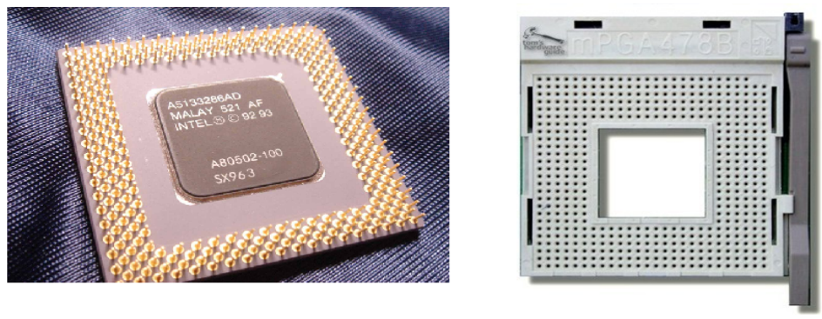
In order to cool the CPU, the design calls for a heatsink, which can be viewed as a radiator with
an electric fan to move air through it. Some enthusiasts, called “overclockers”, try to run the
CPU at a clock speed faster than is specified. In these situations, a large heatsink is required.
The following picture shows a typical large commercial heatsink. The CPU is mounted on the
small square area at the top with the tubes protruding from it.
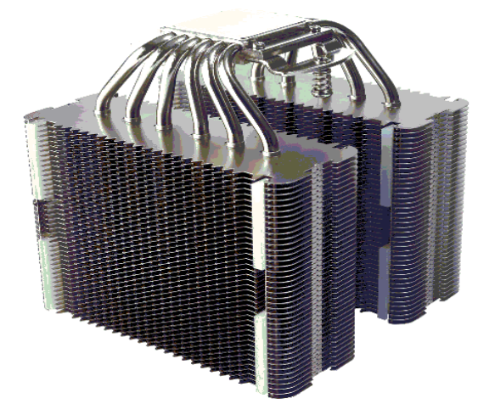
Components of a Modern Computer
The four major components of a modern stored program computer are:
1. The Primary Memory (also called “core memory” or “main memory”)
2. The Input / Output system
3. The Central Processing Unit (CPU)
4. One or more system busses to allow the components to communicate.
Note that some authors do not consider the bus when counting subsystems.
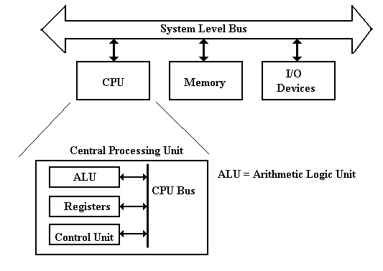
The system memory (of which your author’s computer has 512 MB) is used for transient
storage of programs and data. This is accessed much like an array, with the memory
address serving the function of an array index. Later chapters in this book will consider the
structure of this memory, including the use and advantages of cache memory.
The Input / Output system (I/O System) is used for the computer to save data and programs
and for it to accept input data and communicate output data. The keyboard is an input device,
the video display is an output device. Technically the hard drive is an I/O device, though we
can also consider it as a part of the memory system. As we shall see, I/O devices are divided
into classes by speed of data transfer, with controlling hardware adapted to the speed.
The Central Processing Unit (CPU) handles execution of the program.
It has four main components:
1. The ALU (Arithmetic Logic Unit), which performs all of the arithmetic
and logical operations of the CPU, including logic tests for branching.
2. The Control Unit, which causes the CPU to follow the instructions
found in the assembly language program being executed.
3. The register file, which stores data internally in the CPU. There are user
registers and special purpose registers used by the Control Unit.
4. A set of 3 internal busses to allow the CPU units to communicate.
A System Level Bus, which allows the top–level components to communicate. The idea of
a single system bus is logically correct, and has been implemented on many early designs
including the PDP–11, of which your author is so fond.
This design was acceptable for older computers, but is not acceptable for modern designs.
Basically, a single system level bus cannot handle the data load expected of modern machines.
Modern gamers demand fast video; this requires a fast bus to the video chip. The memory
system is always a performance bottleneck. We need a dedicated memory bus in order to allow
acceptable performance. Here is a refinement of the above diagram.
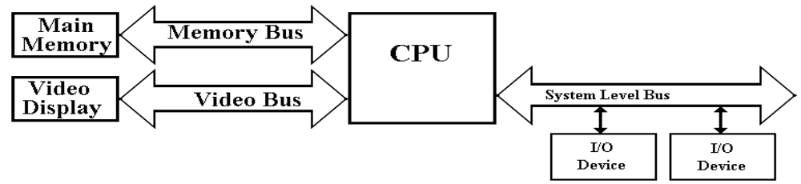
This design is getting closer to reality. At least, it acknowledges two of the devices requiring
high data rates in access to the CPU. We now turn to commercial realities, specifically legacy
I/O devices. When upgrading a computer, most users do not want to buy all new I/O devices
(expensive) to replace older devices that still function well. The I/O system must provide a
number of busses of different speeds, addressing capabilities, and data widths, to
accommodate this variety of I/O devices.
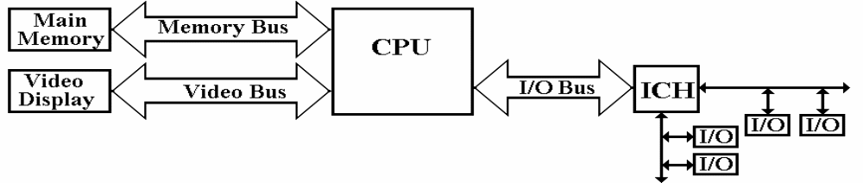
Here we show the main I/O bus connecting the CPU to the I/O Control Hub (ICH), which is
connected to two I/O busses: one for slower (older) devices, one for faster (newer) devices.
Note that each of the revised designs has two, or possibly three, point–to–point busses. The
memory bus is a good example of a point–to–point bus; it connects only two devices. The end
result is a significant improvement in data transfer speed, something that is demanded of this
bus. The downside is the complexity of the design.
While it would offer significant speed advantages for each component to be connected directly to
all of the other components, this option was not taken due mostly to the design complexity. Any
scheme connecting N devices via point–to–point busses must have N•(N – 1) /2 busses. This
would be 120 data busses for just 16 devices. The number grows quadratically.
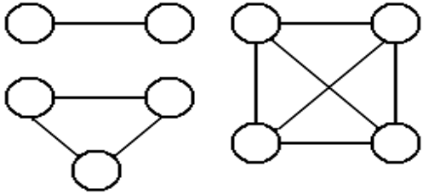
Just because the author likes to show off, he presents a
proof of this count. Two devices have 1 connection, 3
devices have 2 connections, and four devices have 6.
If N devices have N•(N – 1) /2 connections, and we
add another device, we must connect the new device
to the original N devices.
The new total is N•(N – 1) /2 + N = [N•(N – 1) + 2N] / 2 = [N² – N + 2N] / 2
= [N² + N] / 2 = N•(N + 1) /2.
The modern computer will have a bus structure suggested by the second modification. The
requirement to handle memory as well as a proliferation of I/O devices has lead to a new
design based on two controller hubs:
1. The Memory Controller Hub or “North Bridge”
2. The I/O Controller Hub or “South Bridge”
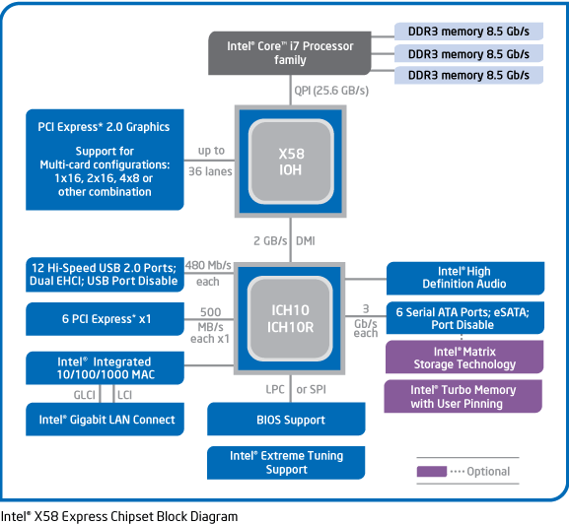
Such a design allows for grouping the higher–data–rate connections on the faster controller,
which is closer to the CPU, and grouping the slower data connections on the slower controller,
which is more removed from the CPU. The names “Northbridge” and “Southbridge” come from
analogy to the way a map is presented. In almost all chipset descriptions, the Northbridge is
shown above the Southbridge. In almost all maps, north is “up”. It is worth note that, in later
designs, much of the functionality of the Northbridge has been moved to the CPU chip.
The System Clock
The modern computer is properly characterized as a synchronous sequential circuit. For the
purposes of this course, a sequential circuit is one that has memory. The ALU (Arithmetic
Logic Unit) is not a sequential circuit as its output depends only on the input at the time. It does
not store results or base its computations on any previous inputs. The most fundamental
characteristic of synchronous circuits is a system clock, used to coordinate processing. This is
an electronic circuit that produces a repetitive train of logic 1 and logic 0 at a regular rate, called
the clock frequency. Most computer systems have a number of clocks, usually operating at
related frequencies; for example – 2 GHz, 1GHz, 500MHz, and 125MHz.

The inverse of the clock frequency is the clock cycle time or period. As an example, we
consider a clock with a frequency of 2 GHz (2•10⁹ Hertz). The cycle time is 1.0 / (2•10⁹)
seconds, or 0.5•10^{–9} seconds = 0.500 nanoseconds = 500 picoseconds. A slower bus clock
with a frequency of 250 MHz (2.5•10⁸ Hertz) would have a period of 1.0 / (2.5•10⁸) seconds,
or 4.0•10^{–9} seconds = 4.0 nanoseconds.
Synchronous sequential circuits are sequential circuits that use a clock input to order events.
Asynchronous sequential circuits do not use a common clock and are much harder to design and
test. As we shall focus only on synchronous circuits, we immediately launch a discussion of the
clock. The following figure illustrates some of the terms commonly used for a clock.
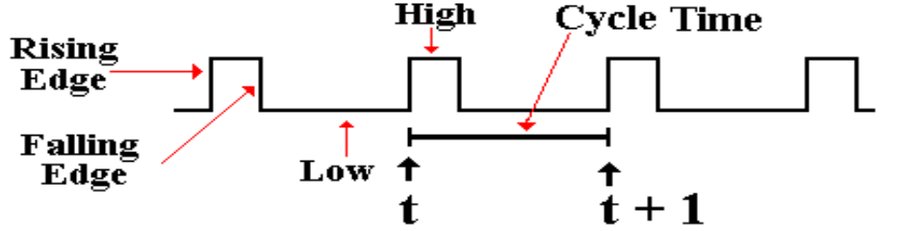
The clock input is very important to the concept of a sequential circuit. At each “tick” of the
clock the output of a sequential circuit is determined by its input and by its state. We now
provide a common definition of a “clock tick” – it occurs at the rising edge of each pulse. In
synchronous circuits, this clock tick is used to coordinate processing events.
Diversion: What the Clock Signals Really Look Like
The figure above represents the clock as a well-behaved square wave. This is far from the actual
truth, as can be seen by examining the clock pulses with sufficient resolution. The following
figure presents three views of the clock pulse train produced by a typical clock: a realistic
physical view and two notations for approximating the clock. In reality, the clock pulse is not
square, but rises and falls exponentially. This is shown in the top view.
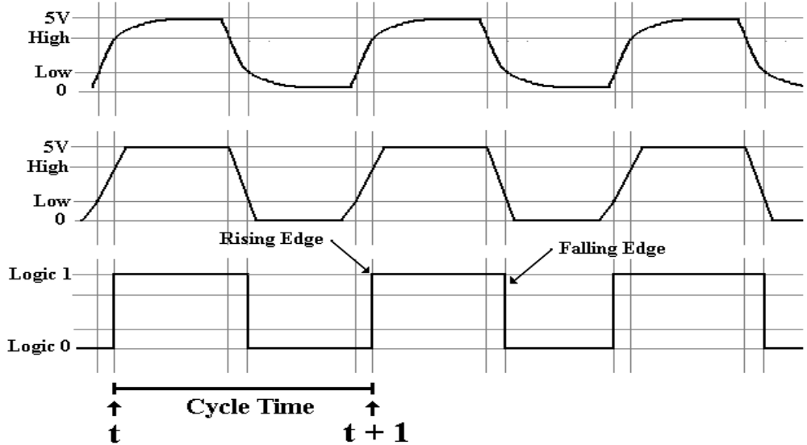

For those with mathematical interest, the clock falls in a function of the form e ^{–αx} and rises with
the form of the function 1 – e ^{–βx}, where α ≈ β. Use of this precise form does not gain us
anything and leads to significant difficulties, so that unless we are troubleshooting at a very low
level, we approximate the clock by either a trapezoidal wave or a square wave.
The trapezoidal wave form is used when it is important to emphasize the fact that the clock does
take some time to rise and fall. One sees this form of clock representation often when examining
timing diagrams for system buses. The square wave is a further abstraction of the real electrical
form of the wave; fortunately it is quite often an adequate representation. The square wave
representation remains at logic 0 until the real electrical clock crosses the threshold for logic high
at which time the square wave jumps to logic 1. The square wave remains at logic 1 until the
real electrical clock signal crosses the threshold for logic low at which time the square wave
goes to logic 0. The figure above is drawn to reflect that fact.
In any system of electronics based on positive voltages, there are three voltage ranges. There is a
threshold voltage below which the signal is interpreted as a logic 0. There is another threshold
voltage above which the signal is interpreted as a logic 1. There is also a “middle level” in
which the device is not required to assign a consistent logic value. The original values were
specified by Texas Instruments for its TTL (Transistor–Transistor Logic, most gates had two
transistors) circuits. The standard is based on a full voltage of 5.0 volts.
2.8 to 5.0 volts logic 1
0.8 to 2.8 volts indeterminate, may be interpreted as either logic 0 or logic 1
0.0 to 0.8 volts logic 0.
Earlier we hinted at the heat problem in a CPU and discussed the problems associated with
cooling it to a temperature at which it would operate reliably. One law of physics is that the heat
emitted by a circuit varies as the square of the power supplied to it. For this reasons, modern
computer designs have reduced the operating voltage, first to 3.5 volts and then to 1.8 volts.
Consider (5.0/1.8)² = 7.72. A 5 volt CPU produces over seven times the heat of a 1.8 volt unit.
With some minor reworking of the circuitry, the CPU would perform just as well at the lower
voltage. Given the recent emphasis on power management, the voltage change was adopted.
As noted above, if a bus has a clock it is usually slower than the system clock. This is achieved
by use of a straightforward sequential circuit called “divide by N”. For example, a system clock
signal at 2.0 GHz might be input into a “divide by 4” circuit to output a signal at 500 MHz.
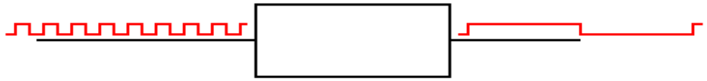
Computer Busses
We now turn our attention to computer busses. A bus is nothing more than a collection of wires
(or etched signal traces) along which a set of related electrical signals is sent. Busses are often
characterized by their “width”, which is the number of signal wires the bus contains.
Signals that traverse a bus can be divided into three groups:
1. Data – usually 32 bits or 64 bits at a time.
2. Address – now commonly either 32 bits or 64 bits.
3. Control – a number of lines for controlling the bus activities.

A bus may be either multiplexed or non–multiplexed. In a multiplexed bus, bus data and
address share the same lines, with a control signal to distinguish the use. A non–multiplexed
bus has separate lines for address and data. The multiplexed bus is cheaper to build in that it
has fewer signal lines. A non–multiplexed bus is likely faster.
There is a variant of multiplexing, possibly called “address multiplexing” that is seen on most
modern memory busses. In this approach, an N–bit address is split into two (N/2)–bit addresses,
one a row address and one a column address. The addresses are sent separately over a dedicated
address bus, with the control signals specifying which address is being sent. Modern memory
chips are designed to be addressed in two stages, called row address and column address.
Another way to characterize busses is whether the bus is asynchronous or synchronous. A
synchronous bus is one that has one or more clock signals associated with it, and transmitted
on dedicated clock lines. In a synchronous bus, the signal assertions and data transfers are
coordinated with the clock signal, and can be said to occur at predictable times. Synchronous
busses require all attached devices to operate at fixed speeds, either the bus clock speed or some
integer fraction of that speed; a 400 MHz bus might have devices at 400 MHz, 200 MHz, or
100 MHz. Such a bus is easier to design than an asynchronous bus.
An asynchronous bus is one without a clock signal. The data transfers and some control signal
assertions on such a bus are controlled by other control signals. Such a bus might be used to
connect an I/O unit with unpredictable timing to the CPU. The I/O unit might assert some sort of
ready signal when it can undertake a transfer and a done signal when the transfer is complete.
The memory bus used to be asynchronous, but modern memory is synchronous. Think of main
memory advertised as being “133 MHz”. This is the frequency of the memory bus.
Bus Signal Levels
Many times bus operation is illustrated with a timing diagram that shows the value of the digital
signals as a function of time. Each signal has only two values, corresponding to logic 0 and to
logic 1. The actual voltages used for these signals will vary depending on the technology used.
A bus signal is represented in some sort of trapezoidal form with rising edges and falling edges,
neither of which is represented as a vertical line. This convention emphasizes that the signal
cannot change instantaneously, but takes some time to move between logic high and low. Here
is a depiction of the bus clock, represented as a trapezoidal wave.
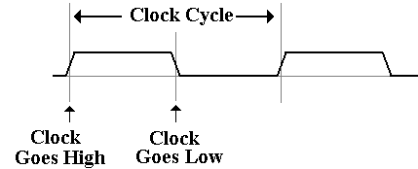
As noted above, this trapezoidal wave form is used in bus timing diagrams just to remind the
reader that the signal transitions are not instantaneous. Square waves would work just as well.

Signal Assertion Levels
A control signal is said to be asserted when it enables some sort of action. This applies to any
component of the computer, but here we are discussing bus transfers. Some signals are asserted
by being driven to a logic 1 (5.0 volts for TTL), but most are asserted by being driven to logic 0
(any voltage less than 0.8 volts for TTL, but commonly 0 volts). There are several notations
used to denote these signals. The book by Rob Williams uses an older notation. We use both.
Here are the notations used for active low signals, that is signals that are asserted at logic 0.
The over–bar is less used now, as it is not common for word processors to have this format
feature. A two–value signal is one that has meaning for each of its values. One of the easiest to
understand is 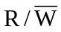; when 1 the first option is asserted, when 0, the second option is asserted.
The standards for denoting these signals are illustrated by the controls for a standard RAM
(Random Access Memory), discussed in detail below. We need two control signals to
specify the three options for a RAM unit. One standard set is
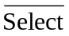 – the memory unit is selected. This signal is active low.
– if 0 the CPU writes to memory, if 1 the CPU reads from memory.
We can use a truth table to specify the actions for a RAM. Note that when = 1,
nothing is happening to the memory.
It is not being accessed by the CPU
and the contents do not change. When
= 0, the memory is active and
something happens.
 | 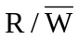 | Action
1 | 0 | Memory contents are not changed.
1 | 1 | Memory contents are not changed.
0 | 0 | CPU writes data to the memory.
0 | 1 | CPU reads data from the memory.

Recent there has been a change in the notation to denote the asserted low signals, replacing the
over–bar by a sharp sign. Given this convention, the table above would have been show as:
Select# | R/W# | Action
1 | 0 | Memory contents are not changed  or accessed. Nothing happens.
1 | 1
0 | 0 | CPU writes data to the memory.
0 | 1 | CPU reads data from the memory.
Here is a sample diagram, showing two hypothetical discrete signals. Here the discrete signal B#
goes low during the high phase of clock T1 and stays low. Signal A# goes low along with the
second half of clock T1 and stays low for one half clock period.
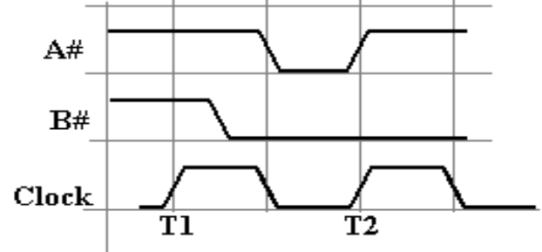

A collection of signals, such as 32 address lines or 16 data lines cannot be represented with such
a simple diagram. For each of address and data, we have two important states; the signals are
valid, and signals are not valid
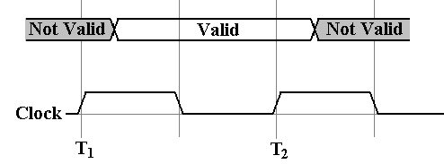
For example, consider the address lines on the bus. Imagine a 32–bit address. At some time
after T₁, the CPU asserts an address on the address lines. This means that each of the 32 address
lines is given a value, and the address is valid until the middle of the high part of clock pulse T2,
at which the CPU ceases assertion.
Having seen these conventions, it is time to study a pair of typical timing diagrams. We first
study the timing diagram for a synchronous bus. Here is a read timing diagram.
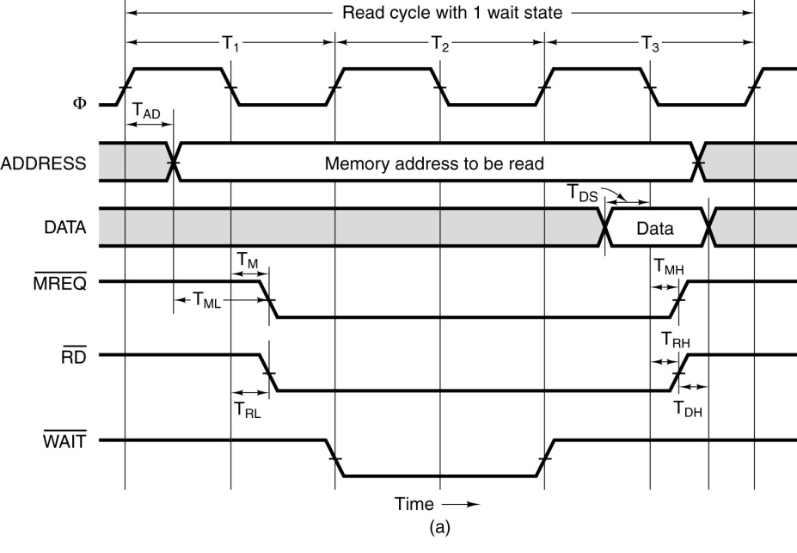
What we have here is a timing diagram that covers three full clock cycles on the bus. Note that
during the high clock phase of T₁, the address is asserted on the bus and kept there until the low
clock phase of T₃. Before and after these times, the contents of the address bus are not specified.
Note that this diagram specifies some timing constraints. The first is T_{AD}, the maximum allowed
delay for asserting the address after the clock pulse if the memory is to be read during the high
phase of the third clock pulse.
Note that the memory chip will assert the data for one half clock pulse, beginning in the middle
of the high phase of T₃. It is during that time that the data are copied into the MBR.

Note that the three control signals of interest, now called MREQ#, RD#, and WAIT# are
asserted low. The reason for changing from the over–bar notation is that your author’s word
processing program was consistently messing up the format when displaying that.
We also have another constraint T_{ML}, the minimum time that the address is stable before the
signal MREQ# is asserted. The purpose of the diagram above is to indicate what has to happen
and when it has to happen in order for a memory read to be successful via this synchronous bus.
We have four discrete signals (the clock and the three control signals) as well as two multi–bit
values (memory address and data).
For the discrete signals, we are interested in the specific value of each at any given time. For the
multi–bit values, such as the memory address, we are only interested in characterizing the time
interval during which the values are validly asserted on the data lines.
The timing diagram for an asynchronous bus includes some additional information. Here the
focus is on the protocol by which the two devices interact. This is also called the “handshake”.
The bus master asserts MSYN# and the bus slave responds with SSYN# when done.
The asynchronous bus uses similar notation for both the discrete control signals and the
multi–bit values, such as the address and data. What is different here is the “causal arrows”,
indicating that the change in one signal is the causation of some other event. Note that the
assertion of MSYN# causes the memory chip to place data on the bus and assert SSYN#. That
assertion causes MSYN# to be dropped, data to be no longer asserted, and then SSYN# to drop.
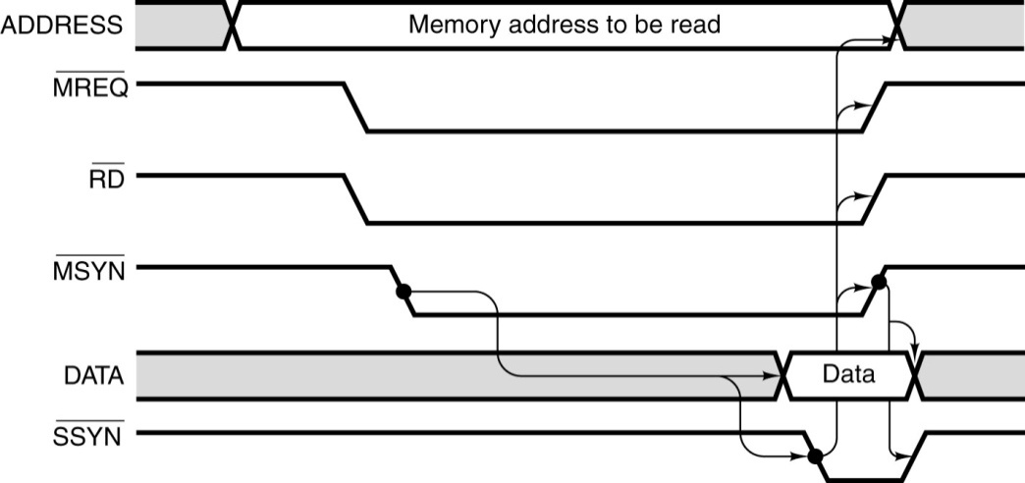
The Fetch–Execute Cycle
As noted several times before in this text, a stored program computer operates by fetching
instructions from memory and executing them; this is the “fetch–execute cycle”. Depending on
the level of detail one wishes to discuss, there are quite a few ways to characterize this process.
One common way is to break the cycle into three parts:
1. Fetch the instruction is copied from memory into the CPU.
2. Decode the control logic identifies the instruction.
3. Execute the CPU executes the instruction and possibly writes the result to memory.
Your instructor has written a textbook on Computer Architecture, in which he wants to focus on
addressing modes in a computer. For this purpose, he breaks the cycle also into 3 parts: fetch,
defer, and execute. Others may break the cycle into 5 phases, or as many as 12.
No matter how it is described, the basic function of the fetch–execute cycle is the same: bring
instructions from the memory and execute them. At the time an instruction is fetched from
memory, it has been converted to binary machine code and stored at a fixed memory location.
In raw form, the binary instructions are almost unreadable. Here is how the code might appear in
a hexadecimal data representation, in which each hexadecimal digit represents 32 binary bits.
We shall first show a listing with eight hexadecimal digits per line and then show the meaning of
the code. We shall not present the absolute binary. Hexadecimal notation is covered soon.
B8 23 01 05
25 00 8B D8
03 D8 8B CB
2B C8 2B C0
EB EE
The process of converting this mess into something that can be understood is called disassembly.
We shall work with that in the near future. The key is to find the opcode in the machine code
listing and then to identify what other digits go with it. In the first line, we would note that the
one–byte value B8 is the numeric code for moving a value into a register, an instruction that is
three bytes in length. Hence the first complete instruction is B82301. Here is the complete
disassembly of the above code fragment. It seems to be toy code with little real purpose.
B82301 MOV AX, 0123 Move value 0x0123 to AX
052500 ADD AX, 0025 Add value 0x0025 to AX
8BD8 MOV BX, AX Copy contents of AX into BX
03D8 ADD BX, AX Add contents of BX to AX
8BCB MOV CX, AX Copy contents of AX into CX
2BC8 SUB CX, AX Subtract AX from CX
2BC0 SUB AX, AX Subtract AX from AX, clearing it
EBEE JMP 100 Go to address 100
The above mess shows the advantage of using assembly language over pure binary code, and
further the significant advantage of coding in a higher level language.
At this point, we mention three registers found in the Pentium CPU. As noted above, both
registers and memory store data. The primary difference between a register and a memory word
is that the register is considered logically a part of the CPU, while memory is considered a
separate subsystem. Two of these registers, IP and IR, are special purpose registers; they are
used by the CPU Control Unit and cannot be referenced directly by the program. The other
register, AX, is a general purpose register; assembly language instructions can reference it
directly and often do. Here are the definitions of these registers.
AX This is also called the Accumulator, in that it accumulates results. The best
analogy is the display on a single line calculator, which holds the results of the
calculation as it progresses. As we shall see later, there are a number of ways to
access the accumulator; as AX it is 16 bits, as EAX it is 32 bits.
IR This is called the Instruction Register. The fetch–execute cycle functions by
copying a binary machine language instruction into the Instruction Register for
access by the Control Unit, which decodes it and begins execution.

IP This is the Instruction Pointer, pointing to the instruction to be fetched next.
Other designs call this register the PC or Program Counter, probably because it
does not count anything. As an efficiency, while one instruction is executing the
Instruction Pointer is already pointing to the next instruction. This often causes
confusion for the inexperienced assembly language programmer.
Using pseudo–Java, the instruction fetch is simply described: IR = Memory[IP++].
Instruction Prefetching
There have been a number of design changes undertaken in order to speed up the execution of
machine language instructions. One is based on the realization that the execution of one
instruction can be done in parallel with the fetching of the next instruction. This design option,
called “prefetching” works because instructions are normally executed in sequence. Breaks in
the sequence, such as loops, jumps, and subroutine calls tend to be less common.
Here is a diagram showing the idea of a prefetch unit. The idea originated with the IBM 7030,
called “Stretch” in the late 1950’s.
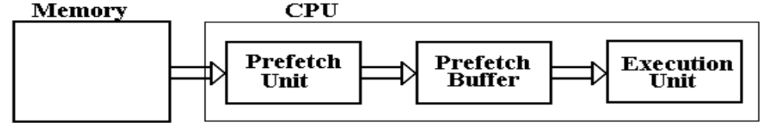
The prefetch buffer is implemented in the CPU with on–chip registers. It is implemented as a
single queue, which is a FIFO (first–in, first–out) data structure. Normally the instructions are
issued to the execution unit in the order they are fetched and placed in the prefetch buffer.
When the execution of one instruction completes, the next one is already in the buffer and can be
quickly executed. Any program branch (loop structure, conditional branch, etc.) will invalidate
the contents of the prefetch buffer, which must be reloaded.
The Memory Component
We shall speak of computer memory in more detail in chapters 6 and 12 of this textbook. For the
moment, we shall confine ourselves to a few general remarks. The memory stores the
instructions and data for an executing program. Memory is characterized by the smallest
addressable unit:
Byte addressable the smallest unit is an 8–bit byte.
Word addressable the smallest unit is a word, usually 16 or 32 bits in length.
Most modern computers are byte addressable, facilitating access to character data. The CPU has
two registers dedicated to handling memory.
The MAR (Memory Address Register) holds the address being accessed.
The MBR (Memory Buffer Register) holds the data being written to the memory or being
read from the memory. This is sometimes called the Memory Data Register.

We have already discussed the memory control signals issued by the CPU when we used them as
an example of notation for bus control. Here they are again, Select# and R/W#.
Select# | R/W# | Action
1 | 0 | Memory contents are not changed  or accessed. Nothing happens.
1 | 1
0 | 0 | CPU writes data to the memory.
0 | 1 | CPU reads data from the memory.
Byte Addressing vs. Word Addressing
The addressing capacity of a computer is dictated by the number of bits in the MAR. If the
MAR (Memory Address Register Contains) N bits, then 2^{N} items can be addressed. In a byte
addressable machine, the maximum memory size would be 2^{N} bytes. If the machine is word
addressable, with 2–byte words, the maximum memory size is 2^{N} words or 2^{N+1} bytes.
Word addressable machines might have their memory sized quoted in bytes, but they do not
access individual bytes. As an example, we examine two obsolete computers, the PDP–11/70
and the CDC–6600. Each used an 18–bit address; the PDP–11/70 addressed 256 KB, the
CDC–6600 addressed 256 K words (60 bits each). The CDC–6600 could have been considered
to have 1,920 KB of memory. However, it was not byte addressable; the smallest addressable
unit was a 60–bit integer.
Almost every modern computer is byte addressable to allow direct access to the individual bytes
of a character string. A modern computer that is byte addressable can still issue both word and
longword instructions. These just reference data two bytes at a time and four bytes at a time.
Word Addressing in a Byte Addressable Machine
Each 8–bit byte has a distinct address. A 16–bit word at address Z contains bytes at addresses Z
and Z + 1. A 32–bit word at address Z contains bytes at addresses Z, Z + 1, Z + 2, and Z + 3.
Note that computer organization and architecture refer to addresses, rather than variables.
The idea of a variable is an artifact of higher level languages.
Big–Endian vs. Little–Endian Addressing
Here is a problem. Consider a 32–bit integer, which takes four bytes to store. Suppose that the
value is in the 32–bit accumulator, EAX. Following standard practice, we number the bits in the
integer with values from 0 through 31. Following practice that is standard for every computer
design except the IBM Mainframe series, we number the most significant bit 31 and the least
significant bit 0. We assume that the hexadecimal value 0x01020304 is stored in this register.
For those who are interested, the decimal value is 16, 909, 060.

Suppose the instruction MOV Z, EAX is executed. What is placed into address Z. This depends
on whether the Pentium is a big–endian or little–endian device. (It is a big–endian device, but
we shall examine both options.)

Here is one representation of the two options for storing the value. The value that goes into
each address is a one–byte number, comprising two hexadecimal digits.
Address Big-Endian Little-Endian
Z 01 04
Z + 1 02 03
Z + 2 03 02
Z + 3 04 01
The following diagram might make things more obvious. Note that the value in the
32–bit register EAX is the same on both sides.
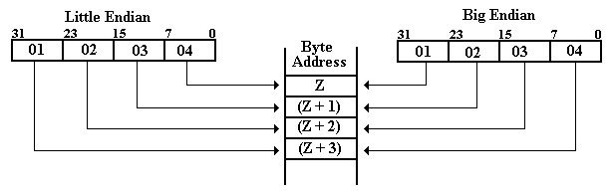
Example: “Core Dump” at Address 0x200
Basically a core dump is an obsolete term for a listing, by address, of the hexadecimal values in
each addressable byte of primary memory. The name is due to the fact that, for 20 to 30 years,
the most popular implementation of primary memory used magnetic cores. We have already
seen one example of a core dump in the above listing of binary machine code in hexadecimal
format. Core dumps contain both instructions and data; they are very tedious to read. It is here
that modern debugging tools really shine. In reading these examples, remember the powers of
16, the basis of hexadecimal numbers.
The powers of 256 are 256⁰ = 1, 256¹ = 256, 256² = 65536, and 256³ = 16,777,216
Suppose one has the following memory map as a result of a core dump. The memory is byte
addressable; each byte holds a number represented by two hexadecimal digits.
Address | 0x200 | 0x201 | 0x202 | 0x203
Contents | 02 | 04 | 06 | 08
What is the value of the 32–bit long integer stored at address 0x200?
This is stored in the four bytes at addresses 0x200, 0x201, 0x202, and 0x203. For the
big–endian option, the number is 0x02040608. Its decimal value is
2•256³ + 4•256² + 6•256¹ + 8•1 = 33,818,120
Little Endian: The number is 0x08060402. Its decimal value is
8•256³ + 6•256² + 4•256¹ + 2•1 = 134,611,970.
NOTE: Read the bytes backwards, not the hexadecimal digits.

Example 2: “Core Dump” at Address 0x200
Suppose one has the following memory map as a result of a core dump.
The memory is byte addressable.
Address | 0x200 | 0x201 | 0x202 | 0x203
Contents | 02 | 04 | 06 | 08
What is the value of the 16–bit integer stored at address 0x200?
This number is stored in the two bytes at addresses 0x200 and 0x201. The bytes at addresses
0x202 and 0x203 are not part of this 16–bit integer.
Big Endian The value is 0x0204.
The decimal value is 2•256 + 4 = 516
Little Endian: The value is 0x0402.
The decimal value s 4•256 + 2 = 1,026
Simple I/O – Parallel Ports
In our discussion above on memory, we hinted at the operation. An address is provided to
memory and the CPU commands either a read from that address or a write to that address. While
there may be a bit more to it than this, we have stated the essence of these operations. However,
there is no requirement that addresses refer only to memory.
Beginning with at least the Intel 8085 (1977), the Intel architectures have supported two distinct
busses, a bus to memory and a bus to Input / Output devices. In the terminology used for these
devices, the addressable locations on the I/O bus are called “ports”. Each port corresponds to an
8–bit register, sometimes called a data latch.
For an input port, the data latch holds the byte generated by the input device so that it can be
read by the CPU. For an output port, the data latch holds the data written to the device so that
the CPU does not stall while the output device processes the data.
At this point, we should notice that most input and output devices are served by more than one
port address. This is due to the requirement for device control and status checking. Each device
commonly has at least three registers associated with it, each on a different port.
Command This is an output port allowing the CPU to send commands to the I/O device.
Even input devices, such as card readers, have such a register.
Status This is an input port allowing the CPU to determine the status of the I/O
device. Even output devices, such as printers, have such a register.
Data This is the register that allows the data to be transferred. Depending on
the device, it maps to either an input port or an output port.
We shall discuss matters of I/O design more in chapters 9, 10 and 11 of this text.

Gulliver’s Travels and “Big-Endian” vs. “Little-Endian”
The author of these notes has been told repeatedly of the literary antecedents of the terms
“big–endian” and “little-endian” as applied to byte ordering in computers. In a fit of scholarship,
he decided to find the original quote. Here it is, taken from Chapter IV of Part I (A Voyage to
Lilliput) of Gulliver’s Travels by Jonathan Swift, published October 28, 1726.
The edition consulted for these notes was published in 1958 by Random House, Inc. as a part of
its “Modern Library Books” collection. The LC Catalog Number is 58-6364.
The story of “big-endian” vs. “little-endian” is described in the form on a conversation between
Gulliver and a Lilliputian named Reldresal, the Principal Secretary of Private Affairs to the
Emperor of Lilliput. Reldresal is presenting a history of a number of struggles in Lilliput, when
he moves from one difficulty to another. The following quote preserves the unusual
capitalization and punctuation found in the source material.
“Now, in the midst of these intestine Disquiets, we are threatened with an Invasion from the
Island of Blefuscu, which is the other great Empire of the Universe, almost as large and powerful
as this of his majesty. ….
[The two great Empires of Lilliput and Blefuscu] have, as I was going to tell you, been engaged
in a most obstinate War for six and thirty Moons past. It began upon the following Occasion. It
is allowed on all Hands, that the primitive Way of breaking Eggs before we eat them, was upon
the larger End: But his present Majesty’s Grand-father, while he was a Boy, going to eat an Egg,
and breaking it according to the ancient Practice, happened to cut one of his Fingers. Whereupon
the Emperor his Father, published an Edict, commanding all his Subjects, upon great Penalties,
to break the smaller End of their Eggs. The People so highly resented this Law, that our
Histories tell us, there have been six Rebellions raised on that Account; wherein one Emperor
lost his Life, and another his Crown. These civil Commotions were constantly fomented by the
Monarchs of Blefuscu; and when they were quelled, the Exiles always fled for Refuge to that
Empire. It is computed, that eleven Thousand Persons have, at several Times, suffered Death,
rather than submit to break their Eggs at the smaller end. Many hundred large Volumes have
been published upon this Controversy: But the Books of the Big–Endians have been long
forbidden, and the whole Party rendered incapable by Law of holding Employments.”

Jonathan Swift was born in Ireland in 1667 of English parents. He took a B.A. at Trinity College
in Dublin and some time later was ordained an Anglican priest, serving briefly in a parish
church, and became Dean of St. Patrick’s in Dublin in 1713. Contemporary critics consider the
Big–Endians and Little–Endians to represent Roman Catholics and Protestants respectively. In
the 16th century, England made several shifts between Catholicism and Protestantism. When the
Protestants were in control, the Catholics fled to France; when the Catholics were in control; the
Protestants fled to Holland and Switzerland.
Lilliput seems to represent England, and its enemy Blefuscu is variously considered to represent
either France or Ireland. Note that the phrase “little–endian” seems not to appear explicitly in
the text of Gulliver’s Travels.

